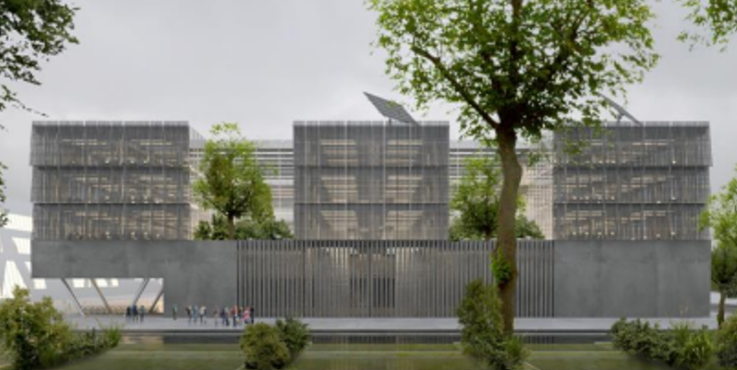

Construction of Scientific Research Center for Electrical Engineering and Computer Sciences (FERIT)

ENVIRONMENTAL AND SOCIAL MANAGEMENT PLAN (ESMP)

DIGIT - Digital, Innovation, and Green Technology Project (P180755)



MINISTRY OF SCIENCE, EDUCATION AND YOUTH

May 2024

CONTENT
1 INTRODUCTION 4
1.1 Objectives of ESMP 4
1.2 Project background 4
1.3 General information about the Sub-Project 5
1.4 Study Team 6
1.5 Timeline 6
1.6 Policy framework 7
1.6.1 National environmental and social legislation 7
1.6.2 International environmental and social legislation 13
2 DESCRIPTION OF THE CONSTRUCTION OF SCIENTIFIC RESEARCH CENTER FOR ELECTRICAL ENGINEERING AND COMPUTER SCIENCE FERIT SUB-PROJECT 16
2.1 Background information 16
2.2 Location and building plot 22
2.3 Technical description of planned reconstruction 23
2.3.1 Construction elements 31
2.3.2 Water supply 31
2.3.3 Wastewater collection and management 32
2.3.4 Electrical installations 32
2.3.5 HVAC installations (heating, cooling and ventilation) 34
2.3.6 Accessibility of the building to persons with disabilities and persons with reduced mobility 35
2.3.7 Fire safety 35
2.3.8 Landscaping 36
2.3.9 Parking lots at the location 37
2.4 Archeology 38
2.4.1 Archeological zone „Mursa“ 38
2.4.2 Research carried out so far 39
2.4.3 Project of Restoration, Conservation and Presentation of Archaeology 44
2.4.4 Archaeological presentation 49
2.4.5 Treatment of archaeological finds 57
2.4.6 Construction and materials 58
2.4.7 Materials and linings 58
2.4.8 Construction pit 58
3 ENVIRONMENTAL CONDITIONS OF SUB-PROJECT AREA 60
3.1 Land use 60
3.2 Air quality 61
3.3 Radon emission 61
3.4 Noise 62
3.5 Biodiversity, Nature protection areas and Natura 2000 Ecological Network 62
3.6 Water and flood areas 65
3.7 Seismic characteristics and soil stability 67
3.8 Climate and climate change 68
3.9 Site history 70
3.10 Pollutants in the vicinity of the Sub-Project 70
4 SOCIAL-ECONOMIC BASELINE OF SUB-PROJECT AREA 71
4.1 Population 71
4.2 Socio-economic context 71
4.3 Buildings and infrastructure in the vicinity of the planned Sub-Project 71
4.4 Cultural Heritage 72
5 STAKEHOLDER CONSULTATION AND INFORMATION DISCLOSURE 73
5.1 Summary of previous stakeholder engagement activities 73
5.1.1 Public presentations 77
5.1.2 Information disclosure 78
5.1.3 Additional Stakeholder Engagement Activities 78
6 POTENTIAL ENVIRONMENTAL AND SOCIAL RISK, IMPACTS AND MITIGATION MEASURES 83
6.1 Ambient air quality 85
6.2 Indoor air quality 87
6.3 Soil 88
6.4 Water Quality 89
6.5 Vulnerability of Sub-Project to the floods 90
6.6 Biodiversity, Nature Protection Areas and Natura 2000 90
6.7 Noise exposure 92
6.8 Vibration 93
6.9 Traffic 94
6.10 Cultural Heritage 95
6.11 Land acquisition 97
6.12 Labor and Working Conditions and Occupational Health and Safety 98
6.13 Community Health and Safety 100
6.14 Waste Management 102
6.15 Positive social impacts 103
7 INSTITUTIONAL ARRANGEMENT 105
8 GRIEVANCE REDRESS MECHANISM 108
8.1 Project GRM 108
8.2 Contractors GRM 108
9 ENVIRONMENTAL AND SOCIAL MITIGATION AND ENHANCEMENT PLAN 109
9.1 Environmental and social mitigation plan - Construction phase 110
9.2 Environmental and social mitigation plan - Use Phase 128
10 ENVIRONMENTAL AND SOCIAL REPORTING AND MONITORING PLAN 132
11 ANNEXES 143
ANNEX 1. Stakeholder Engagement Plan (SEP) 143
ANNEX 2. CHMP (Cultural Heritage Management Plan) 157
ANNEX 3. Documentation issued from the Ministry of Economy and Sustainable Development) related to Environmental Impact Assessment 166

ABBREVIATIONS

Abbreviation | Full term
EHSG | Environmental Health and Safety Guidelines
E&S | Environmental and Social
ESMF | Environmental and Social Management Framework
ESMP | Environmental and Social Management Plan
ESS | Environmental and Social Standards
FERIT | Faculty of Electrical Engineering, Computer Science and Information Technology
GIIP | Good International Industry Practice
GDA | Gross Development Area
GMP | Good Manufacturing Practices
MSEY | Ministry of Science, Education and Youth
OHS | Occupational Health and Safety
OG | Official Gazette
NFPA | National Fire Protection Association
PPE | Personal Protective Equipment
RoC | Republic of Croatia
WB | World Bank
WHO | World Health Organization

INTRODUCTION

Objectives of ESMP
The main objective of ESMP is to ensure that the Sub-Project activity is compliant to national and EU regulations, as well as to World Bank Environmental and Social Framework (ESF) in all phases of the Sub-Project’s lifecycle. Accordingly, ESMP addresses requirements of WB Environmental Health and Safety Guidelines (EHSG) and Good International Industrial Practices (GIIP). For that purpose, ESMP defines measures to minimize adverse effects and risks on the biophysical and socio-economic environment during construction works and use of Scientific Research Center for Electrical Engineering and Computer Science Sub-Project. Application and content of ESMP are guided by the Project Environmental and Social Commitment Plan (ESCP) and ESMF, WB ESSs, WB EHSG and GIIP. This document will help assess potential environmental and social impacts associated with the proposed Sub-Project, identify potential environmental and social improvement opportunities, and recommend measures for the prevention, minimization, and mitigation of adverse environmental and social impacts. Environmental and Social Mitigation Plan and Monitoring Plan encompassing all stages of the Sub-Project, with a purpose to supervise E&S compliance and streamline implementation of measures (and corrective actions) are an integral part of the ESMP.

Project background
The Government of the Republic of Croatia and the International Bank for Reconstruction and Development (IBRD) have signed the Loan Agreement (Loan No. 9558-HR) for the DIGIT- Digital, Innovation, and Green Technology Project (P180755).
The DIGIT Project`s aim is to facilitate the digital transformation and the green transition of the economy, increase resources for applied research and experimental development, and support the efforts of the Croatian government to strengthen its institutional capacity to deliver research and innovation policies. Activities under the DIGIT Project are designed to finance research and innovation through Sub-grant schemes, with a focus on digital and green, and complement and enhance the effectiveness of investments and build the capacities of institutions to deliver on this agenda. The DIGIT Project will also support reforms envisaged in the National Recovery and Resilience Plan 2021-2026 (NRRP), the Croatia Smart Specialization Strategy 2021-2027 (S3), Programme Competitiveness and Cohesion 2021-2027 (PCC), and activities important for the country’s accession to the Organization for Economic Co-operation and Development (OECD).
Digital, Innovation, and Green Technology Project (DIGIT) consists of components and sub-components presented in Table 1.
Table 1. Project components and sub-components
Component 1: Enabling institutional conditions for digital and green research and innovation
Subcomponent 1.1: Strengthening the institutional infrastructure for research and innovation policy
- Capacities development for design, implementation, and M&E of research and innovation programs
- Institutional support for performance-based funding reform in research organizations
- Financing for selected research and technology infrastructure projects
Subcomponent 1.2: Strengthening effectiveness of research and innovation financing
- Funding to enhance effectiveness of the program mix
- Online diagnostic and technology scouting
- Professionalization of research centers
Component 2: Programs for digital and green research and innovation
Subcomponent 2.1: Pre-commercial digital and green R&D support
- Grants for pre-commercial digital and green R&D
- Challenge program
Subcomponent 2.2: Synergies program
- Synergies program

Sub-Project Construction of Scientific Research Center for Electrical Engineering and Computer Science (FERIT) falls under the Subcomponent 1.1. Strengthening the institutional infrastructure for research and innovation policy, activity: Financing for selected research and technology infrastructure projects. This activity finances grants to research organizations addressing gaps in the availability of quality equipment and access to research infrastructure. The Sub-Project was selected based on a number of non-exclusive criteria, including contribution to digital transformation and green transition, public-private cooperation, private sector demand, performance-based financing reform, lagging regional development.

General information about the Sub-Project
General information are listed in Table 2.

Table 2. General information – Construction of Scientific Research Center for Electrical Engineering and Computer Science FERIT Sub-Project
Name of the Sub-Project | Construction of the Scientific Research Center for Electrical Engineering and Computer Science FERIT.
Purpose | The Scientific Research Center is conceived as a specialized organizational unit with the aim of improving the research organizational structure of FERIT and more effectively connecting the research group at FERIT, but also with researchers at the University and beyond.
Beneficiary | Faculty of Electrical Engineering, Computer Science and Information Technology Osijek (FERIT)
Location (Address, City/Municipality, County) | Ulica Andrije Mohorovčića, City of Osijek, Osijek-Baranja County, Republic of Croatia
Cadastral parcel and municipality | Cadastral plot no. 6660/22 and 6660/23, Cadastral municipality Osijek. The owner of the plot is Josip Juraj Strossmayer University in Osijek.
Landowner | Josip Juraj Strossmayer University in Osijek.
Sub-Project description | The planned Sub-Project envisages the construction of the building of the Scientific Research Center for Electrical Engineering and Computer Science within the area of existing campus of the Josip Juraj Strossmayer University in Osijek.
Are there any associated facilities related to the sub-project? | NO
Is the Sub-Project aligned with spatial planning documents? | YES  Spatial plan of Osijek -Baranja County (OG 1/02, 4/10, 3/16, 5/16, 6/16, 5/20, 7/20, 1/21, 3/21, 16/22 and 1/23).  Spatial plan of the City of Osijek (OG 8/05, 5/09, 17A/09, 12/10, 12/12, 20A/18 and 8A/19, 24/22).  Urban General Plan of the City of Osijek (OG 5/06, 12/06, 1/07, 12/10, 12/11, 12/12, 2/13, 4/13, 7/14, 11/15, 5/16, 2/17, 6a/18, 12A/20, 4/21 and 24/22).  Urban Plan of University J. J. Strossmayera in City of Osijek - Donji Grad (OG 4/03, 12/10, 9/13 and 2/15).
Is the Sub-Project protected cultural heritage? | YES  According to the Register of Cultural Goods of the Republic of Croatia and the current spatial planning documentation, the project in question is located within two protected cultural goods for which the Conservation Department in Osijek, Ministry of Culture and Media is responsible: Cultural and Historical Urban Units of the City of Osijek, registration number: Z-4341, Archaeological Zones "Mursa, Pristanište i Vijenac Ivana Meštrovića", registration number Z -6380.
Is the Sub-Project located within the archaeological/cultural protection zones? | YES  The project is planned within the archaeological zone "Mursa".
Is the Sub-Project located within the nature protection areas or Natura 2000 sites? | NO

Study Team
This ESMP was prepared by the Environmental and Social Specialists of the Project Implementation Unit (PIU) Team, supported also by the other team members, and FERIT E&S team. During all phases of the project E&S specialists of the Project Implementation Unit will cooperate closely with the FERIT E&S team on implementation of the Environmental and Social Monitoring Plan.

Timeline
ESMP for Construction of Scientific Research Center for Electrical Engineering and Computer Science FERIT Sub-Project will be developed in following phases:
- Draft version of ESMP: May 2024;
- Public consultations: May/June 2024;
- Final version of ESMP: June 2024;
- Implementation, monitoring and reporting: July 2024 – July 2026.

Policy framework

National environmental and social legislation
Croatian national legislation covering the field of environmental protection is fully compliant with the regulations of the European Union.
The following most relevant Croatian environmental legal acts (including stemming and/or relevant bylaws) define a legal framework for environmental management, including but not limited to:

Legislation | Overview
Environmental Protection Act (OG 80/13, 153/13, 78/15, 12/18, 118/18) | Environmental Protection Act regulates environmental protection principles and objectives within the concept of sustainable development, environment components protection and environmental stress protection. Furthermore it regulates environmental protection entities, sustainable development and environmental protection documents, environmental protection instruments, environmental monitoring, information system, access to information on the environment, access to justice in the environmental issues, public participation in the environmental issues, responsibility for environmental damage, funding and general policy instruments in environmental protection as well as administrative and inspection control. Environmental protection ensures comprehensive preservation of environmental quality, preservation of biodiversity and landscape diversity and geodiversity, rational use of natural resources and energy in the most favorable way for the environment, as a basic condition for a healthy life and the basis of the concept of sustainable development.
Nature Protection Act (OG 80/13, 15/18, 14/19,127/19, 155/23) | Nature Protection Act regulates the nature protection system and integral nature preservation and its parts. Act Nature Protection Act objectives and tasks are:  - preservation and / or restoration of biodiversity by preserving natural habitat types, wild species and their habitats, including all birds species that occur naturally in the territory of the Republic of Croatia, as well as bird eggs and nests, by establishing an appropriate protection, management and control system,  - preservation of landscape and geodiversity in the natural balance state and harmonized relations with human activities,  - determination and monitoring the state of nature,  - providing of nature protection system for its permanent preservation,  - ensuring the sustainable natural resources usage without significant damage to parts of nature and with the least possible disturbance of the balance of its components,  - contribution to the preservation of the soil naturalness, the quality preservation, water and sea quantity and availability, the preservation of the atmosphere and the production of oxygen, and the preservation of the climate,  - prevention or mitigation harmful interventions of people and disturbances in nature as a consequence of technological development and activities performance.
Regulation on Environmental Impact Assessment (OG 61/14, 3/17) | This Regulation inter alia specifies: the criteria and procedure for conducting environmental impact assessment; the content of the environmental impact assessment study and elaborate (preparation of elaborate is part of the screening process); the manner of participation of persons authorized to prepare the environmental impact assessment study/elaborate; public participation process, the manner of work of the commission participating in the environmental impact assessment procedure, development of guidelines for the preparation of environmental impact studies, etc. Regulation determines the list of interventions/projects that are within the competence of the Ministry in charge of environmental protection and the competent administrative body in the counties and City of Zagreb for which it is necessary to conduct EIA procedure or screening procedure.
Waste Management Act (OG 84/21, 142/23) | Waste Management Act is an umbrella regulation that sets major principles and requirements for sustainable waste management. It is compliant to the EU Waste Directive. Amongst other things the Act:  - prescribes measures for protecting the environment and human health by preventing or reducing the generation of waste, reducing the negative effects of waste generation and management, reducing the overall effects of the use of raw materials and improving the efficiency of the use of raw materials and increasing the recycling, which is necessary for the transition to a circular economy;  - regulates the waste management system, including the waste management priority order, waste management principles, targets and methods, strategic and programming waste management documents, waste management responsibilities and obligations, types of waste management sites and facilities, waste management operations, transboundary movement of waste, the waste management information system, and administrative supervision and inspections of waste management;  - prescribes the conditions for the operation of waste disposal sites and requirements for waste that is allowed to be disposed in order to prevent or reduce harmful effects on the environment, especially pollution of surface water, underground water, soil and air, including the greenhouse effect, and risks to human health due to waste disposal;  - prescribes measures for the purpose of preventing and reducing the impact of plastic products on the environment, especially the aquatic environment, and on human health, as well as promoting the transition to a circular economy;  - prescribes measures to prevent the production of packaging waste and encourages the reuse of packaging, recycling and other forms of recovery of packaging waste and the reduction of the amount of final disposal of such waste as a contribution to the circular economy;  - prescribes measures for the purpose of achieving the goals of the European Green Deal in the transformation into a modern prosperous society with resource-efficient and competitive economy in which there will be no net emissions of greenhouse gases in 2050 and in which economic growth is not linked to the use of resources.
Ordinance on waste management (OG 106/22) | This ordinance prescribes the manner of performing waste management procedures, performing waste trade activities and other details related to waste management.
Air Protection Act (OG 127/19, 57/22) | Air Protection Act determines the competence and responsibility for air protection, planning documents, monitoring and assessment of air quality, measures for prevention and reduction of air pollution, reporting on air quality and data exchange, air quality monitoring and air emissions, air protection information system, air protection financing, administrative and inspection supervision. This Act determines protection and improvement measures of air quality with the purpose of:  - avoiding, preventing or reducing harmful consequences on human health, quality of life and the environment;  - prevention and reduction of pollution affecting air quality;  - preservation of air quality if the air is clean or slightly polluted and improvement of air quality in cases of pollution;  - the use of more efficient technologies with regard to energy consumption and supporting the use of renewable energy sources in order to reducing the air pollution;  - establishing, maintaining and improving a complete air quality management system on the territory of the Republic of Croatia;  - assessment of air quality and obtaining appropriate data on air quality based on standardized methods and criteria that are applied in the EU territory;  - ensuring public availability of information on air quality;  - fulfilling the obligations assumed by international contracts and agreements and participation in international cooperation in the field of air protection.
Water Act (OG 66/19, 84/21, 47/23) | Water Act regulates the legal status of water, water resources and water structures, water quality and quantity management, protection against harmful effects of water, detailed reclamation drainage and irrigation, special activities for water management, institutional structure for conducting these activities and other issues related to waters and water good. Amongst other things, Water Act stipulates that legal and natural persons are obliged to discharge wastewater through public drainage buildings, urban storm water drainage buildings and individual drainage systems (e.g. cesspools) in accordance with the decision (issued by Croatian Waters) on wastewater drainage. Decision (and measures it prescribes) of Croatian Waters is mandatory.
Energy Efficiency Act (OG 127/14, 116/18, 25/20, 32/21, 41/21) | Energy Efficiency Act regulates the area of energy efficient use , adoption of plans at the local, regional and national level for improving energy efficiency and their implementation, energy efficiency measures, energy efficiency obligations, obligations of the energy regulator, transmission system operator, distribution system operator and energy market operators in connection with the transmission, i.e. transport and distribution of energy, obligations of energy distributors, energy and / or water suppliers, and in particular energy service activities, determination of energy savings and consumer rights in the application of energy efficiency measures. The purpose of this Act is to achieve goals of sustainable energy development: reducing negative impacts on the environment from the energy sector, improving the security of energy supply, meeting the needs of energy consumers and fulfilling the international obligations of the RoC in the area of reducing greenhouse gas emissions by encouraging energy efficiency measures in all consumption sectors energy. Compliant to the Act, RoC implements National Action Plan for Energy Efficiency for the Period from 2022 to 2024.
Noise Protection Act (OG 30/09, 55/13, 153/13, 41/16, 114/18, 14/21) | Noise Protection Act establishes measures to avoid, prevent or reduce harmful effects on human health that cause environmental noise, including noise disturbance, in particular in relation to: determining noise exposure by making noise maps based on the method for assessing environmental noise, ensuring the availability of environmental data to the public, development and adoption of action plans based on data used in the development of noise maps. The provisions of this Act apply to the assessment and management of environmental noise to which people are exposed, especially in built-up areas, in public parks or other quiet areas in populated areas, in quiet areas in nature, next to schools, hospitals and other buildings and areas sensitive to noise.
Ordinance on the maximum allowed noise levels with regard to the type of noise source, time and place of occurrence (OG 143/21) | Determines the maximum permissible noise levels with regard to the type of noise source, time and place of origin.
Ordinance on activities for which it is necessary to determine the implementation of noise protection measures (OG 91/07) | This Ordinance determines the activities for which it is necessary to determine the implementation of noise protection measures, as well as the procedure and method of determining these conditions. The obligation to determine whether noise protection measures have been implemented is subject to all activities that use noise sources, and whose noise emission may cause noise immission in the surrounding living and/or working spaces that exceeds the permitted limits.
Act on Climate Change and Protection of the Ozone Layer (OG 127/19) | Act on Climate Change and Protection of the Ozone Layer determines the authority and responsibility for mitigating climate change, adapting to climate change and protecting the ozone layer, documents on climate change and protecting the ozone layer, monitoring and reporting on greenhouse gas emissions, the greenhouse gas emissions trading system, aviation, sectors outside the trading system greenhouse gas emissions, Union Register, ozone-depleting substances and fluorinated greenhouse gases, financing of climate change mitigation, adaptation to climate change and protection of the ozone layer, information system for climate change and protection of the ozone layer, administrative and inspection supervision.  Measures to mitigate climate change, adapt to climate change and protect the ozone layer are applied for the purpose of:  - protection of the climate system and the achievement of goals in accordance with the Paris Agreement on climate change;  - strengthening resistance to climate change and reducing the vulnerability of natural systems and society to climate change, increasing the ability to recover from harmful impacts and exploiting the possible positive effects of climate change;  - avoiding, preventing or reducing harmful consequences on human health, quality of life and the environment;  - prevention and reduction of pollution affecting the ozone layer and climate change;  - the use of more efficient technologies with regard to energy consumption and encouraging the use of renewable energy sources;  - ensuring public availability of information on greenhouse gas emissions and consumption of substances that damage the ozone layer and on fluorinated greenhouse gases;  - fulfillment of obligations assumed by international agreements to which the Republic of Croatia is a party, and participation in international cooperation in the field of protecting the ozone layer and mitigating climate change.
Act on Fire Protection (OG 92/10, 114/22) | This Act regulates the fire protection system. The fire protection system includes fire protection planning, the prescription of building fire protection measures, the organization of fire protection entities, the implementation of fire protection measures, the financing of fire protection, and the training and authorization to perform fire protection tasks, with the aim of protecting life, health and safety of people and animals and the safety of material goods, the environment and nature from fire, with a socially and economically acceptable fire risk.
Act on the Protection and Preservation of Cultural Property (OG 69/99, 151/03, 157/03, 100/04, 87/09, 88/10, 61/11, 25/12, 136/12, 157/13, 152/14, 98/15, 44/17, 90/18, 32/20, 62/20,117/21, 114/22) | This Law regulates the types of cultural property, the establishment of protection over cultural property, the obligations and rights of owners of cultural property, measures for the protection and preservation of cultural property, the performance of work on the protection and preservation of cultural property, the performance of administrative and inspection work, the work and scope of the Croatian Council for Cultural goods, financing the protection and preservation of cultural goods, as well as other issues related to the protection and preservation of cultural goods.
Construction Act (OG 153/13, 20/17, 39/19, 125/19) | Construction Act stipulates that each building, independently of its purpose, must be designed and built in a way that during its lifetime it meets the basic requirements for construction and other requirements, including conditions prescribed by this Act and special regulations that affect the fulfilment of the basic requirements for a construction/building or otherwise condition the construction of structures or affect construction and other products that are built into the building.  Basic requirements for a construction/building include:  - mechanical resistance and stability;  - fire safety;  - hygiene, health and the environment;  - safety and accessibility during use;  - noise protection;  - energy management and heat conservation;  - sustainable use of natural resources.
Technical regulation for building constructions (17/17, 75/20, 7/22). | This regulation prescribes mandatory implementation of EU Eurocode 8: Design of structures for earthquake resistance. This regulation, within the framework of fulfilling the basic requirements for construction, prescribes the technical properties for construction structures in buildings, requirements for design, execution, maintenance, removal and other requirements for construction structures, properties that construction products must have in relation to their essential features and others requirements for building products intended for installation in building structures.

Regarding national social legislation, it should be highlighted that the right to equality and non-discrimination is a fundamental human right protected by the Constitution of the Republic of Croatia. The other social legislation include:
- Constitutional Act on National Minorities Rights (OG 155/02, 47/10, 80/10, 93/11, 93/11);
- Labor Act (OG 93/14, 127/17, 98/19, 151/22, 46/23, 64/23);
- Gender Equality Act (OG 82/08, 69/17);
- Anti-discrimination act (OG 85/08, 112/12);
- Occupational Safety and Health Act (OG 71/14, 118/14, 94/18, 96/18);
- Foreigners Act (OG 133/20, 114/22, 141/22);
- Law on EEA Member States Nationals and Their Family Members (OG 66/19, 53/20, 144/20, 114/22);
- Law on International and Temporary Protection (OG 70/15, 127/17, 33/23);
- Decision of the Government of the Republic of Croatia on the introduction of temporary protection in the Republic of Croatia for displaced persons from Ukraine, March 2022.
- Ratified International Conventions:
  - Convention Concerning Equality of Treatment for National and Foreign Workers as Regards Workmen’s Compensation for Accidents (OG 11/03);
  - Employment Policy Convention (OG 11/00);
  - Discrimination (Employment and Occupation) Convention (OG 5/00);
  - The Abolition of Forced Labor Convention (OG 7/97);
  - The Equal Remuneration Convention (OG 3/00);
  - Convention concerning Forced or Compulsory Labor (OG 5/00);
  - Convention Concerning Safety in the Use of Asbestos (OG 11/03);
Main Croatian legislation on right to access information:
- Act on the Right of Access to Information (OG 25/13, 85/15, 69/22);
- Convention on Access to Information, Public Participation in Decision-making and Access to Justice in Environmental Matters (Aarhus Convention);
- General Data Protection Regulation (GDPR).
More detailed description of environmental and social legislation is elaborated in Environmental and Social Management Framework

International environmental and social legislation
WB ESS, supported by WB Group Environmental, Health and safety Guidelines (ESHG),
(https://www.ifc.org/wps/wcm/connect/topics_ext_content/ifc_external_corporate_site/sustainability-at-ifc/policies-standards/ehs-guidelines) and GIIP (IFC good practice life and fire safety notes) also mandatory under ESF, are applied in parallel to the national policies where, as a rule, the stricter one prevails.

Overview of the World Bank Environment, Health and Safety Guidelines (EHSG)
Recommendations for the management of EHS impacts during the Sub-Project implementation are provided in the General WB EHS Guidelines. Available at
https://documents1.worldbank.org/curated/en/157871484635724258/pdf/112110-WP-Final-General-EHS-Guidelines.pdf

EHSG applicable to the Sub-Project:

Environmental
1.1 Air Emissions and Ambient Air Quality
1.2 Energy Conservation
1.3 Wastewater and Ambient Water Quality
1.4 Water Conservation
1.5 Hazardous Materials Management
1.6 Waste Management
1.7 Noise

Occupational health and safety
2.1 General Facility Design and Operation
2.2 Communication and Training
2.3 Physical Hazards
2.4 Chemical Hazards
2.7 Personal Protective Equipment (PPE)
2.9 Monitoring
3. Community Health

Community Health and Safety
3.1 Water Quality and Availability
3.2 Structural Safety of Project Infrastructure
3.3 Life and Fire Safety (L&FS)
3.4 Traffic Safety
3.7 Emergency Preparedness and Response

Overview of the World Bank Environmental and Social Standards (ESS)
The World Bank developed an Environmental and Social Framework (ESF) setting out the World Bank’s commitment to sustainable development through application of Bank Policy (defined in the ESF) and a set of Environmental and Social Standards (ESS) that are designed to support Borrowers’ projects, with the aim of ending extreme poverty and promoting shared prosperity.
There are 10 ESSs. Each of the ESSs sets out a number of objectives. The objectives describe the outcomes that each of the ESSs is intended to achieve.
The following ESSs are relevant for this Sub-Project:
- ESS1 Assessment and Management of Environmental and Social Risks and Impacts;
  - It sets out the Borrower’s responsibilities for assessing, managing and monitoring environmental and social risks and impacts associated with each stage of Sub-Project in order to achieve environmental and social outcomes consistent with the ESSs.
- ESS2 Labor and Working Conditions;
  - Objectives of this standard are: to promote safety and health at work; the fair treatment, non-discrimination and equal opportunity of project workers; to protect health and safety of workers, to protect workers, including vulnerable workers such as women, persons with disabilities, children (working age) and migrant workers, contracted workers, community workers and primary supply workers, as appropriate; to prevent the use of all forms of forced labor and child labor; to support the principles of freedom of association and collective bargaining of project workers in a manner consistent with national law; to provide project workers with accessible means to raise workplace concerns.
- ESS3 Resource Efficiency and Pollution Prevention and Management;
  - Objectives of this standard are: to promote the sustainable use of resources, including energy, water and raw materials; to avoid or minimize adverse impacts on human health and the environment by avoiding or minimizing pollution from project activities; to avoid or minimize project-related emissions of short and long-lived climate pollutants; to avoid or minimize generation of hazardous and non-hazardous waste; to minimize and manage the risks and impacts associated with pesticide use.
- ESS4 Community Health and Safety;
  - Objectives of this standard are: to anticipate and avoid adverse impacts on the health and safety of project-affected communities during the project life cycle from both routine and nonroutine circumstances; to promote quality and safety, and considerations relating to climate change, in the design and construction of infrastructure, including dams, to avoid or minimize community exposure to project-related traffic and road safety risks, diseases and hazardous materials, to have in place effective measures to address emergency events; to minimize and manage the risks and impacts associated with pesticide use; to ensure that the safeguarding of personnel and property is carried out in a manner that avoids or minimizes risks to the project-affected communities.
- ESS6 Biodiversity Conservation and Sustainable Management of Living Natural Resources;
  - Objectives of this standard are: to protect and conserve biodiversity and habitats; to apply the mitigation hierarchy and the precautionary approach in the design and implementation of projects that could have an impact on biodiversity and to promote the sustainable management of living natural resources.
- ESS8 Cultural Heritage;
  - The Standard sets out (i) general provisions on risks and impacts to cultural heritage from project activities, as well as (ii) presents measures designed to protect cultural heritage throughout the project life cycle. ESS8 recognizes that cultural heritage provides continuity in tangible and intangible forms between the past, present and future. Cultural heritage, in its many manifestations, is important as a source of valuable scientific and historical information, as an economic and social asset for development, and as an integral part of people’s cultural identity and practice. Amongst other (ESS7 and ESS10), it is supplemented by ESS6 recognizes the social and cultural values of biodiversity.
- ESS10 Stakeholder Engagement and Information Disclosure;
  - Objectives of this standard are: to establish a systematic approach to stakeholder engagement that will help Borrowers to identify stakeholders and build and maintain a constructive relationship with them, in particular project-affected parties; to assess the level of stakeholder interest and support for the project and to enable stakeholders’ views to be taken into account in project design and environmental and social performance, etc.
The ESS set out the mandatory requirements that apply to the Borrower and projects. They present set of obligatory guidelines and instructions with the main objective to foster efficient and effective identification and mitigation of potentially adverse environmental and social impacts that may occur in the development projects, with proper stakeholder engagement and sustainable management.
The Ministry of Science, Education and Youth of RoC prepared an Environmental and Social Management Framework (ESMF). The ESMF is the environmental and social instrument guiding the identification and management of potential risks and impacts and hence, to ensure that the proposed Project is implemented in accordance with the World Bank operational guidelines, including WB Environmental, Health and Safety Guidelines (EHSG), GIIPs (e.g. EU Practical Guidelines for the Information and Training of Workers Involved with Asbestos Removal or Maintenance Work, best practices in Occupational Health and Safety management, EU OHS guidelines, radon emissions prevention measures, and similar guidelines of EU, other competent international organizations and relevant internationally recognized technical guidelines for good practice), World Bank Environmental and Social Standards (ESS), national legislation related to environmental and social protection, as well as a mandatory practical tool to be used during design, implementation, and monitoring of the Sub-Project activities.
.

DESCRIPTION OF THE CONSTRUCTION OF SCIENTIFIC RESEARCH CENTER FOR ELECTRICAL ENGINEERING AND COMPUTER SCIENCE FERIT SUB-PROJECT

Background information
Scientific research work at the Faculty of Electrical Engineering, Computer Science and Information Technology at the University of Osijek seeks to be improved by building and equipping the Scientific Research Center of Electrical Engineering and Computer Science and comprehensive implementation of organizational reform.
In October 2017, the Faculty of Electrical Engineering, Computer Science and Information Technology (FERIT), as its organizational unit, established the Scientific Research Center of Electrical Engineering and Computing Science in order to carry out all activities related to scientific research work, previously dispersed through several different organizational units, focused through the Scientific Research Center as a specialized organizational unit with the aim of improving the research organizational structure of FERIT and more efficient connection of the research group at FERIT with each other, but also with researchers at the University and beyond.
The goal of the construction and use of the Scientific Research Center building is to develop excellence and innovation in the field of electrical engineering and computer science with the aim of achieving competitiveness of small and medium-sized enterprises, and to help the knowledge-based economy.
The current situation, which reflects the lack of spatial capacity for researchers, the lack of accommodation for the procured, and equipment planned to be procured under the Sub-Project, is not sustainable in the long run. By building new spatial capacities, the organizational reform would fully come to life and the Center would use its full research potential, attract new competent researchers, strengthen cooperation and transfer of knowledge to the economy.
Sub-Project goals:
- improving the quality of scientific research by providing infrastructure, laboratory equipment and technical and administrative support to the implementation of scientific projects;
- creating a database of new ideas and technological solutions in the field of electrical engineering, computer science and information technologies as a basis for economic growth and increasing the competitiveness of the economy;
- cooperation with the economy on the application and implementation of scientific projects;
- improving knowledge transfer - research, development and innovation in the field of electrical engineering, computer science and information technologies in the economy;
- improving international cooperation on scientific research and application of EU projects;
- conducting the procedure for the protection of intellectual rights, i.e. patent protection of new research solutions;
- increasing the number of ICT experts on the market.
Documents and permits issued so far are listed in Table 3.

Table 3. Documents prepared and permits issued so far (by May 2024)
Mandatory documents/permits | Status | Year | Additional information/Comments
BUILDING
Conceptual Design – for building | COMPLETED | December  2021 | PROJECTS:  - Architectural project: BIRO space society Ltd., 104/21  - Construction project: TRINAS PROJEKT Ltd., 056/21  - Electrotechnical project: NOVA LUX d.o.o., 076/21  - Mechanical project: TERMOINŽENJERING-PROJEKTIRANJE Ltd., 211009/SI, PL  STUDIES:  - Geotechnical Study (Premur Ltd., Varaždin)
Location permit for building  (City of Osijek, Administrative department for urban planning)  CLASS: UP/I-350-05/21-01/000008  REGISTRY NUMBER: 2158-1-12-00/04-22-0008 | COMPLETED | March 4,  2022
Location permit conditions – for building | COMPLETED | September 2021-February 2022 | Special construction conditions from the following public law bodies:  - HEP-ODS Ltd. Elektroslavonija Osijek- electric power consent  - HEP- Plin Ltd. Pogon Osijek  - HEP Toplinarstvo Ltd - Special conditions for heating and hot water supply/distribution  - HAKOM  - Hrvatske vode VGO za Dunav i Donju Dravu -water law requirements  - Vodovod Osijek Ltd. - special conditions and connection conditions, water supply  - Vodovod Osijek Ltd. - special conditions and connection conditions, drainage and wastewater collection  - City of Osijek, Administrative department for communal economy, promotion and local self-government  - GRADSKI PRIJEVOZ PUTNIKA Ltd.  - Ministry of Culture and Media, Directorate for the Protection of Cultural Heritage, Osijek Department for Conservation  - Ministry of Interior, Directorate of civil protection, Regional office of civil protection Osijek, State Inspectorate – special conditions for fire protection  - State Inspectorate - sanitary technical conditions
Amendments to Conceptual Design - building | COMPLETED | February 2023 | PROJECTS:  - Architectural project: NEKOLIKO Ltd., 104/22 IP  - Construction project: TRINAS PROJEKT Ltd., 056/21  - Electrotechnical project: NOVA LUX d.o.o., 076/21  - Mechanical project: TERMOINŽENJERING-PROJEKTIRANJE Ltd., 211009/SI, PL
Amendments to Location Permit – building (City of Osijek, Administrative department for spatial planning, construction and environmental protection) CLASS: UP/I-350-05/22-01/000014, REG.NO.: 2185-1-17-05/03-23-0015 | COMPLETED | March 2023
Special conditions of Amendments to Location Permit | COMPLETED | February 2023 | Special construction conditions from the following public law bodies:  - Ministry of Culture and Media, Administration for the protection of cultural heritage, Conservation department in City of Osijek  - Directorate of civil protection, Regional office of civil protection Osijek, State Inspectorate
Main Design (building), 104/22-GP  (Author: NEKOLIKO Ltd.) | COMPLETED | August 2023 | PROJECTS:  - Architecture project- part 1 and 2 (NEKOLIKO Ltd.), 104/22-GP.  - Architecture project- physics of the building (Neboder ideja Ltd.), 06-03/2022.  - Presentation of all applied fire protection measures (Inspekting Ltd.), 301/21-ZOP.  - Construction project- part 1 and 2 (Trinas Ltd.), 056/21/1.  - Open pit protection project (Premur Ltd.), 15/22.  - Electrotechnical project of installations – part 1 and 2 (NOVA-LUX Ltd.), 076/21-E.  - Project of Fire alarm system (NOVA-LUX Ltd.), 076/21-V.  - Project of Fire alarm system (NOVA-LUX Ltd.), 076/21-V.  - Electrotechnical project of the transformer station (NOVA-LUX Ltd.), 076/21-T.  - Mechanical project of thermotechnical plants and installations (Termoinženjering-projektiranje Ltd.), 211009/SI.  - Mechanical project of gas installations (Termoinženjering-projektiranje Ltd.), 211009/PL.  - Mechanical project of water supply and drainage (Termoinženjering-projektiranje Ltd.), 21015.  - Project of fire protection system (Termoinženjering-projektiranje Ltd.), 1783-21.  - Mechanical project – vertical transport (Otis dizala Ltd.), G5NE3889K - 3892K, G5NE4048K.  - Project of restoration, conservation and presentation of archaeology (NEKOLIKO Ltd.), 104-22 RKP  STUDIES:  - Study of occupational safety and health (Inspecting Ltd.), 301/21-ZNR  - Geotechnical study (Premur Ltd.), 148/21
Building Permit | COMPLETED | October 2023.
Detailed Design and Bill of Quantities | COMPLETED
Usage Permit | NO
ACCESS ROAD
Conceptual Design – access road | COMPLETED
Location permit for access road  (City of Osijek, Administrative department for urban planning)  CLASS: UP/I-350-05/21-01/000009  REGISTRY NUMBER: 2158-1-12-00/04-22-0008 | COMPLETED | March 2022
Location permit conditions – for access road | COMPLETED | August 2022 | Special construction conditions from the following public law bodies:  - HEP-ODS Ltd. Elektroslavonija Osijek - electric power consent  - HEP- Plin Ltd. Pogon Osijek  - HEP Toplinarstvo Ltd.- special conditions for heating and hot water supply/distribution  - HAKOM  - Hrvatske vode VGO za Dunav i Donju Dravu - water law requirements  - Vodovod Osijek Ltd.- special conditions and connection conditions, water supply  - Vodovod Osijek Ltd.- special conditions and connection conditions, drainage and wastewater collection  - City of Osijek, Administrative department for communal economy, promotion and local self-government  - Ministry of Culture and Media, Ministry of Culture and Media, Directorate for the Protection of Cultural Heritage, Osijek Department for Conservation Ministry of Interior, Directorate of civil protection, Regional office of civil protection Osijek, State Inspectorate.  GRADSKI PRIJEVOZ PUTNIKA Ltd.
Amendments to Conceptual Design of-access road | COMPLETED |  | PROJECTS:  - Construction project – project of parking spaces and traffic areas (TRINAS PROJECT Ltd.), 056/21-2-3NS  - Electrotechnical project (NOVA LUX Ltd.), 056/21-2-3NS
Amendments to Location permit for access road (City of Osijek, Administrative department for urban planning) CLASS: UP/I-350-05/22-01/000015, Reg.No. 2158-1-17-02/05-23-0010 | COMPLETED | April 2023
Main Design - parking spaces and traffic areas, 056/21-2 - 3NS  (Author: TRINAS PROJECT Ltd.) | COMPLETED | May 2023 | PROJECTS:  - Construction project - project of parking spaces and traffic areas (TRINAS PROJEKT Ltd.), 056/21-2  - Electrotechnical project (NOVA LUX Ltd.), 107/21
Building Permit | COMPLETED | January 2024.
Detailed Design and Bill of Quantities | COMPLETED
Usage Permit | NO | -

Location and building plot
The planned Sub-Project envisages the construction of the building of the Scientific Research Center for Electrical Engineering and Computer Science within the area of existing campus of the Josip Juraj Strossmayer University in Osijek. The building is planned on the newly formed cadastral plot no. 6660/22 in the cadastral municipality Osijek. Parking spaces and traffic areas are planned on the newly formed cadastral plot no. 6660/23 (new access road Andrije Mohorovčića Street Osijek).
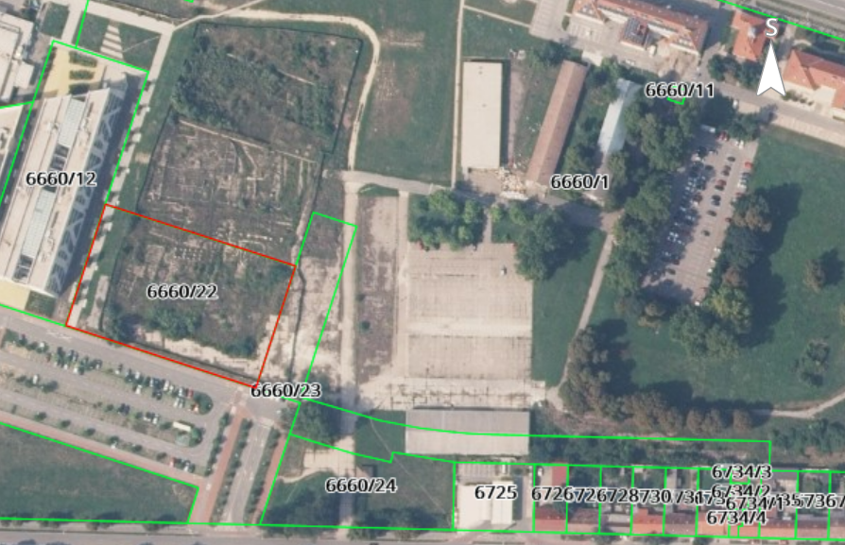
Figure 1. Building plot 6660/22 and 6660/23
On the northwest side, the plot borders with a plot of the Faculty of Civil Engineering and Architecture Osijek (cadastral plot number 6660/12 cadastral municipality Osijek) and south with Vladimira Preloga Street (cadastral plot number 6660/5 cadastral municipality Osijek). The location has access from Lavoslav Ružička Street. A new access road (Andrije Mohorovičića Street cadastral plot no. 6660/23) is planned to the east of the parcel in question, and to the north a new building of the Faculty of Food Technology. In the immediate vicinity of the planned building there is a Faculty of Agrobiotechnical Sciences Osijek and a new student dormitory (on the west side, behind the Faculty of Civil Engineering and Architecture) and a space that is used as an "art colony" (the old military facility which is used for exhibitions on the northeast side). There are no records of abandoned houses or other buildings suitable for bat colonies (which could be harmed by wind turbines).

Technical description of planned reconstruction
Technical description of planned Sub-Project is based on the Main Designs: “Scientific Research Center for Electrical Engineering and Computer Science” prepared in August 2023 (project number 104-22 GP) and “Construction project - parking places and traffic surfaces” developed in May 2023 (project number 056/21-2).
The planned Sub-Project envisages the construction of the building of the Scientific Research Center for Electrical Engineering and Computer Science and associated vehicular and parking area within the area of existing campus of the Josip Juraj Strossmayer University in Osijek.
This Sub-Project is located within two protected cultural goods (monuments) for which the Conservation Department in Osijek (within the Ministry of Culture and Media) is responsible: Cultural and Historical Urban Units of the City of Osijek, registration number: Z-4341, and Archaeological Zones "Mursa, Pristanište i Vijenac Ivana Meštrovića", registration number Z -6380; the Sub-Project is planned within the archaeological zone "Mursa".
In the area of construction of the future building of the Scientific Research Center of Electrical Engineering and Computer Science within the University Campus in Osijek, Special Conditions for the protection of cultural property (Ministry of Culture and Media, Directorate for the Protection of Cultural Heritage, Osijek Department for Conservation) were issued on the basis of which protective archaeological research was carried out. After conducting protective archaeological research, expert valorization of the researched area issued Conservation Guidelines for the site, which prescribe measures for the protection of archaeological finds in situ and the obligation to prepare the Archeology restoration, conservation and presentation project. Archaeological sites and planning of their presentation largely determined accommodation of the newly planned building on the plot and the disaggregation of the volume buildings. Consequently, the building will be elevated on the northwest side and archaeological excavations will be presented on the plot.
The issued Special Conditions stipulate the obligation to carry out additional archaeological research on part of the planned access road and parking lot, which is foreseen in the project documentation and planned in the bill of quantities. Certain preliminary archaeological investigations have been carried out on the part of the road, which do not indicate that there will be material or archaeology that needs to be presented, but this will be determined with certainty only after the archaeological investigation has been carried out.
The Sub-Project is a subject of the “Do No Significant Harm” (DNSH) principle. The DNSH states that the actions outlined in national NRRPs may not cause any significant harm to the environment: this is a fundamental principle for accessing funding from the RRF. In addition, the plans must include actions which contribute 37% of the resources to the ecological transition. The DNSH principle is based on the provisions of the "Taxonomy for Sustainable Finance" adopted to promote private sector investment in green and sustainable projects and help achieve the goals of the Green Deal.

DNSH principle identifies six criteria for determining how each economic activity substantially contributes to protecting the ecosystem, without undermining any of the environmental goals:
- Climate change mitigation;
- An economic activity must not lead to significant emissions of greenhouse gases (GHG).
- Climate change adaptation;
- An economic activity must not have an increased negative impact on the current and future climate, on the activity itself or on people, nature or property.
- Sustainable use and protection of water and marine resources;
- An economic activity must not be detrimental to the good health of water bodies (surface, groundwater or marine) or harm its quality or reduce its ecological potential.
- Transition to the circular economy, including waste prevention and recycling;
- An economic activity must not result in significant inefficiencies in the use of recovered or recycled materials, increase the direct or indirect use of natural resources, or significantly increase waste or the burning or disposal thereof, causing significant long-term environmental damage.
- Prevention and reduction of air, water and soil pollution;
- An economic activity must not cause increased emissions of pollutants in the air, water or soil.
- Protection and restoration of biodiversity and health of ecosystems.
- An economic activity must not harm the good condition and resilience of ecosystems or the conservation status of habitats and species, including those of interest to the Union.
Planned Sub-Project meets all the stated requirements of the DNSH principle.

The procedure of Screening on the need for the environmental impact assessment was carried out for this Sub-Project, as obligation according to Regulation on Environmental Impact Assessment (OG 61/14, 3/17). As part of this procedure a Study of the need for environmental impact assessment was prepared by the company that has the authorization of the Ministry of Economy and Sustainable Development to perform professional work in the field of environmental protection.

The Ministry of Economy and Sustainable Development issued on 18.1.2022. Decision (Annex 4.a) confirming that the planned intervention does not require the environmental impact assessment procedure under the national (EU) law. In compliance with national (EU) regulations in the field of environmental and nature protection, and special conditions of other competent authorities, and with regard to the characteristics of the Sub-Project, the Ministry assessed that the intervention will not have a significant negative impact on environmental components and will not lead to a significant burden on the environment.
Given that during the design phase, there was an increase in the number of floors, the Ministry was informed, and 10.11.2022. issued an Opinion (Annex 4.b) confirming that it is not necessary to carry out the procedure of Screening of the need for Environmental Impact Assessment for planned Sub-Project.

The total area of the Sub-Project is 11 887,1 m² and includes: a plot for the construction of a building of 6 252,0 m² and the associated vehicular and parking area of 5 635, 10 m².
The building is planned on 7 floors: basement, ground floor, 5 floors and an exit to the flat roof. Landscaping of the surrounding terrain with an access square and a presentation of archaeological research found on the plot are also planned. The total gross building area of planned building is 16 569,31 m².
Table 4. Gross area of the planned building
Level | Total area
BASEMENT | 2.276,20 m²
GROUND FLOOR | 2.110,12 m²
FIRST FLOOR | 2.318,58 m²
SECOND FLOOR | 2.496,90 m²
THIRD FLOOR | 2.435,32 m²
FOURTH FLOOR | 2.468,01 m²
FIFTH FLOOR | 2.287,23 m²
TECHNICAL FLOOR | 176,95 m²
TOTAL | 16.569,31 m²

The planned building of the Scientific Research Center for Electrical Engineering and Computer Science is vertically divided into several volumes: the base and three lamellae.
The basement, ground floor and first floor make the base, and three lamellae consists of the second, third, fourth, fifth floor and technical floor with exit to the roof make. The lamellae extend in a north-south direction and are connected by multi-level common areas that form the communication axis of the building. By retracting the ground floor assemblies of the research center, the presentation of archaeological finds is ensured and also orientation of all public and common areas on archaeology and the accentuated pedestrian promenade is provided.
On the ground floor and on the first floor, public spaces are planned: entrance hall, canteen, congress hall, conference rooms, library and administration premises. On the upper floors in three transverse lamellas, laboratories of research groups are planned. The common and communication spaces of the higher floors are formed by multi-storey spaces between the lamellas, which are connected on the ground floor by a hall. The technical floor is a flat impassable roof, exclusively for the purpose of service and maintenance.

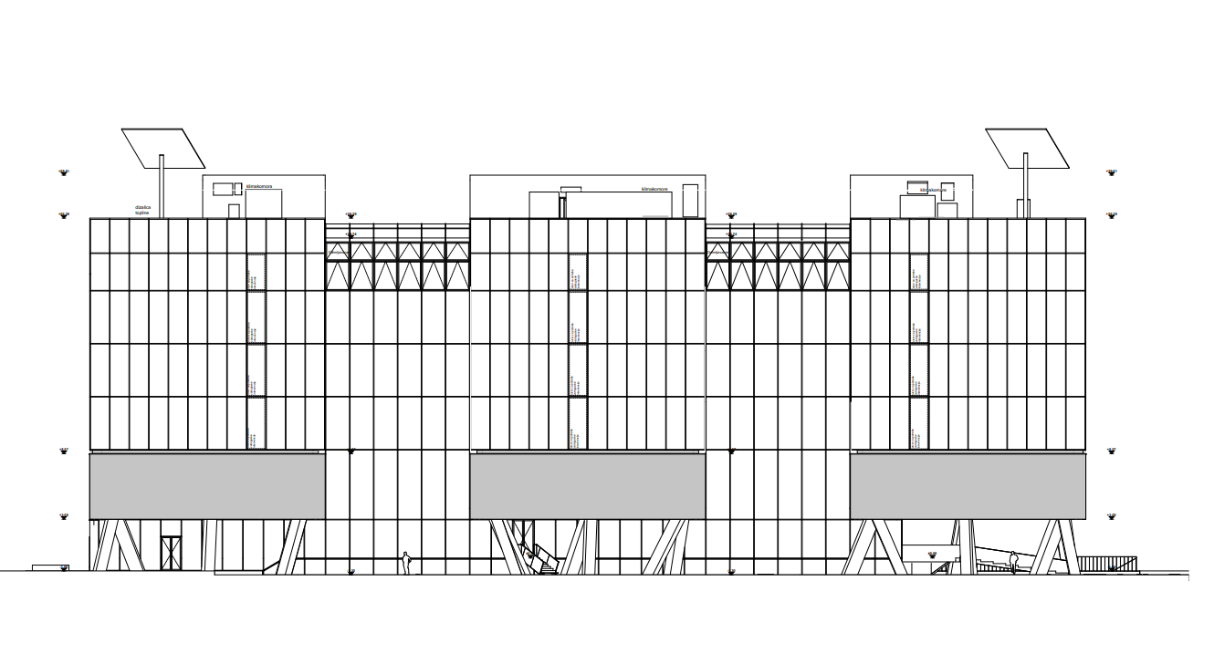

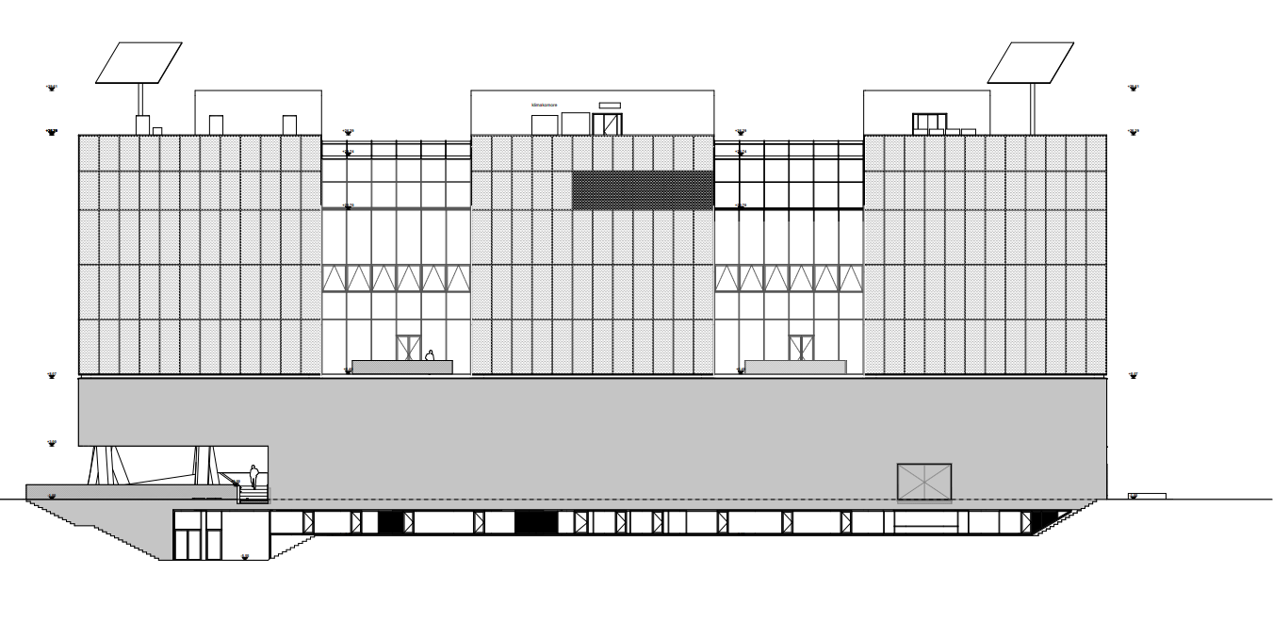
Figure 2. North facade and south facade

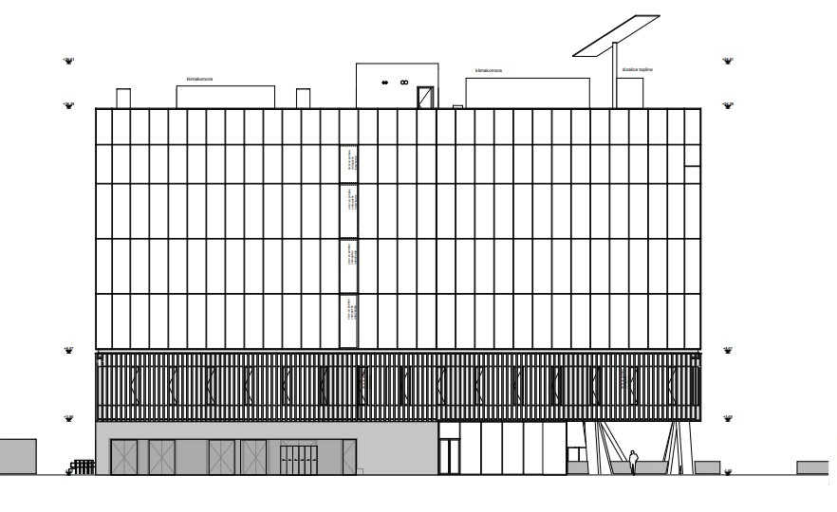
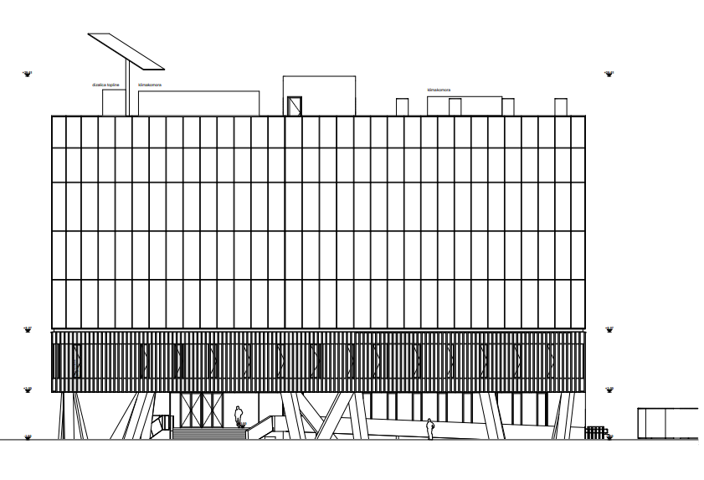
Figure 3. East and west facade

The building is designed as a nearly zero-energy smart building (nZEB) that has very high energy properties. The building will significantly use energy from renewable sources (RES), which will be produced in and on the building itself. Special attention is paid to the application of passive thermal protection measures. Building management is envisaged by the KNX-EIB smart installation system throughout the facility that will enable general communication and building management, as well as electricity consumption management. The envisaged solar, wind, water and earth energy systems will not only be in the function of electricity and heat generation for the building, but will also serve as a research training ground of the Laboratory for RES, Energy Efficiency and Advanced Microgrids of FERIT:
- for the use of solar and wind energy (for the production of electricity and hot water): on the roof there will be a photovoltaic system, a system of solar collectors on the roof and 3 wind turbines,
- for the use of water energy (for the production of electricity): it is envisaged to collect and use roof stormwater to start the turbine - mHE pumping-accumulation hydroelectric power plant.
Energy efficiency and sustainability of construction will also be achieved through the reuse of water (rainwater collection) and planned green roofs and atriums.
The main pedestrian approach to the Science Research Center building will be formed from the southwest corner across the porch to the main hall. Landscape design includes parterre landscaping next to the building itself, atrium decoration on the 2nd floor and roof garden. Landscaping and the implementation of greenery in the building itself will contribute to biodiversity and achieving the microclimate of space. Within the building of the Scientific Research Center, it is planned to install a charging station for electric bicycles, as well as roof covered parking spaces for bicycles and charging station for electric vehicles.
The Sub-Project also envisages construction of access road with a total length of about 328 m with a storm drainage and public lighting system.
Road section 1 is the continuation of Andrija Mohorovičić Street, with a total length of approximately 91 m. On this section, a road with three lanes of traffic, a double-sided footpath, sloping parking spaces and a green belt will be carried out.
Section 2 is the continuation of Vladimir Prelog Street, with a total length of approximately 237 m. On that section, a road with two lanes of traffic, a footpath and vertical parking spaces will be carried out. There is a building on the part of the existing cadastral plot 6660/23 that will be removed.
Connection to the existing bicycle and footpath is envisaged. The bicycle path is designed in accordance with the Ordinance on cycling infrastructure (OG 28/16). It is planned in Andrije Mohorovičić Street, as a continuation of the trail from Vladimir Prelog Street. It is designed as a two-way, with a total width of 2.50 m.

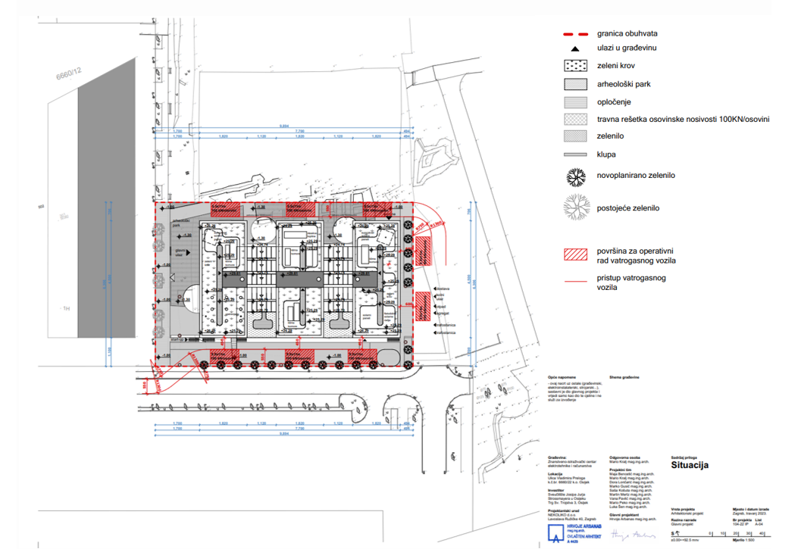
Figure 4. Planned situation of Sub-Project – building

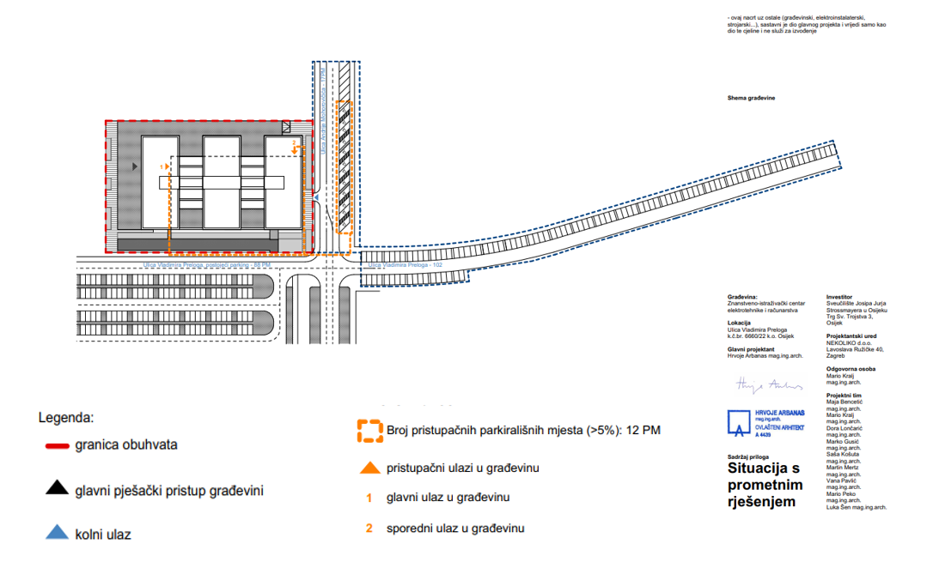
Figure 5. Planned situation of Sub-Project – building with traffic solution

Construction elements
Building
The main vertical load-bearing structure of the building will consist of reinforced concrete columns and walls interconnected by reinforced concrete beams and full reinforced concrete ceiling slabs. Columns with a square cross section, dimensions 60x60 cm, extend through all floors from the roof to the ground floor (where they measure 80x80 cm) all the way to the foundation structure.
From the conditions of preserving the archaeological site, most of the columns on the ground floor are designed obliquely on both axes (because of the large forces they absorb and because of the impossibility of dimensional extensions due to bypassing archaeological excavations), and as such form part of the architecture of the building. Reinforced concrete walls are planned in thicknesses of 20, 30 and 40 cm in both directions. The bulk of the load-bearing walls of the above-ground structure will be located in the longitudinal tract that will connect all three lamellas of the building and define the communication cores.
Basement/ground will be constructed in the part of the plot with no archaeological findings. In the part where the basement is absent, the sloping columns of the ground floor are based dotted avoiding archaeological sites.
The base of the building (basement, ground floor and first floor) will be of a more closed character and will be lined with concrete façade elements. The upper floors (second, third and fourth floors) will have a double glass façade envelope.

Access road
Envisaged pavement structure, meets all climatic conditions, as well as the conditions of bearing capacity and deformation of individual layers. When building an access, the stability of the public road or road users on a public road will not be jeopardized.

Water supply
Building
Water supply of the building will be provided through a new household connection to the municipal water supply system, which passes along the building plot. Plumbing installations consist of provided equipment and distribution of sanitary water to individual connection points or sanitary facilities and associated sanitary facilities. The installation of the hydrant network is envisaged as a separate system of hydrotechnical installations for the purpose of fire protection of the building and consists of a fire hydraulic station and the distribution of the hydrant network with associated hydrants.
The construction of a water meter shaft is envisaged in such a way that three lines of the main water meter are formed according to the concept of functional water distributions: line with main water meter for the needs of hydrant and sprinkler installation, line for the needs of sanitary water consumption and line for irrigation purposes. Central preparation of hot consumable water is foreseen. The supply of heat energy for the purpose of preparing consumable hot water is foreseen by connecting to the central heat system of the city of Osijek with connection to the main hot water system. To meet the overall thermal needs of the building, an indirect heat station with a rated capacity of 1,000 kW is foreseen.

Wastewater collection and management
Building
A mixed drainage and wastewater collection system is planned. In accordance with the special conditions, connection solution of the mixed drainage and wastewater collection will be carried out with the connection to the existing road sewerage on the adjacent parking lot.
For the purpose of drainage and wastewater collection from the building, separate functionally divided systems of networks according to the purpose are provided:
- basic mixed wastewater collection of the building with connection to the public sewerage system;
- sanitary wastewater collection in the building, vertical and horizontal collection;
- greased wastewater collection from the kitchen area with grease separators for wastewater treatment before discharge into basic sanitary wastewater collection system
- rainwater drainage of roof surfaces with retention;
  - the complete roof structure is foreseen using a system with retention blocks for the blue / green roof. The system consists of shallow blocks of high load capacity designed for stormwater retention. A minimum height system was selected to allow rainwater storage for the purpose of irrigation of the green roof, while the rest of the height of 100 mm is used for retention.

Access road
Stormwater drainage is designed in such a way that one storm drainage pipeline is planned for each section of the road. The pipelines are connected, and the storm water is jointly drained into the wastewater drainage system that was built within the roads on the south side of planned building. Drainage of road stormwater is carried out by longitudinal and transverse falls of the newly designed pavement that direct water towards the edge of the road where the designed drains are drawn into the green area. Surfaces intended for idle traffic are designed with permeable grass cubes that partially absorb rainwater. The remaining amount of stormwater is directed by transverse falls of the parking lot surfaces towards the drains to the municipal collection system.

Electrical installations
Building
The building uses a blend of the traditional power grid and the concept of renewable sources.
Planned electrical installations are power distribution, distribution cabinets, high current electrical installation, lighting, low current electrical installation, sound system installation, installation of SOS signalization of sanitary facilities for the disabled, grounding and equalizing potential, protection against touch voltage, smoke system, lightning protection system, installation of a fire alarm system and transformer stations.
The connection of distribution production to Croatian Electricity Company’s (HEP's) power grid is provided in a way that each individual microgrid has its own switch with appropriate protections, all individual microgrids are protected by the main switch according to HEP, which disconnects all power plants in the networks.
For the electricity production for the building, but also as part of the research, it is envisaged the use of photovoltaic systems, the use of solar collectors for the preparation of hot water, the use of roof storm water to start the turbine (small hydroelectric power plant), the use of wind energy (wind turbine).

Planned microgrids of the Scientific Research Center:
- photovoltaic system
Photovoltaic panels will be installed on the southern façade, implemented in its configuration, and the sloping part of the roof of the building. A set of movable photovoltaic panels that follows the path of the sun ("sunflower") are planned on the roof of the Scientific Research Center. The installed power of movable photovoltaic panels is 10kW. It is also envisaged to use flexible photovoltaic panels (self-adhesive membrane based on bitumen with integrated photovoltaic cells) on curved surfaces. The installed power of flexible photovoltaic panels is 2kW. Based on the available roof surface and surface on the façade, custom-made glass-glass panels will be defined. Before commissioning, the solar power plant will perform a test operation according to the conditions of the power distributor. Photovoltaic modules are positioned in such a way that they do not reflect sunlight towards the roads and do not endanger the safety of traffic.
- solar collectors
For the preparation of hot water, solar collectors will be used. It is planned to use four panel and four vacuum solar collectors that have a panel slope of 30° to the south.

- wind farm
The wind farm system consists of 12 wind turbines with a vertical rotation axis and a spiral blade shape. The installed capacity of the wind farm is 6 kW (accumulatively). They are a small-scale vertical-axis wind turbine with a nominal power of up to 500W. Turbines are placed in a cluster with proper horizontal spacing, meaning larger power can be generated despite their small height of around 3 m and diameter of approximately 6 meters. These features result in a very low impact on the environment and people in the surroundings. Small-scale turbines are necessary for conducting scientific research on the adequacy of this technology for urban areas with lower wind speeds. Furthermore, wind turbines would be integrated into the building's energy generation system (microgrid) with the rest of renewables, energy storage technologies, and loads to accomplish net zero energy building goal. Finally, wind turbines would be integrated into courses of undergraduate and graduate study programs in the field of electrical engineering.
- Biodiesel powered generator
As a reserve source of electricity in case of outage of the public electricity distribution network an automatic diesel generator with a power of 250kVA/200kW is planned. For the purposes of diesel engines, a tightly tied tank with a capacity of 415 liters is provided. This generator has a predicted consumption of 42.2 liters per hour. Diesel generator is located in a separate fire sector on the ground floor. The floor of the aggregate area will be made of non-flammable material and impermeable to water and fuel. The aggregate area will have ventilation openings towards the open space. The size of the ventilation surface will be at least 5% of the size of the floor surface.
Transfer and all other manipulation of dangerous substances will be carried out exclusively within the attested digestor (for collection and exhaust) that has its own ventilation system with direct access to the roof of the building. The ventilation of the digestor will be guided up to 3 m above the roof, and the ventilation duct of the digestor will be protected by fire-resistant elements for 90 minutes (EI 90).

- fuel cells
For the production of electricity using hydrogen, obtained in an electrolyzer with an approximate installed capacity of 10kW, a system of two fuel cells is used, and the power of each fuel cell is 5kW. The hydrogen generation system is designed for educational purposes for the production of ultra-high purity hydrogen. The specified generator will be installed as a standard product and placed within a separate fire sector. It may contain danger zones and when installing it, appropriate measures will be prescribed in accordance with ÖNORM M 7379 (Austrian standard for Storage of gases – Storage of gas cylinders and other transportable pressure receptacles that applies to the storage of compressed gases and gas mixtures, liquefied under pressure, dissolved and liquefied under pressure in refrigerated state, etc.) and the manufacturer's instructions. The manufacturer will prescribe the conditions of safe installation and the method of use with the verification of the danger zones around the device itself and the method of protection.

- pumping - accumulation hydroelectric power plant
For the exploitation of stormwater, an inflow pool is provided, which will be located on the floor under the roof. Water from the pool will be directed by pressure pipelines to the turbine with a swimming pool (with overflow) located on the ground floor. In the night hours, if no large amounts of stormwater are provided, when the electricity tariff is cheaper, the water located in the lower pool will be pushed into the upper pool by pumps. The total production of energy obtained by this type of power plant is negligible and serves educational purposes.
Access road
Public lighting will be installed on new metal poles, with LED lamps on top of the pole. Public lighting will be powered from the newly planned terminal cabinet. The construction of public lighting provides the appropriate illumination of the parking lot in this street according to the standard HRN EN 13201. Design of the lamps will be such to minimize light pollution. The charging station of electric vehicles has a minimum power of 22kW AC, i.e. it allows simultaneous charging of two electric vehicles.

HVAC installations (heating, cooling and ventilation)
Building
- The air treatment plant (air conditioning, ventilation and exhaust ventilation) treats all premises in the building that do not have the possibility of natural ventilation and / or their purpose requires the need for mechanical ventilation. The plant consists of air chambers, pressure and exhaust fans arranged in six air conditioning systems.
- Basic heating/cooling is provided for by the installation of fan convectors on the circulator, freon installation for the needs of units that require independent heating / cooling, hot water underfloor heating and electro-resistant heating for secondary rooms.
- The power plant for the production of heating / cooling medium consists of two air-to-water heat pumps as the basic source of heating / cooling energy and connection to the central heating system of the City of Osijek with connection to the main hot water source, the power plant is based on two air-cooled multifunction heat pumps with the possibility of year-round simultaneous preparation of hot and cold water, while exploiting waste heat.
- An automatic control system of mechanical installations with a connection to the central control system (CNUS) is provided.
Access road
Not applicable.

Accessibility of the building to persons with disabilities and persons with reduced mobility
Building
Measures and design solutions to ensure accessibility of persons with reduced mobility in the premises intended for their movement, residence and work are determined according to the Ordinance on ensuring the accessibility to the buildings for persons with disabilities and reduced mobility (OG 78/13). Stay of persons with disabilities and persons with reduced mobility is envisaged on all floors of the building (up to 2 persons on the basement floor and up to 3 persons on each of the above-ground floors). Evacuation of disabled persons and persons with reduced mobility is provided from all floors of the building, two accesses are envisaged. The entrance area meets the accessibility requirements for people with disabilities and people with reduced mobility (doors, signs, windshield, thresholds...). All staircases and lifts are adapted for people with disabilities and reduced mobility, the width of all corridors is greater than 150 m, all walking surfaces are at the same level. Electrical installations and lighting are adapted for people with disabilities and reduced mobility. Sanitations are adapted to people with disabilities and reduced mobility (door, accessible doorknob, toilet bowl, holders, sink...). Workspaces are adapted for people with disabilities and reduced mobility (turning space, desks, classroom entrance doors).

Access road
The project of access road is compliant with the Regulation on ensuring accessibility of buildings for persons with disabilities and reduced mobility (OG 78/13).

Fire safety
Building
Along the northern façade of the building, a fire road will be formed in width of 5,5 m. The fire road will be made of (grass) lattice blocks of appropriate carrying capacity for the passage and operation of a fire engine (100 kN/axles). Since the described fire path passes between the building in question and the future building of the Faculty of Food Technology, it will be used as a fire road for both buildings.
The following firefighting systems and installations are planned:
- sprinkler system - in accordance with NFPA 13/2022 (Guidelines for the Design of Sprinkler Systems);
- gas fire extinguishing system – in accordance with HRN EN 15004 standard;
- kitchen fire extinguishing system – in accordance with NFPA 96 and UL300 standard.
An external hydrant network will be designed for the entire complex. The internal hydrant network will be installed and performed depending on the fire load and the use of the space. A fire alarm system will be installed in the building.
Special Conditions related to fire safety and fire protection measures were issued from the Ministry of the Interior, Directorate of Civil Protection, Regional Office Civil Protection Osijek, Inspection Department. It is necessary to apply Croatian laws and regulations, and exceptionally, in the absence of Croatian regulations for a specific area, the application of foreign regulations and guidelines is allowed, which must be defined in special conditions. In accordance with the current Croatian regulations and the special conditions of the Ministry of the Interior for building design, the primary regulation used is the Regulation on Fire Resistance and Other Requirements that Buildings Must Meet in Case of Fire (OG 29/13 and 87/15). For issues such as the calculation of fire compartment areas, fire load, the need for the introduction of certain systems (sprinklers, etc.), and other issues not regulated by the Regulation on Fire Resistance and Other Requirements that Buildings Must Meet in Case of Fire or other Croatian regulations, internationally recognized standards and other regulations used as recognized rules of technical practice (Österreichisches Institut für Bautechnik OIB, British Standard (BS), National Fire Protection Association (NFPA), etc.) must be applied for the part not defined by Croatian regulations, as required by the Ministry of Interior and in the process of issuing special construction conditions.
In this case, the following foreign regulations and guidelines are anticipated to be applied as recognized rules of technical practice in the absence of Croatian regulations:
- Austrian guidelines TRVB 126 Austrian Technical Guidelines for Preventive Fire Protection (Fire technical characteristics for various purposes, storage, goods);
- NFPA 13/2022 (Guidelines for the Design of Sprinkler Systems);
- NFPA 101/2021 (National Fire Protection Association Code for Safety to Life from Fire in Buildings and Structures);
- NFPA 5000 (Building Construction and Safety Code);
- SZPV 512 (Standard on Fire Protection for Solar Panels).
Flammable liquids, gases and other substances expected to be used are:
- Diesel fuel
Diesel fuel tank with a capacity of 415 l for diesel generator as a reserve source of electricity,
- Natural gas
For combustion of hot water gas boiler room (Q = 1000 kW) on the roof of the building and for the needs of consumers in the kitchen on the ground floor, natural gas will be used.
- Hydrogen
For educational purposes, a system for generating ultra-high purity hydrogen is provided. A type generator installed can potentially contain danger zones.
Fire Safety Design Study has been carried out by a licensed fire safety expert.

Access road
The access road is designed in such a way that during the period of use it cannot be the cause or carrier of fire.

Landscaping
Building
Ground floor landscaping around the building and parking zones
Planting tall trees in the tree row on the east and south sides of the building was planned. This will create an additional shade for the building, pedestrians, and parked vehicles. Native species (Fraxinus angustifolia ''Raywood") will be used for minimal maintenance requirements and complete integration into the landscape of the climate. Ground floor will be dominated by grassland on the south side, while on the northern and eastern sides in the green islands, combinations of ground covers suitable for shade are proposed (Ophiopogon japonicus - Liriope muscari). Under parts of the building in shadow ground covers will be provided (Vinca minor 'White', Hedera helix). Along the main pedestrian entrance on the west side, the green surface will consist of Cotoneaster dammeri varradicans. In some positions, such as the outdoor terrace in the north and around the pillars, groups of lower shrubs and perennials that survive in shade conditions are planned.
Green atrium on the 2th floor
Atriums are conceived as roof gardens so they must have all the necessary layers (drainage – accumulation tubs, layers of geotextiles and a special substrate for roof gardens). By placing tall trees of narrower habitus and loose crowns (multistem Acer ginnala) in atriums, the sun's rays will be leaked in winter and neutralized in summer. Around the residential zones there will be formed areas with ornamental grasses that have minimal maintenance requirements, require little water and are a reminiscence of Slavonian meadows. Along the residence zones of the atrium more decorative grasses (Miscanthus sinensis 'Kleine Fontane', Pennisetum alopecuriodes) will be located, while towards the edge lower grasses, perennials and ground covers will be placed (Stipa tennuisima, Liriope muscari 'White', Hakonechloa macra, Festuca gautieri).
Green roof
The roof will be shaped as an extensive roof garden, with the strategic positioning of higher plants in relation to the elements of the roof and directing the views of users of the space. It will also serve as a "green buffer" and frame to the central roof zone.
The central positions of the green roof zones will consist of clusters of tall and medium-tall decorative grasses (Calamagrostis x acutiflora 'Karl Foerster', Miscanthus sinensis 'Kleine Fontane, Panicum virgatum 'Strictum'). Towards the edges of the roof garden, zones of lower decorative grasses will be formed (Carex buchananii, Pennisetum alopecuriodes, Stipa tenuissima). At the joints of the higher and lower grasses spotty and irregular flowering perennials of crooked color and white flower will appear (Sanguisorba albiflora, Echinacea purpurea 'White Swan').
All zones need to be connected into an automatic irrigation system that will supply rainwater collected in reservoirs for one part of the year.
None of the plants for greening and re-greening are classified as invasive species.
Access road
The free green area will be partially greened and horticulturally arranged by planting trees and low greenery and will be maintained by regular mowing.
None of the plants for re-greening are classified as invasive species.

Parking lots at the location
Vehicular access provides access to the basement floor, i.e. it is used for delivery. The movement of vehicles inside the building is enabled by a car elevator and a pedestrian road on the basement floor.
A total of 207 parking spaces are planned in public areas next to the plot in question:
- 17 parking spaces in Andrije Mohorovčića Street
- 88 parking spaces Vladimir Prelog Street (existing parking lot)
- 102 parking spaces Vladimir Prelog Street (in continuation)
The number of parking spaces for people with reduced mobility (5 %) is 12. On the adjacent road on the newly created cadastral plot no. 6660/23, an electric vehicle charging station is planned. Testing of exclusively electric engines will be carried out in the basement.

Archeology

Archeological zone „Mursa“
According to the description of the Cultural and Historical Urban Complex of the City of Osijek from the Register, Osijek is a city that has existed continuously for almost two thousand years. It is interesting that during its long survival the city "moved": Roman Mursa stretched in the area of today's Donji Grad, medieval Osijek was formed in a completely new location, a kilometer to the west, where Osijek under Ottomans continued to exist. In the and post-Ottoman era, Osijek is developing (to this day) in the areas of ancient and medieval city, as well as city under Ottoman ruling, as well as in addition of completely new previously undeveloped areas. According to the description of the Archaeological Zone "Mursa, Pristanište i Vijenac Ivana Meštrovića" from the Register, the Roman castrum Mursa, was located on the Roman border – Limes as one of a series of military fortifications of the defence system of southern Pannonia. In 133, Mursa was granted colony colonia Aelia Mursa. Built on an important strategic position, it was connected by roads to many cities of Pannonia and the rest of the Roman Empire.
The University campus is located within the protected Cultural and Historical Zone of the City of Osijek, which is registered in the Register of Cultural Goods of the Republic of Croatia, list of protected cultural goods under no. Z-4341 (zone C) and within the protected archaeological zone "Mursa, Pristanište i Vijenac Ivana Meštrovića" in Osijek, which is registered in the Register of Cultural Goods of the Republic of Croatia under no. Z-6380.

The Republic of Croatia actively participates in the nomination "Borders of the Roman Empire - Danube Limes in Croatia" for inclusion on the UNESCO World Heritage List, and the archaeological site "Mursa" due to its specific position, at the intersection of Roman roads for Aquincum, Poetovio and Sirmij is also inscribed on the tentative list of UNESCO for the nomination of the Croatian part of Limes.
Limes in the territory of the Republic of Croatia, in the length of 138 km, includes the area of the Croatian Danube region, i.e. the areas of Baranja, eastern Slavonia and western Srijem, which administratively belong to Osijek-Baranja and Vukovar-Srijem counties.
The archaeological site of Mursa is classified in the category of Roman cities, initially of a military character, which remained in military use in the area of today's University Campus almost until the end of the 20th century.
The archaeological zone "Mursa" is located in the wider area of the Donji Grad in Osijek and represents a wider zone of the Roman city with associated suburbs and necropolises, located mostly at the exits of cities.
The narrower zone of the Roman city is the space within the ramparts that in Mursa partly passes through the area of the University Campus in Osijek (Figure 6).
Most of the University Campus, in its western part, belongs to the area of the Roman suburb of Mursa, while the eastern, smaller part, is located within the ramparts and in the archaeological sense represents the urban and planned urban zone of construction. The future building of the Scientific Research Center is located along the very edge of an ancient suburb at the western entrance to the Roman city.

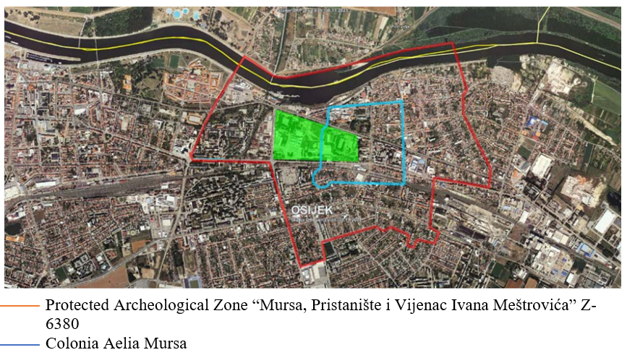
Figure 6. University Campus area in relation to ancient Mursa

Research carried out so far
Archaeological research at the location of the planned building has been completed, and the archaeological findings have been fully recorded and documented. By considering all the prescribed protection measures (CHMP) the negative impact of construction works on the preservation of archaeological finds can be minimized. Archaeological research on the unexplored part of the road will be carried out before the start of work on the access road.
Based on the Special Conditions for the protection of cultural property of the Osijek Department for Conservation, during 2016, for the purpose of the construction of the Scientific Research Center building, protective archaeological research was carried out by the company Delmat Galiot Ltd. from Split with the research leader Srđan Đuričić, mag. archeol.
The location of part of the western wall and the western city gate was explored in 2016 by protective archaeological research as part of the Archaeological Heritage of Ancient Mursa project. After completing archaeological research on the site of the building of Scientific Reasearch Center, protective archaeological excavations continued, which explored and documented part of the western wall and western city gates. Archaeological excavations of the western wall and the western city gate were explored as part of the project Archaeological Heritage of Ancient Mursa, carried out by the Archaeology Division of the Croatian Academy of Sciences and Arts with the head of research dr.sc. Tino Leleković.
Additional archaeological excavations were carried out during 2022 in the far western part of the plot of construction of the Science Research Center building. Archaeological research of the western part of the construction on the plot of the Scientific Research Center building explored the archaeological Object 1, which completely overlaps with previously explored archaeological Objects 1 and 2, and together with them forms a single unit, i.e. Object 1, which during antiquity was built in at least two phases of construction, and was destroyed during recent uses of the 20th century.
In the area of construction of the Scientific Research Center, objects belonging to the western suburb of ancient Mursa were found, along the western entrance to the city. Ten complete residential buildings of different sizes, purposes, degrees of preservation, methods and times of construction were investigated. Some of them were used over a long period of time, with constant renovations and upgrades, and the best preserved ones are positioned in the northern part of the plot, right next to the continuation of decumanus, on Via Poetovio. Due to their preservation and representativeness, three objects that were selected for presentation in situ stand out.

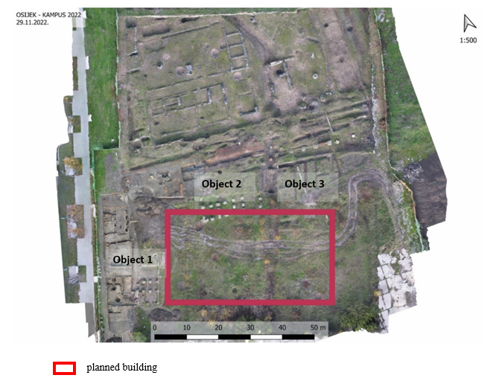
Figure 7. Archaeological Object at the site

OBJECT 1
Object 1 is located in the western part of the plot of construction of the Building of the Scientific Research Center, however its western part is not in the construction zone. The area that enters the sub-project (construction) site is fully researched, documented and protected. A rectangular elongated building in the north-south direction was explored with a porch and entrance laid along the Roman road and partially or fully preserved foundations and walls. On the walls, the remains of plaster restored in several layers with traces of painting with red paint, vegetative and floral motifs have been preserved. In this object, the transverse walls as well as the foundations of the walls are preserved, from which layout of the rooms can be clearly red.
The function of most premises due to the unexploredness of the entire facility is unknown for now. Only a room in the south-western corner of the plot is defined as a possible bathroom in which a smaller firebox has been explored. West of the firebox, a room with a furnace -praefurnium and an exceptionally well-preserved underfloor heating system - hipokaust - was explored. More than half of the room has a double floor under which warm air circulated, while the other half of the room has a compact floor with a thick plaster base. Studies have not been able to determine whether the hippocaust was covered with stone slabs or bricks although it is more likely that it was covered with bricks. Archaeological research has established that this object had two phases of construction, i.e. that the second phase of construction took advantage of object 1 and spread to the southeast in such a way that the outer wall of Object 1 was used as a partition wall in the second phase of construction.
During 2022, the western part of Object 1 with an inner courtyard – perystilium, i.e. peristyle surrounded by a column colonnade, was explored with recent research. These investigations fully shed light on the situation of the western part of the plot of the Object 1. It is a typical Roman house – domus or a kind of villae suburbanae that had orientation to the Roman road and probably covered porch, which due to the recent destruction during the 20th century could not be determined. Only the eastern part of the house has been archaeologically explored, while the western part is located in the area of firefighting access and the promenade between the Building of the Scientific Research Center and the Faculty of Civil Engineering in the west. Twelve rooms were explored, of which the central part of the open peristyle vaulted by a colonnade of columns. In the southern part of object 1, a room with furnaces – prefurnium and hypocaust, i.e. a floor heating system, was explored, and it can be concluded that Object 1 during the late 2nd century represented a more luxurious way of life right next to the western edge of the city, typical of the Roman elite. The construction is not expected to impede further exploration works.
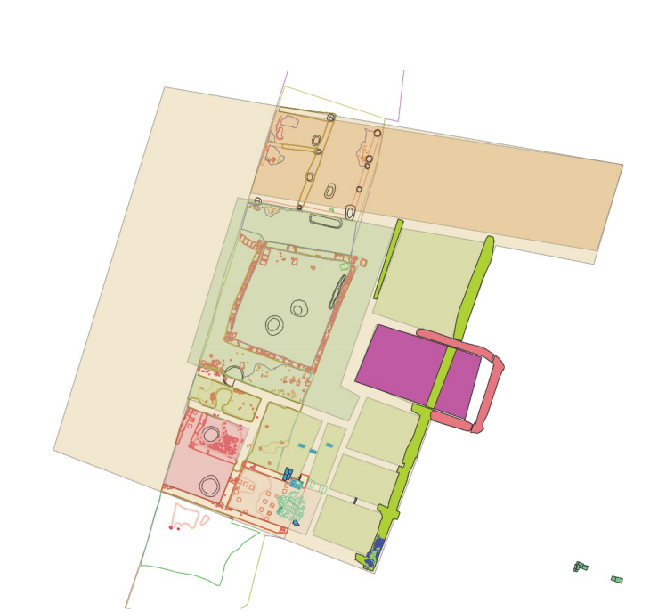
Figure 8. Object 1 (west part of the plot)

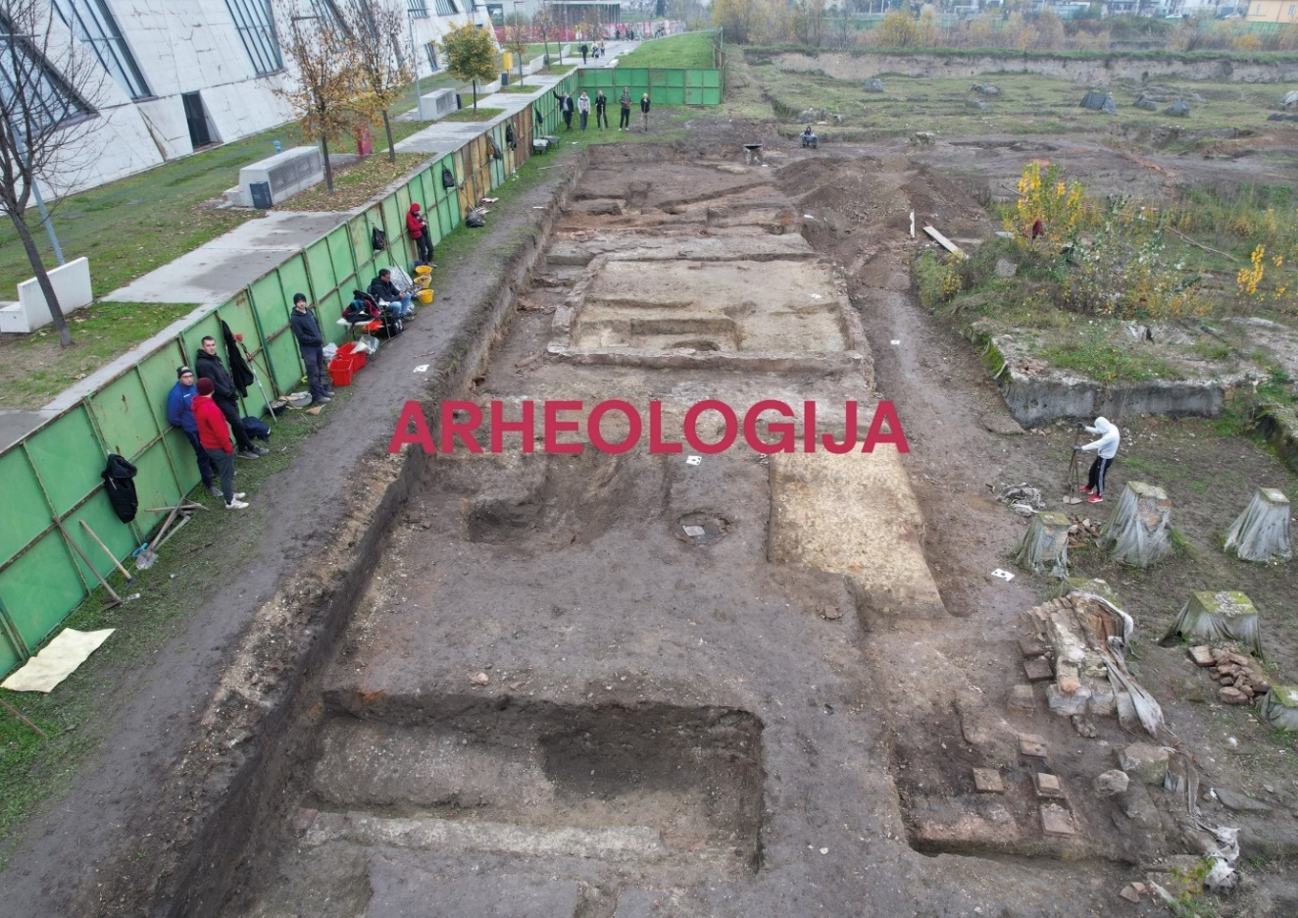
Figure 9. Archaeological excavation Object 1 (west part of the plot)

OBJECT 3
Object 3 is located in the northern part of the plot, and with its northern edge is not in the construction zone. Protective research has documented and investigated only the southern half of the facility (in the zone of the Sub-Project), while its northern part is not in the zone of construction of the Science Research Center building. Further, the construction will not impede further exploration works. Subsequent research during 2016 to 2019 explored a porch with columns that served as a covered entrance to the facility. The porch is located along the Roman road and is an integral part of Object 3, and is partially located in the zone of the Scientific Research Center building. In Object 3, the negatives of foundations and walls, brick pedestals connected by lime mortar are also visible and archaeologically explored, on which massive wooden beams are placed as carriers of external and partition walls. A total of 20 massive pedestals and 2 pedestals in negative were investigated. The far northwest and far northeast pedestals are angular pedestals, built in the shape of the letter L and represent the outer corner of Object 3, i.e. its southern, outer wall. The interior layout of the rooms is partially known and can be reconstructed.

OBJECT 5
Object 5 is located in the northern part of the plot, and with its northern edge is located outside of the planned construction zone. Protective research has documented and explored only the southern part of the object (a subject to the Sub-Project intervention), while the northern part was investigated subsequently during the research from 2016 to 2019. It is important to note that the porch or entrance to this object was explored along the Roman road, which is located in the area of construction of the new building of the future Faculty of Food Technology, i.e. in the area between the two plots of construction. The interior layout of the rooms is well preserved and can be divided into eastern and western parts, separated by a hallway oriented in a north-south direction. West of the hallway there is a smaller room with a completely preserved original floor made of poured lime mortar with small pieces of brick, and next to it a larger room with a floor made of rammed earth. The original function of both rooms is unknown, but the peculiarity and representativeness of this object is found in the room east of the hallway where part of the floor mosaic is almost entirely preserved. The mosaic covered the entire floor surface of the room, and was laid on a subgrade made of broken brick on which lime mortar was poured. The basic motif of the mosaic consists of 12 square fields made in a combination of white and dark blue carved pebbles – tesserae, which created the motif of the chess field. The motif of the chess field is framed by three lines of different thicknesses. The walls of the room with a mosaic are decorated with frescoes of various motifs mostly dark tones. In addition to vegetative leaf motifs and stylized spiral motifs, a figural motif depicting the face of a female person is also visible on one fragment. Because of all of the above, it can be concluded that this object had the status of representative, probably private content, at the western entrance to Roman Mursa.
From all of the above, it can be concluded that the position of the building of the Scientific Research Center in the CH sense is the area of the beginning of the western suburbs, on the continuation of the Decumanus maximus road, on the Via Poetovio with representative parentheses built south of the road in which public and private, and sometimes very luxurious facilities were located.
The works are not expected to impede further exploration.

The position of the objects in relation to the planned Sub-Project is visible in the Figure 10.

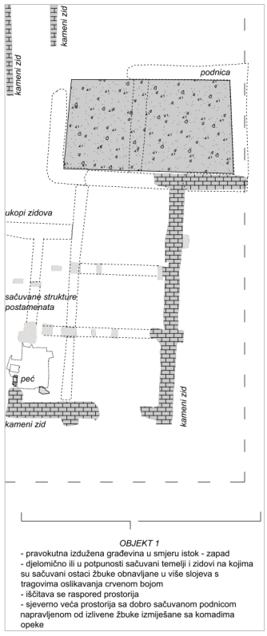
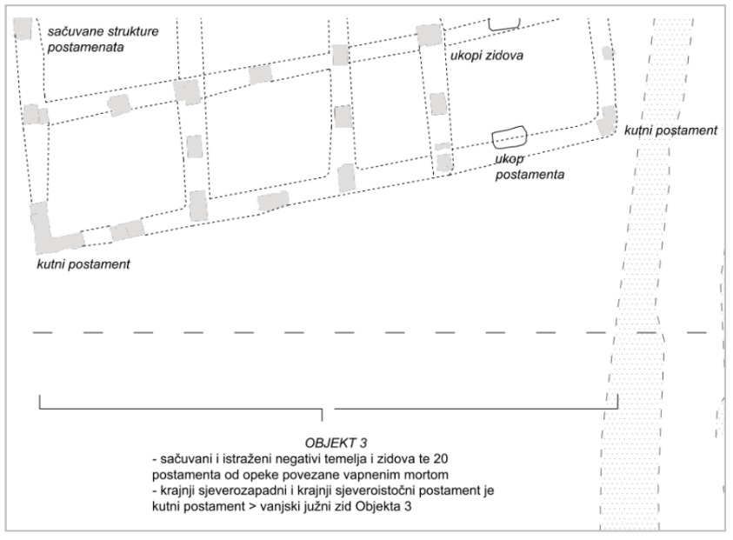

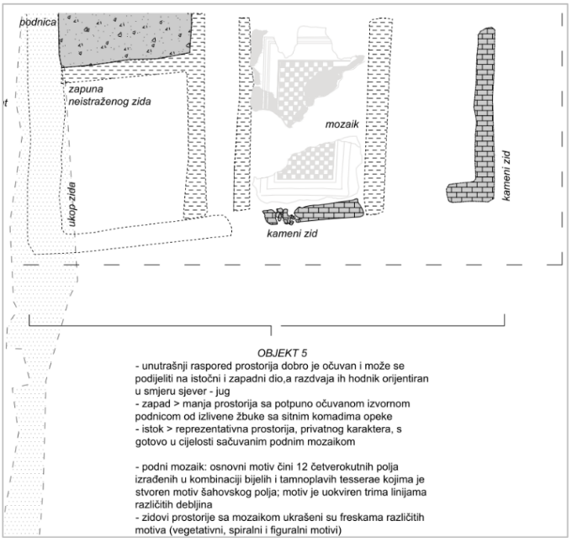

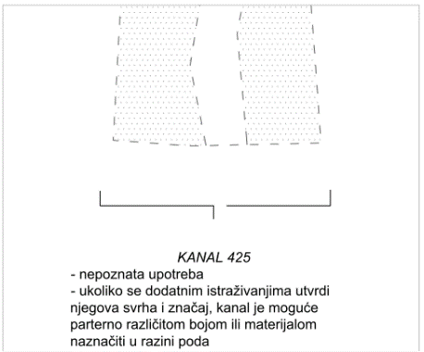

Figure 10. Floor plan and description of the objects within the protected archaeological zone of Mursa

Project of Restoration, Conservation and Presentation of Archaeology
As part of the construction of the new building of the Scientific Research Center of Electrical Engineering and Computer Science, the restoration, conservation and presentation of archaeological finds, i.e. the construction of an archaeological park, is planned. The floor area on which the archaeological park is planned is of irregular rectangular "L" shape, with an external dimension of 88.4 x 50,4 m. The floor area of the park is 2220.4 m². It is planned to build an archaeological park with a presentation of archaeological excavations at the level of the basement below the building of the Scientific Research Center of Electrical Engineering and Computer Science in its northern and western parts. It is located at a depth of 1.25 to 2.4 m in relation to the surrounding landscaped terrain. The distance of the park from the southern border of the plot is 11.1 m, from the western border 5.6 m, from the northern border 0 m, and from the eastern border 4.9 m.
The archaeological park will be a completely passable (walking) area that will present in two basic height levels the findings of the objects of the western suburbs of ancient Mursa dated from the 2nd to the 4.st. The finds are related to objects for primarily residential purposes and are oriented on the ancient road via Poetovio – the former western entrance to the city, which is located on the neighbouring northern plot. The Archaeological Park was conceptually conceived as an open-air park that combines the space under the planned building of the Scientific Research Center of Electrical Engineering and Computer Science and the future building of the Faculty of Food Technology on the neighbouring northern plot. The presentation of the findings of the access road and other public buildings under the future Faculty of Food Technology, as well as the findings of the western city gate below Andrija Mohorovičić Street, is conceived as a whole with an archaeological park at level of passable terrain of the Scientific Research Center of Electrical Engineering and Computer Science, which as the first in order of execution begins the realization of a wider complex.

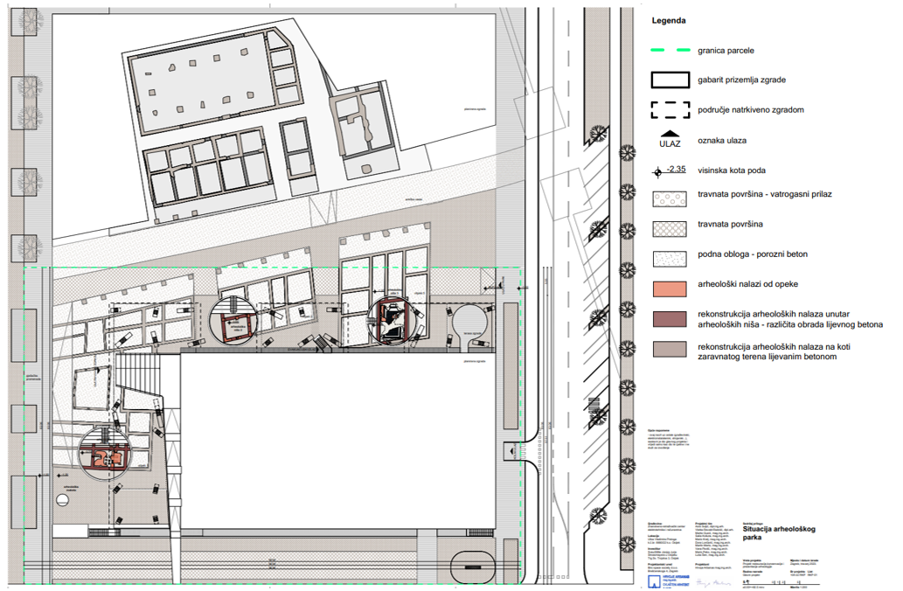
Figure 11. Archaeological Park

The archaeological park consists of two main elements in space; parterre at 30 cm lower level than the level of the surrounding terrain, which serves as an educational and information base and an area of archaeological niches where it is possible to see in-situ exhibited finds on their existing elevation. Archaeological niches are areas whose terrain is located at the height of archaeological finds and where the most important archaeological finds are presented. There are a total of 3 niches within the park. They are circular in shape, and their diameter varies according to the size of the finds. Within the niches for the purpose of providing access and creating urban microspaces there are stairs with stands. The stands serve as a park furniture and a basis for setting up additional informative contents about archaeological finds. At the height of the finds, the terrain is passable and it is possible to move around archaeological finds, except for a covered mosaic where movement is prevented due to the preservation of the finds. The parterre level was performed in one height level, 30 cm lower than the surrounding terrain. Within the plot of the parterre, the boundary between the archaeology of the Roman objects and the terrain outside them is clearly defined. The parterre inside the dimensions of the building occasionally receives additional information panels in the floor that more closely describe the locations in the immediate vicinity, which encourages the user to explore the entire surface of the park. Movement on the floor is enabled unhindered from vertical obstacles and it is possible to walk on all floor surfaces. Users are encouraged to establish their own path when looking at archaeology. The space organized in this way is also not only a place of observation of archaeology, but also a place of gathering and socializing, which is appropriate for the location within the Student Campus in Osijek. With targeted design, the space begins to serve as a square next to the faculty buildings with possible many functions.

Access road
In the area of section 1, where the continuation of Andrija Mohorovičić Street will be built, archaeological finds of ancient city gates and ramparts and ancient roads have been found. Visual presentation of archaeology will be carried out by various finishes of the pavement curtain, depending on the presented elements (ancient, door, walls, etc.). These vistas will be accentuated by the laying of granite cubes and visually accentuated concrete accessories. These parts will be carried out in terms of roughness and flatness as the rest of the paved pavement surface, i.e. pedestrian surfaces.

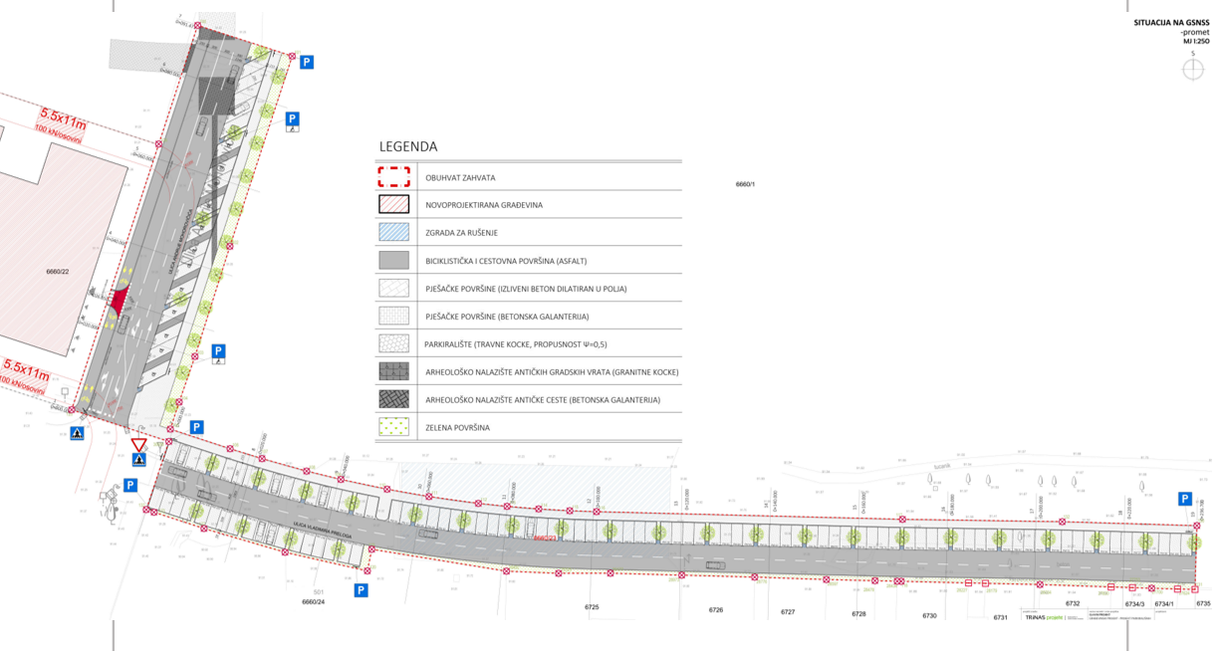

Figure 12. Access road and archaeology (ancient city gates and ramparts and ancient roads)

Archaeological presentation
Archaeological presentation of public and residential objects
The archaeological presentation of public and residential objects is designed in the open space north and west of the planned building of the Scientific Research Center and extends to the continuation of the Roman road Via Poetovio as well as to representative public facilities north of the Roman road that are not the subject of this Sub-Project. It consists of three archaeological objects or houses next to the western and northern parts of the construction plot. The selection of archaeological presentation methods is conditioned by the preservation of archaeological finds and their representativeness. Considering the state of preservation, an attempt was made to show the invisible, and models of presentation were selected that respect the way of construction and fully present the explored archaeological units by combining in situ presentation with the method of reconstruction of the original construction, i.e. parterre presentation.
The presented objects represent a cross-section of the construction of the western city suburbia in the period from the 2nd and 3rd centuries. As the houses were explored and partially renovated and used over a longer period of time, a combination of presentation methods with an emphasis on multi-layered construction and renovation was chosen as the best solution. The presentation consists of emphasizing the external and partition walls of the original, ancient construction with modern materials on the walking level of the terrain, while the best preserved parts of archaeological objects will be presented in situ, partial reconstructions, using original materials, and with minimal intervention in space. For the same reason, the presentation in situ will be performed at the original construction level in the form of archaeological niches that present the most exclusive spaces of explored archaeological objects, which are, fortunately, the best preserved.

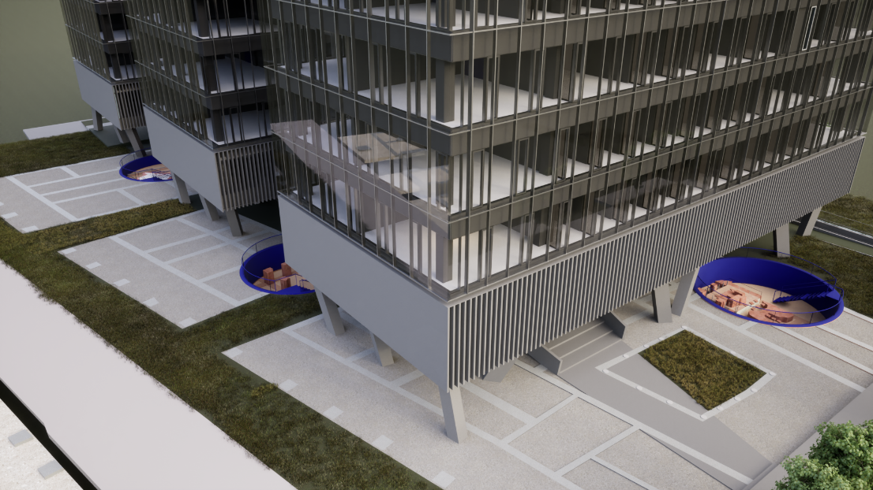

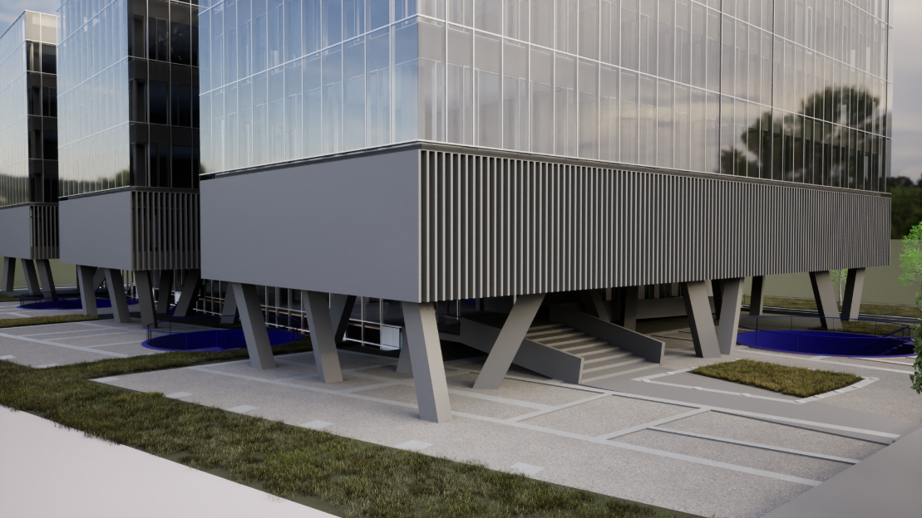

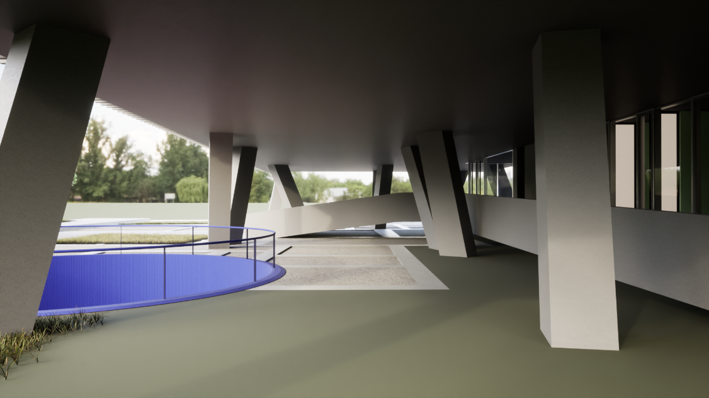

Figure 13. Photos of archaeological presentation of public and residential buildings
The presentation of Object 1 will be carried out by the method of parterre presentation of a fully explored object on the walking level of the terrain. The parterre presentation will be performed with modern material that emphasizes the positions of the explored exterior and interior walls. The interior of archaeological rooms will be carried out with other, also modern, material of different colour and/or structure to emphasize the difference between the wall and the floor of the room. In its southern part, an archaeological niche will be presented in situ, at the original archaeological level of the terrain. The archaeological niche of Object 1 consists of the display of two adjacent rooms (rooms 1 and 4) in which a furnace and underfloor heating system – praefurnium and hippokaust – were found through archaeological research. The walls of the rooms were made of longitudinally laid bricks – opus testaceum, and the floor was built with a double floor under which warm air circulated for the underfloor heating system. The original construction will be presented in its entirety, and the damaged parts of the furnace and hypocast will be reconstructed with minimal interventions and source materials. The floor in room 1 was covered with bricks, while in the room 4 pillars and floors were made of carved stone. Both rooms will be presented with original material.

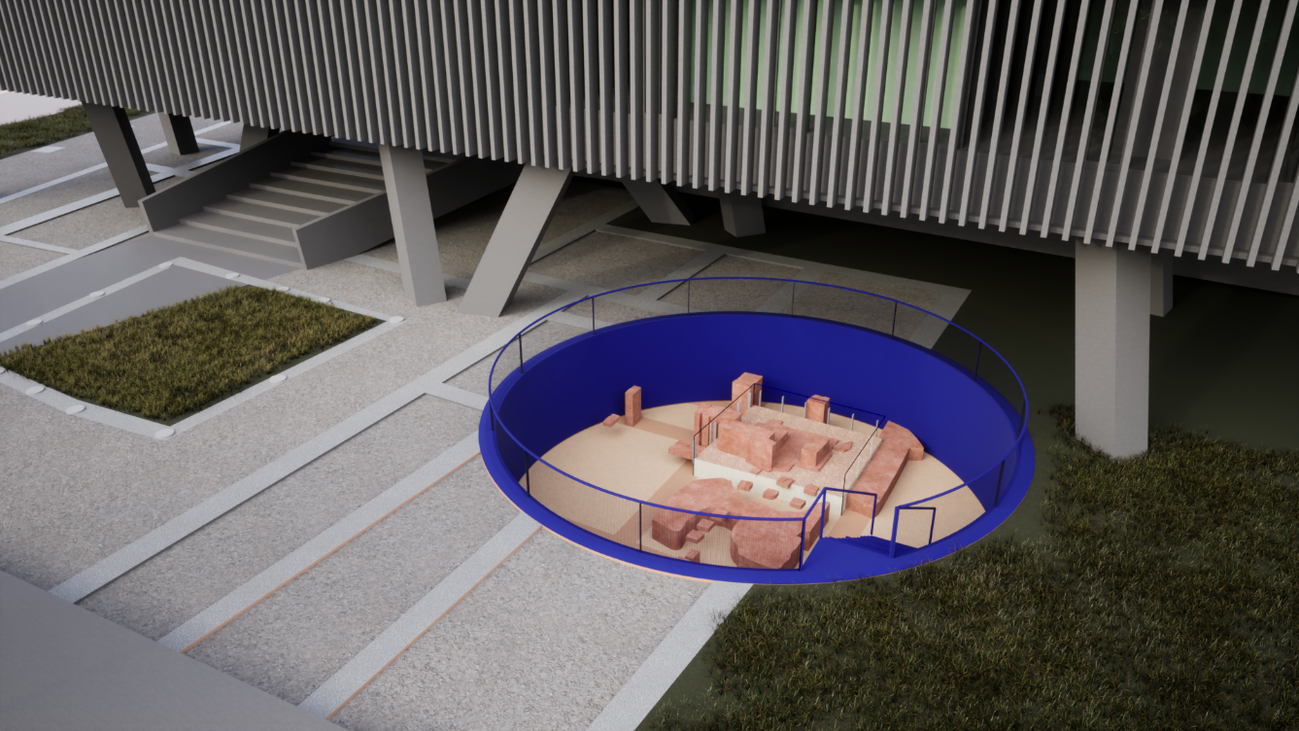

Figure 14. Photo of archaeological presentation of Object 1

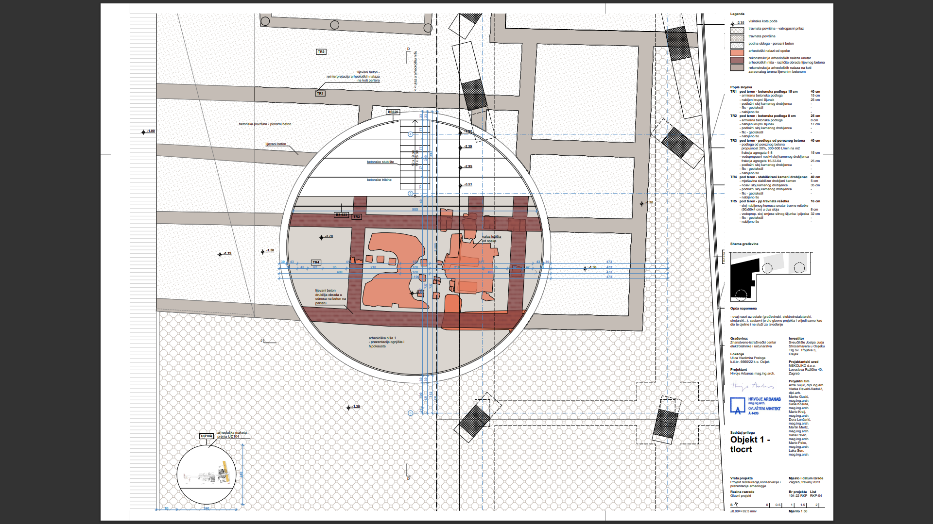
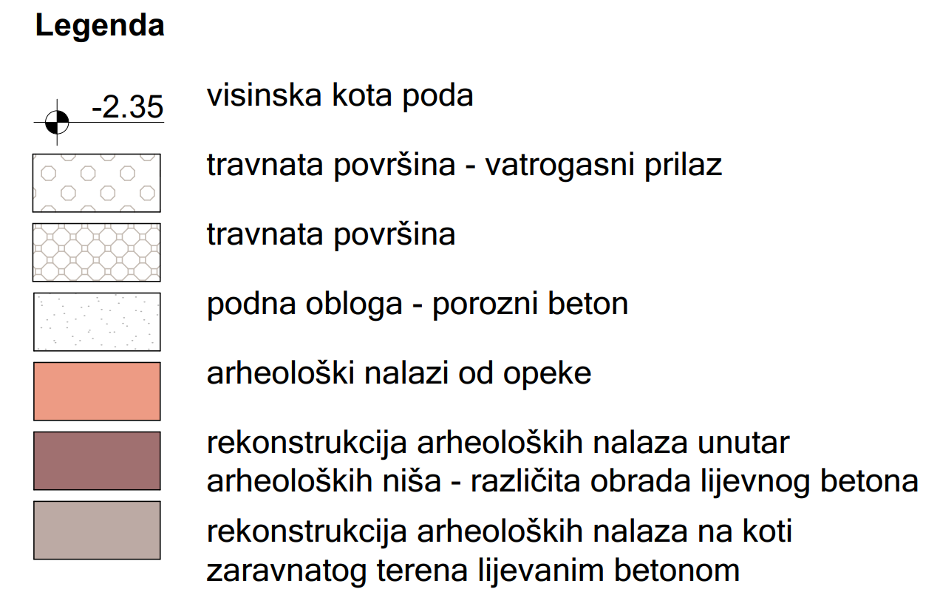

Figure 15.Archaeological presentation of Object 1

Object 3 will be also presented by the method of parterre presentation of a fully explored object on the walking level of the terrain. The parterre presentation will be performed with modern material that emphasizes the positions of the explored exterior and interior walls. The interior of archaeological rooms will be carried out with other, also modern, material of different colour and/or structure to emphasize the difference between the wall and the floor of the room. In its southwestern part, an archaeological niche will be presented in situ, at the original archaeological level of the terrain. The archaeological niche of Object 3 consists of one far southwestern room with explored brick pedestals and horizontally laid beams between the pedestals. The presentation will be carried out on the original archaeological level of the terrain in a way that presents the explored and preserved brick pedestals connected by lime mortar. The interior of the ancient room in the archaeological niche was made of tamped earth that served as a flooring or preparation for the manufacture of a flooring from poured lime mortar. The original construction of brick pedestals will be presented by found bricks in a full investigated height of 3 to 8 rows, and in the space between the pedestals massive wooden beams as carriers of external and partition walls will be placed.

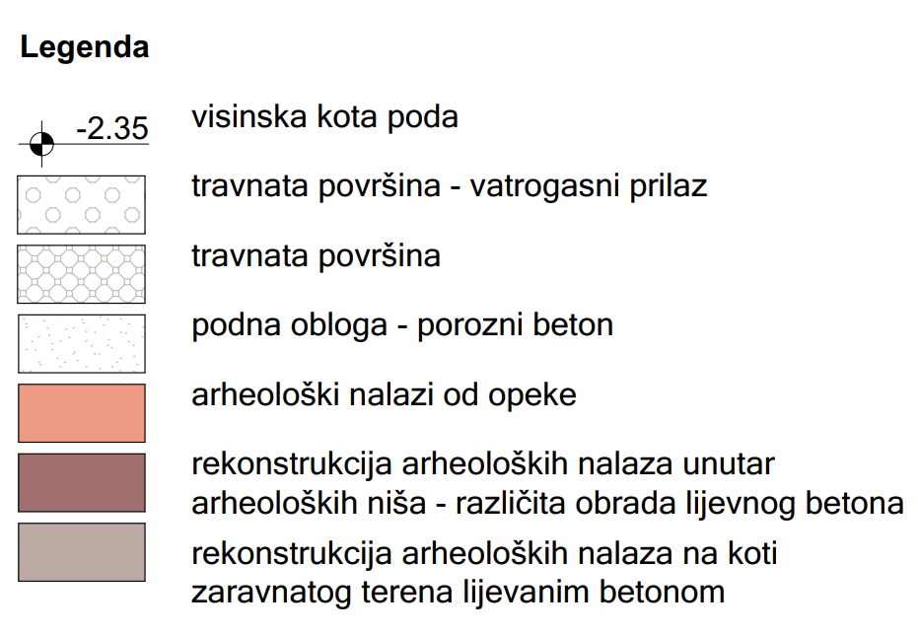
Figure 16.Archaeological presentation of Object 3

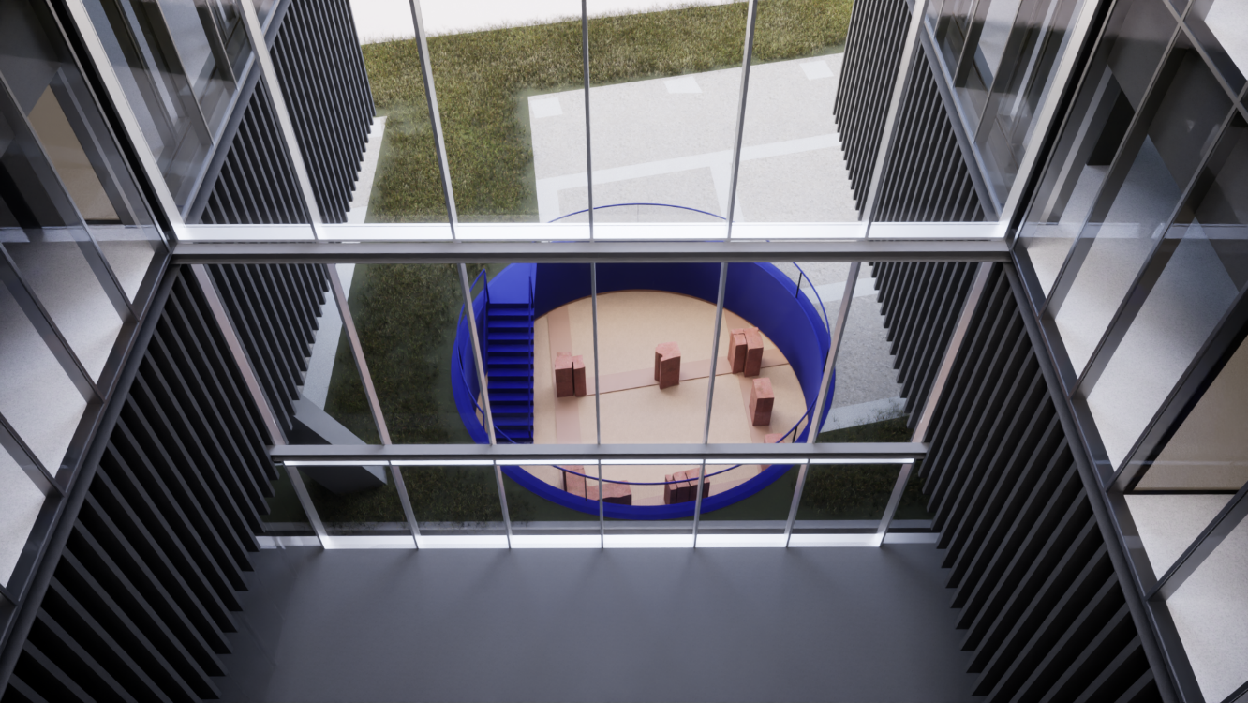
Figure 17. Photo of archaeological presentation of Object 3

Object 5 is the best preserved archaeological object positioned at the very western entrance along the town north of the Via Poetovio road. The presentation of this object will be carried out by the method of parterre presentation of a fully explored object on the walking level of the terrain. The parterre presentation will be performed with modern material that emphasizes the positions of the explored exterior and interior walls. The interior of archaeological rooms will be carried out with other, also modern, material of different colour and/or structure to emphasize the difference between the wall and the floor of the room. In the southern part of the Object 5, an archaeological niche will be presented in situ, at the original archaeological level of the terrain. The archaeological niche of Object 5 is located in the southern, end part of the object, east of the explored corridor. It presents the room with the found mosaic in situ. The foundations of the walls of the room with mosaic are made of pieces of broken orderly assembled stone connected by lime mortar, which will be presented in situ. The wall will be upgraded with original or contemporary material clearly expressed and indicated differences that would suggest walls with a possible presentation of originally found frescoes. The frescoes were painted on lime plaster on all four circumferential walls of the room. The explored mosaic will be fully presented in situ, and the resulting damage will be reconstructed with the original material. The reconstruction of the original eastern wall and the reconstruction of the mosaic are the subject of special conservation and restoration guidelines with the proposal of protective restoration works within the Detailed Design of the Scientific Research Center building.
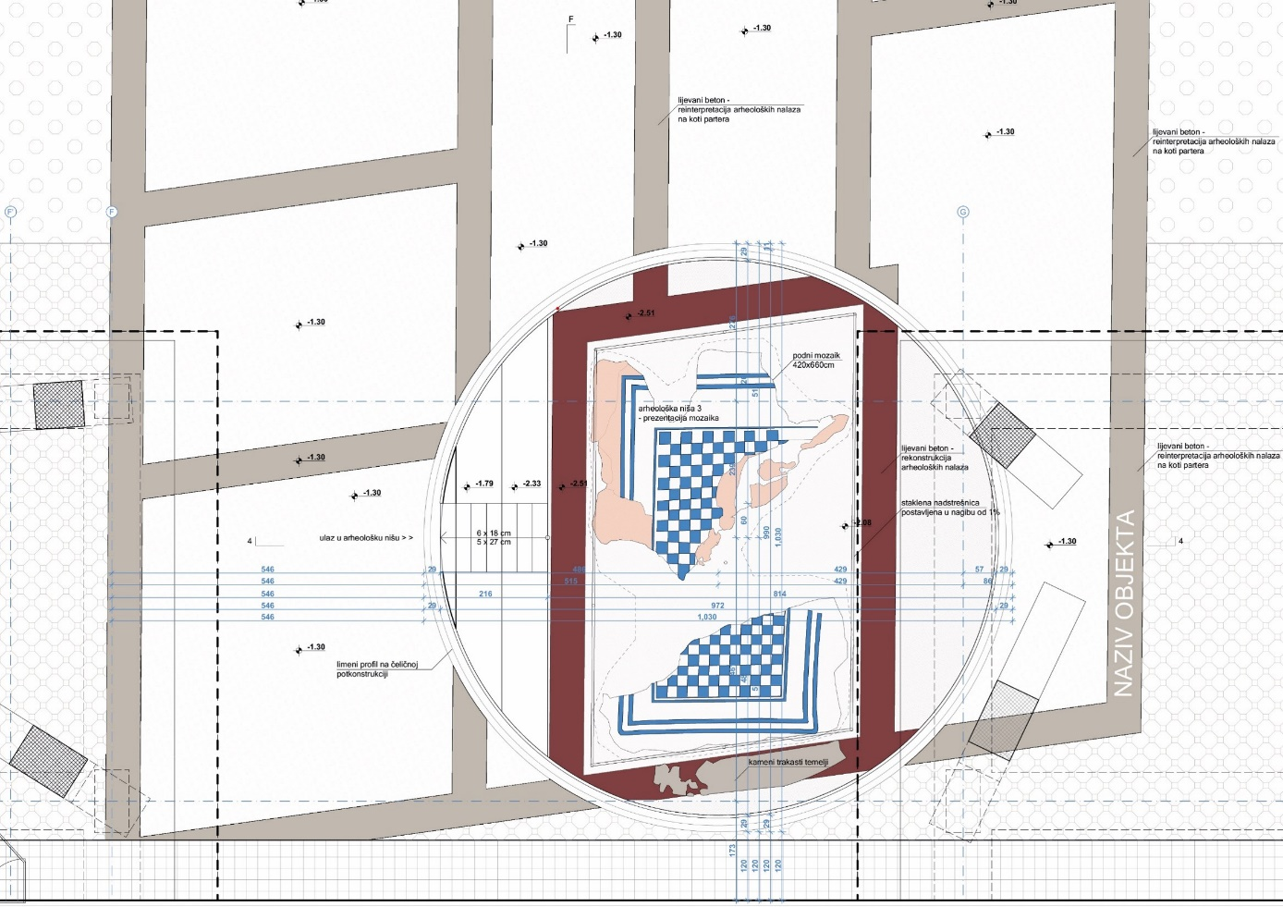
Figure 18.Archaeological presentation of Object 3

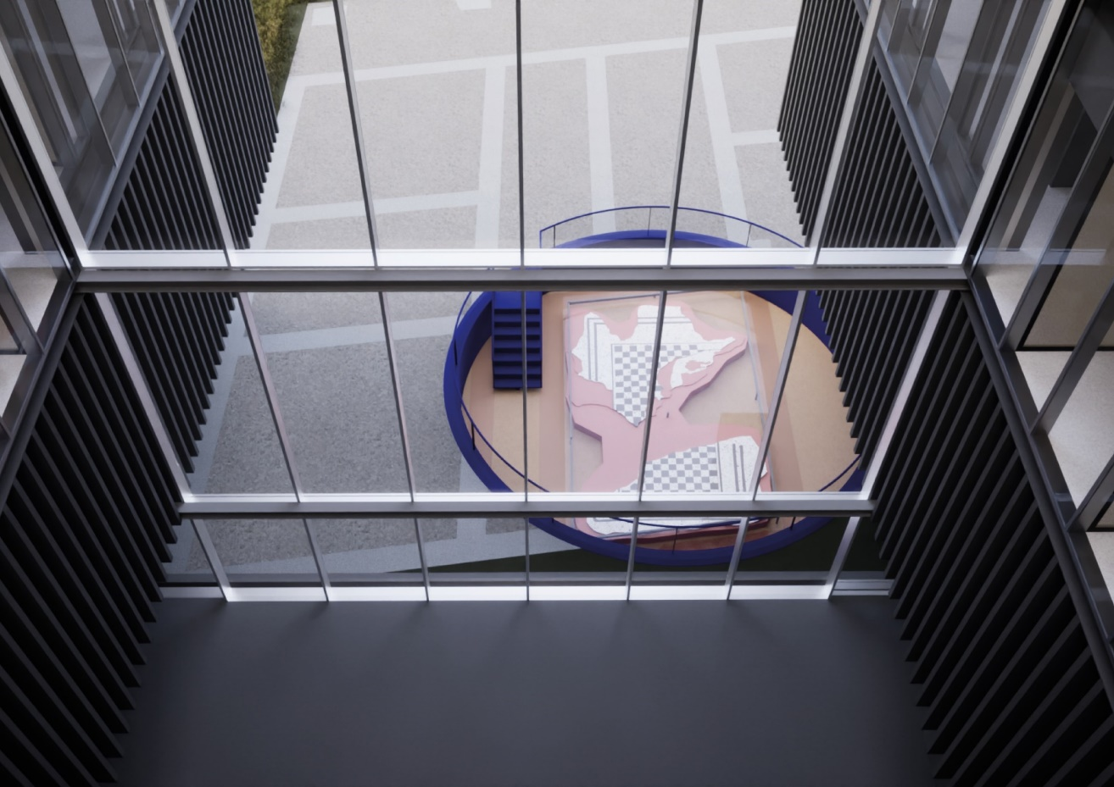
Figure 19. Photo of archaeological presentation of Object 5
Archaeological presentation of part of the western rampart and the western city gate
The location of part of the western wall and the western city gate was explored in 2016 by protective archaeological research as part of the Archaeological Heritage of Ancient Mursa project. Research found a junction of the road with the city gate and the western rampart that continued north and south. The western city gate consisted of two square towers that were highlighted outside the ramparts by one-third of their length. The rampart and the west entrance gate were most likely built of stone, and are preserved only in the negatives of the foundation. From previous research, it can be concluded that the western fortification system of Mursa consisted of a triple ditch (fossae), researched and documented on the plots of the Faculty of Law, Faculty of Food Technology, and the edge of the plot of the Scientific Research Center and a stone wall with stone, square, partially protruding towers. This method of fortification is in accordance with other urban fortifications of Roman cities of the 2nd century. Due to the location of the western wall and the western city gate on the future connecting road in the north-south direction (Andrija Mohorovičić Street), the choice of presentation method has fully adapted to the future purpose. Also, the fact that the western wall and the western city gate were explored exclusively in the negatives of the foundation without any construction remains, imposed the parterre presentation with the only possible selection.
The parterre presentation of the stretches of the western wall and the western gate is planned by selecting another building material with a clearly noticeable difference, and due to clarity and unambiguous interpretation, it is necessary to visually shape and interpret the presentation in accordance with the remaining part of the archaeological presentation of the zone. This will clearly emphasize the area of the ramparts in the space, but also annex it to the remaining part of the archaeological presentation of the Scientific Research Center into a unique archaeological unit. The parterre presentation of the western wall and the western city gate will be upgraded with modern solutions in the form of projections or modelled avatars that could occasionally and if necessary be used and projected for the purpose of understanding and interpretation, but also the exclusivity of the found archaeological finds.

Treatment of archaeological finds
Treatment of public and residential objects presented in situ
After the archaeological research, the objects for archaeological presentation are protected by geotextile, and the flooring and mosaic with an additional layer of geotextile and poured sand. Before construction, it is necessary to clean the area from vegetation and replace the worn-out protection of the finds. It is also necessary to protect the remaining walls, foundations, pedestals and rooms with flooring and mosaic with a new layer of geotextile and sand, and cover everything with wooden formwork. If heavy machinery and mechanization are used in the construction zone, it is necessary to protect the archaeological finds additionally with steel plates in order to protect archaeological finds due to pressure.
On the surface intended for the construction and/or foundation of modern columns or piles, it is necessary to manually decompose archaeological structures directly threatened by the construction. For decomposed archaeological material (brick, stone) it is necessary to provide adequate storage space as it will be used for conservation and restoration of the finds. When carrying out works, it is necessary to ensure constant archaeological supervision and documentation.

Treatment of original archaeological finds presented in situ within archaeological niches
Archaeological niches i.e. in situ presentations of original walls, floors and mosaics in Objects 3, and 5 as well as floors with firebox in Object 1 will be accessible to visitors, and mosaic in the archaeological niche of Object 5 will be protected from precipitation, endangerment and devastation. Also in the archaeological niche of Object 5 it is desirable to partially restore and / or reconstruct the peculiarity of this room, since along with the floor mosaic, parts of decorating the walls with frescoes on lime plaster were found.

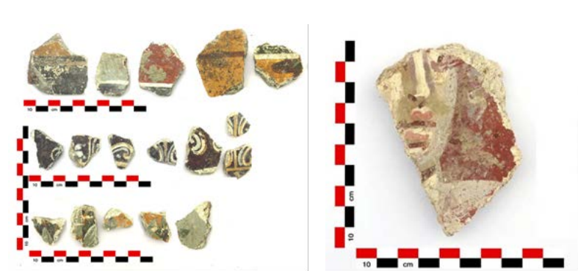
Figure 20. Archaeological finds presented in situ within archaeological niches
Surface damage to the walls needs to be repaired with restoration methods of cleaning, removing and/or replacing damaged bricks. Partitioning and/or wall reconstruction are subject to restoration, consolidation and restoration of wall and floor surfaces as well as mosaics.
Treatment of part of the western walls and the western city gate
The conducted protective archaeological excavations that explored the surface of the western wall and the western city gate did not find the construction remains. They were most likely built of stone and were probably used for some secondary purpose. For the same reason, treatment during construction in this area does not need to be specifically prescribed. Before construction, it is necessary to geodetically position the researched archaeological findings of a part of the western wall and the western city gate in order to perform a parterre presentation with a different material.

Construction and materials
The structural elements of the park were primarily used to secure the soil and overcome sudden height differences. The perimeter supporting reinforced concrete wall inside the niches provides niches from the collapse of the surrounding landscaped terrain. Reinforced concrete retaining walls of niches are floor-plan designed in the form of a circle, statically optimal shape for creating niches inside the ground. The foundation is solved with foundation strips that follow the reinforced concrete retaining wall in the ground plan. In addition to the supporting walls, a staircase with stands was made of reinforced concrete. Inside the park, reinforced concrete columns of the Building of the Scientific Research Center for Electrical Engineering and Computer Science appear, based on pilot foundations.

Materials and linings
The area of the park was solved through four basic materials at two basic levels – levels of archaeological finds and levels at the elevation of flat terrain. At the height of the parterre, the transient area around the buildings where there are no archaeological finds was solved through grassy areas with the use of tartan in the areas below the building. Spaces within the dimensions of ancient objects, i.e. the former rooms are taken over as a floor covering by crushed stone, while the zones of ancient walls are emphasized using cast concrete. Archaeological niches are emphasized by using metal linings on non-archaeological elements – retaining walls, staircases, stands and fences. By comprehensively applying one material through all surfaces of niches, the monolithic character of the volume is obtained and the circular archaeological niche as a prominent artificial volume becomes a clear access point to archaeological finds. At the level of archaeological finds, cast concrete is used to emphasize the strokes of the walls and the crushed stone in the rest of the zones. Concrete will be used only to fill in archaeological negative-features (artificial depressions dug into the soil or the rock), the found archaeological remains (walls, terraces, etc.) will be conserved, protected and displayed.

Construction pit
In order to find a technical solution for the protection of the construction pit for the site in question, geotechnical exploration works were carried out, which resulted in the preparation of a geotechnical study made by the company Premur Ltd., Varaždin.
Calculations of the bearing capacity of the foundation soil show that the foundation can be carried out on the foundation plate and the foundation feet. The basic rates need to be based on AB pilots because of the large forces they are absorbing and because of the impossibility of dimensional extensions due to archaeological excavations. Foundation pits need to be cleaned of segregated material before concreting. The minimum depth of the foundation must be 0.8 – 1.0 m below the surface of the terrain.

Archaeological excavations at the site need to be protected when carrying out works on the construction of the new building of the Scientific Research Center. For the construction of the foundation slab, part of the excavation next to the archaeological excavations will be protected with steel sheet piles, while the foundation footsteps of the pillars of the building with associated AB piles will be carefully carried out between archaeological excavations, all in order to prevent devastation and preservation of excavations.
In order to preserve archaeological excavations and enable the execution of works on the construction of AB piles of foundation feet, an embankment of coarse-grained stone material fraction 0-32 mm, 30 cm thick will be constructed over the archaeological excavations.
Such a working plateau will allow manipulation of the machinery and equipment necessary to perform the pilot. From such a plateau, the construction of reinforced concrete piles is approached to the elevation according to the project designs. After the execution of the pile, it will be necessary to remove all the bulk material and access the excavations for the foundation feet of the pillars of structures. Excavations in the zone of archaeological excavations need to be carried out carefully, with machine and manual excavation. The selected technique will be decided by the Conservationist (Osijek Department for Conservation) in charge.
The work order on the protection of the construction pit and the construction of the AB pile is as follows:
- construction of the working plateau over the archaeological excavations;
- construction of piles foundation feet of construction columns from the arranged working plateau;
- careful manual and machine removal of the bulk material of the working plateau;
- careful manual and machine excavation for the foundation feet of the columns;
- construction of steel sheet pile type as "Larssen 605" with archaeological excavations;
- machine excavation of the construction pit for the foundation slab of the building;
- construction of concrete channels and concrete wells for pumping water.
In addition to archaeological excavations, it will be necessary to carry out the protection of the construction pit with steel sheet pile type as "Larssen 605" with a length of 10 m. Steel sheet pile should be carried out at the minimum possible distance from the dimensions of the foundation plate in order not to interfere with archaeological excavations. According to information obtained from the geotechnical study, the average groundwater level is at a depth of 6.3 m from the existing terrain. Consequently, it will be necessary to provide for continuous pumping of groundwater in order for the works to be carried out in dry land. For this purpose, concrete channels 50/20/50 cm will be installed for the drainage of surface water around the perimeter of the construction pit. Water from the channels will need to be drained into pumping shafts with concrete covers, ø1000 mm in diameter, at least 1.5 m deep, in which pumps are installed. The project envisages the construction of two pump shafts with pumps with a capacity of up to 50 l/s. Water will be discharged from pump shafts into a nearby road sewer (connected to the municipal collection system) using a pump.
After the completion of the works, it is necessary to remove the bulk stone material and return the terrain to its original condition (the removal should be carried out carefully in approximate percentage 50% by machine and 50% manually taking into account the preservation of archaeological excavations.

ENVIRONMENTAL CONDITIONS OF SUB-PROJECT AREA

Land use
According to the cartographic representation 1. Use and purpose of the space (GUP Osijek), the Sub-Project is located in the area designated as an area of public and social purpose (D6) – higher education institution, which is surrounded on the east, west and north side by an area intended for mixed use (M), and from the southern surface of sports and recreational purposes (R) (Figure 21.).

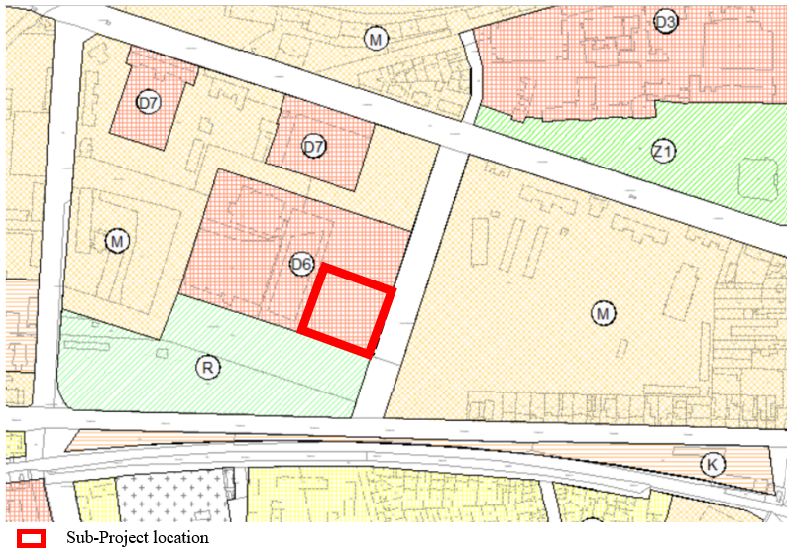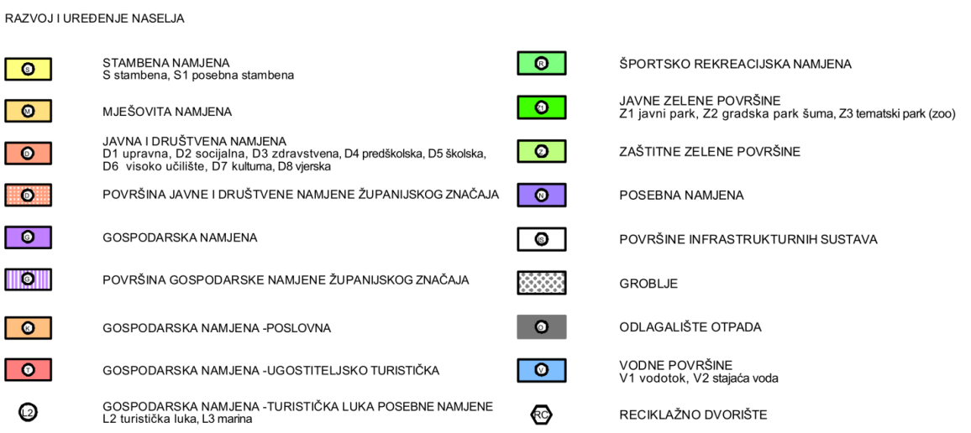
Figure 21. Excerpt from the General Urban Plan of City of Osijek (map 1. Usage and Purpose of the area)

Air quality
According to the Decree on the designation of zones and agglomerations according to the levels of air pollution in the territory of the Republic of Croatia (Official Gazette 1/14), the location of the project is within the HR OS.
The nearest measuring station for air quality measurement is Osijek-1, at a distance of less than a kilometre. According to the Report on air quality monitoring on the territory of the Republic of Croatia in 2021, the air quality at the monitoring station Osijek - 1 was assessed as I. category (clean or slightly polluted air, consistent with the limit value for 1-hourly and the limit value for 24-hour concentrations with regard to the protection of human health) for NO₂, O₃, CO, PM _{2,5}, except PM₁₀ for which category II (polluted air) was determined.

Radon emission
Radon is formed by the radioactive decay of radium found in soil and rocks and is found everywhere in the earth's crust. Guided by various transport mechanisms, it easily exits the ground into the air. The concentration of radon in the outdoor air is small (between 5 and 15 Bqm⁻³) and generally it does not cause any health problems. However, it can be high in indoor air (residential houses, schools, hospitals etc.) from 10 to several thousand Bqm⁻³ and in extreme values up to one million Bqm⁻³).
The main sources of radon in indoor air are: soil just below the building (85 - 90%), building materials (5 - 10 %), groundwater (about 5 %) and natural gas (less than 1 %). The parameters that affect the concentration of radon in buildings can be natural (geological composition and soil structure, climatic and meteorological parameters) and technical or technological (construction methods) as well as people’s habits (ventilation of rooms, way of heating, etc.). Due to such a large number of different parameters that directly or indirectly define the concentration of radon in buildings, it is practically impossible to develop a satisfactory model that will predict the concentration of radon in the house. Therefore, direct measurement is the only correct way to assess radon risk.
The national (and EU) reference level for radon concentration in indoor air is 300 Bqm⁻³. So far, indoor measurements have been carried out with a total of about 6.000 detectors (727 schools, 228 kindergartens and 1.400 residential buildings) in 10 counties (Brod-Posavina, Virovitica-Podravina, Lika-Senj, Karlovac, Istria, Primorje-Gorski Kotar, Požega-Slavonia, Osijek-Baranja, Sisak- Moslavina and Vukovar-Srijem).
Geogenic radon potential in Osijek-Baranja County is rated as lower average (Figure 22.) which will be further addressed in the project design and mitigation measures (Chapter 6.2. Indoor air quality).
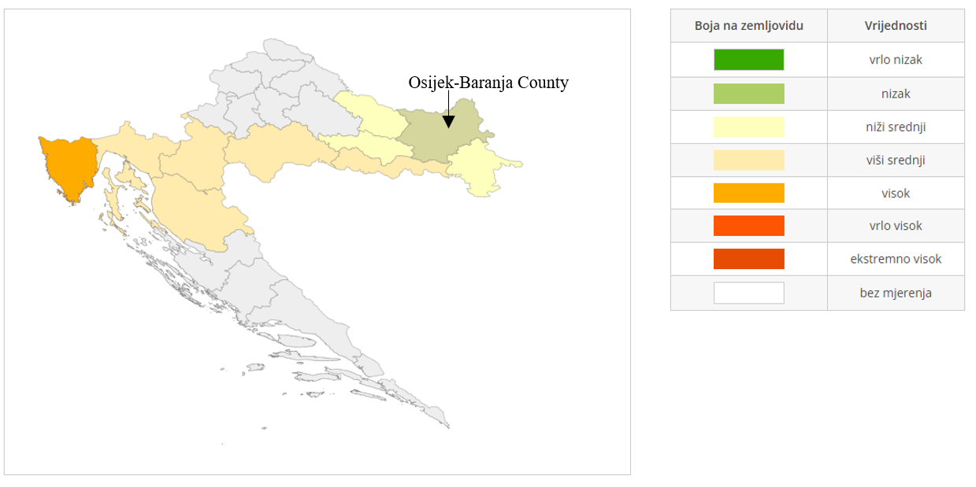
Figure 22. Geogenic radon potential in Croatia

Noise
According to the valid spatial planning documentation the Sub-Project area belongs to public and social (higher education institution) purposes. The surrounding areas belong to area of mixed use (M), and the area of sports and recreational purposes (R).
According to Table 1 in Ordinance on the highest permissible noise levels with regard to the type of noise source, time and place of occurrence (OG 143/21), Sub-Project is located in Zone 3 - Zone of mixed, residential use, in which the highest permitted rated noise levels L_{R,Aeq} are:
- L_{day} 55dB (A);
- L_{evening} 55 dB (A);
- L_{night} 45 dB (A);
- L_{den} 57 dB (A).
Permissible noise level for the construction site is determined by the provisions of the Ordinance on the maximum allowed noise levels with regard to the type of noise source, time and place of occurrence (OG 143/21). The permitted equivalent noise level of the construction site at the most exposed point of sound emission of the open living space during day and evening period is 65 dB(A). According to the mentioned ordinance, it is allowed to exceed that level for an additional 5 dB in the period from 8 to 18 hours. When performing construction works during the "night" period, the equivalent noise level must not exceed 45 dB. Exceeding the permissible noise levels shall be allowed if necessary for the technological process of the construction site and for up to three nights within a consecutive period of thirty (30) days. A minimum of two full night periods shall be provided between periods when exceeding allowable noise levels is anticipated without exceeding allowable noise levels during the night period.

Biodiversity, Nature protection areas and Natura 2000 Ecological Network
According to the Register of Protected Areas, the planned intervention is located outside the areas protected under the Nature Protection Act (OG 80/13, 15/18, 14/19, 127/19, 155/23) (Figure 23.).
The nearest protected area is the Regional Park Mura – Drava located about 320 m north of the planned project, while in the wider area of the project, at a slightly greater distance, there are also the Monument of Park Architecture Kralj Tomislav Park - about 1.3 km west of the Sub-Project and Kopački rit Nature Park with the Kopački rit Special Zoological Reserve - about 3.2 km east of the planned intervention. The site itself is located in the area of the Mura-Drava-Danube Transboundary Biosphere Reserve declared by UNESCO as part of the Man and the Biosphere (MaB) Program (Figure 25.). The area of the site is located in the transition area, which consists of predominantly populated areas where educational activities are carried out and sustainable development is promoted as part of economic development.
According to the Regulation on the Ecological Network and Competences of Public Institutions for the Management of Ecological Network Areas (OG 80/19, 119/23), the Sub-Project in question is located outside the area of the Natura 2000 ecological network (Figure 24.).
In the wider area of the Sub-Project, there are following areas of the Natura 2000 ecological network (POP and POVS:
- HR1000016 Danube region and lower Danube Region (POP) at 330 m distance; it covers the alluvial plain of the Drava River, habitats of rivers, swamps and river forests dominate. Conservation objectives: 50 species of birds and an additional 24 species significant non-breeding (migratory) bird populations;
- HR2001308 The Lower Course of the Drava (POVS) at 330 m distance; it covers the lower course of the Drava River up to estuary, and is located within the Regional Park Mura Drava. Conservation objectives: habitat of alluvial forests and 21 animal species (of which 1 reptile species, 2 amphibians species, 12 fish species, 5 invertebrates species, 1 mammal species);
- HR2000394 Kopački rit (POVS) at 3,2 km distance;
- HR2000372 Danube-Vukovar (POVS) at 3 km distance.
Regional Park Mura Drava (320 m distance) - The Mura-Drava Regional Park extends through five counties: Međimurje, Varaždin, Koprivnica-Križevačka, Virovitica-Podravska and Osijek-Baranja counties, with a total area of 87,680.52 ha. The Mura-Drava Regional Park is part of one of the most important European river ecosystems: the floodplain of the Drava, Mura and Danube rivers, and thus it is also part of the largest unique Mura-Drava-Danube River Biosphere Reserve in Europe, declared by UNESCO in 2021, which extends through several countries: Croatia, Austria, Slovenia, Serbia and Hungary. The purpose of protecting the ecosystem of the Mura-Drava Regional Park is to preserve the natural types of habitats threatened at the national and European level, all taxa that inhabit them, the preservation of exceptional landscape values, geological heritage and cultural-traditional heritage. Wet habitats are particularly important, which are among the most endangered in Europe, and are also protected at the national level: floodplain forests, wet grasslands, dead backwaters, abandoned riverbeds, meanders, and banks and steep collapsed coasts, as well as an extraordinary wealth of ornithofauna and ichthyofauna, and numerous other endangered and rare species at the national and European level, as well as a valuable specific landscape complex that progresses from the natural space along the rivers to the cultural anthropogenic landscape in the peripheral parts of the park with long stretches of settlements. The Transboundary UNESCO Biosphere Reserve combines the cluster of thirteen protected areas along the Mura-Drava-Danube region and jointly manage the shared river ecosystem in a sustainable manner while boosting economic growth and development in the region. The Biosphere Reserve concept defines about 300,000 hectares of core and buffer zones (existing protected area network) and around 700,000 hectares of transition zones. The core zone is the ecological backbone of the reserve. It primarily covers the river and floodplains areas which are mostly situated within flood control dikes. The goals and measures in the core zone are pre-dominantly focused on the preservation of natural habitats, species and processes as well as the restoration of already degraded areas. The buffer zone extends along the rivers outside the inundation zone. It is characterised by a mosaic of cultivated land and village areas and also contains some smaller detached zones like oxbow lakes, fish ponds and small wetlands. Extensive agriculture such as cattle grazing, hay making, organic production, local products marketing and ecotourism are some of the key activities in this area. The outer transition zone provides regional economical and scientific support to the buffer zone. The majority of towns and universities are situated within this area.
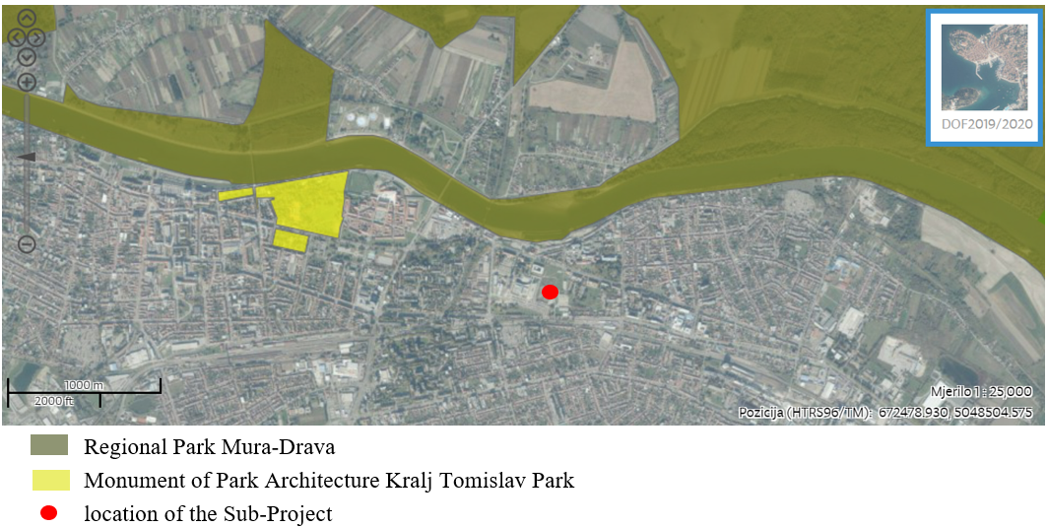
Figure 23. Protected areas
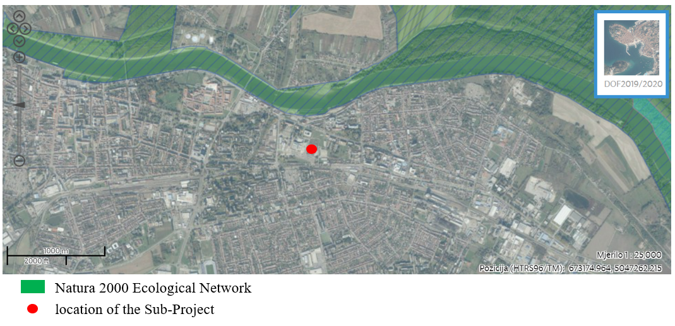
Figure 24. Ecological network Natura 2000
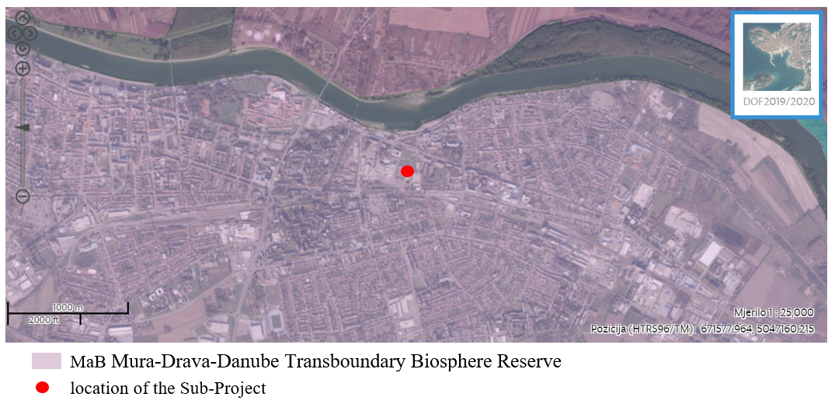
Figure 25. MaB area

Water and flood areas
According to the flood risk map, Sub-Project is located outside the area with a probability of floods (Figure 26.).

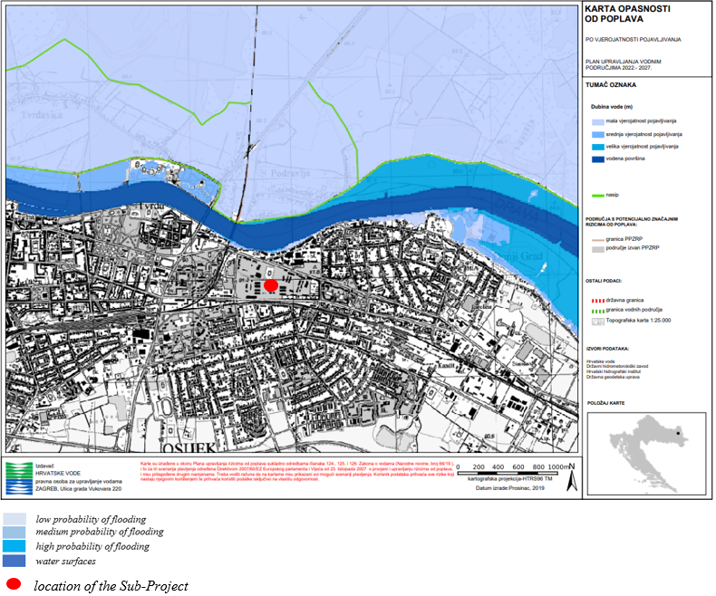
Figure 26. Flood risk map
The Sub-Project is located outside the groundwater protection zones and sanitary protection zones (Figure 27.).

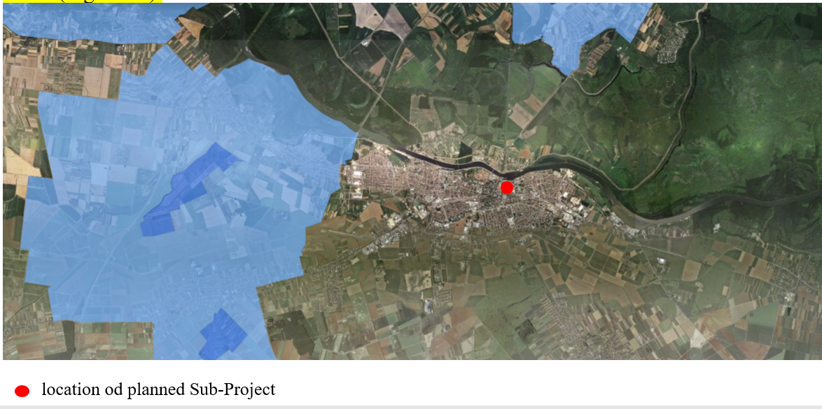
Figure 27. Sanitary protection zones – Geoportal
Planned Sub-Project is located in the sensitive catchment area (Figure 28.).

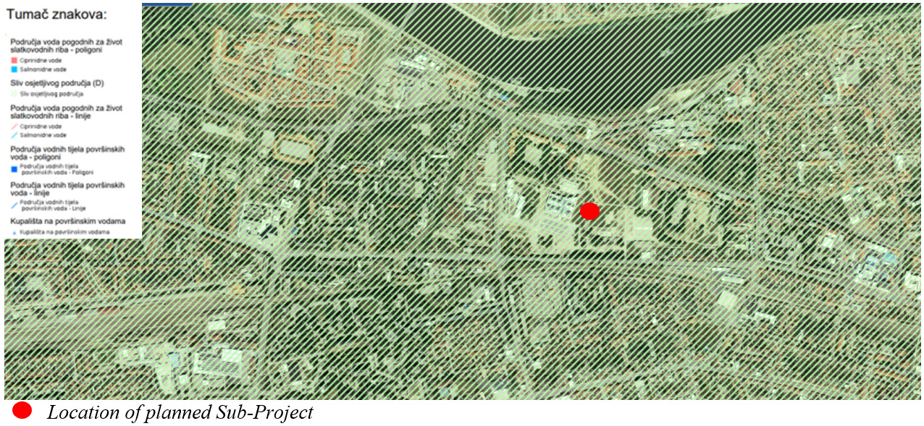

Figure 28. Areas of special water protection according to the River Basin Management Plan 2016.-2020.

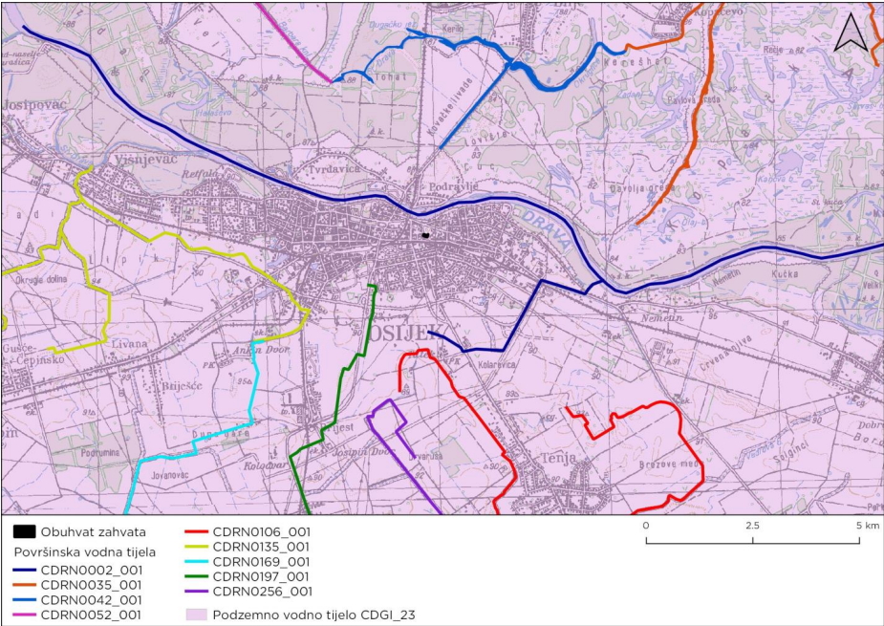
Figure 29. Water bodies in the Sub-Project location and surrounding area
Planned Sub-Project is located at the area of groundwater water body CSGI_23 Istočna Slavonija - Sliv Drave i Dunava. It is characterized by intergranular porosity, moderate to elevated vulnerability (84% of the area). The state of the water body is good (chemical, quantitative and total).
There are no surface water bodies within the scope of the Sub-project, but in the wider area of the Sub-Project (a belt of 5 km), there are surface water bodies CDRN0002_001 Drava, CDRN0035_001 Hulovski kanal, CDRN0042_001 Stara Drava – Bilje, CDRN0052_001 Barbara Kanal, CDRN0106_001 Glavni Tenjski, CDRN0135_001 Crni Fok, CDRN0169_001 Salaj, CDRN0197_001 Seleš and CDRN0256_001 Orlovnjak.

Seismic characteristics and soil stability
According to the Seismic Map of RoC from 2012, for a return period of 475 years, the subject location belongs to the area with a peak acceleration of 0,110 g, where g is the acceleration of the gravity field, 9,81 m/s². The acceleration corresponds to VII. degree of the MCS (Mercalli - Cancani - Sieberg) scale (very strong earthquake, chimneys collapse, tiles fall from the roof, house walls crack.). Looking at the return period of 95 years on the Seismic Map of Republic of Croatia, the peek acceleration at the location amounts 0,049 g, which corresponds to VI. level of the MCS scale (Figure 30).

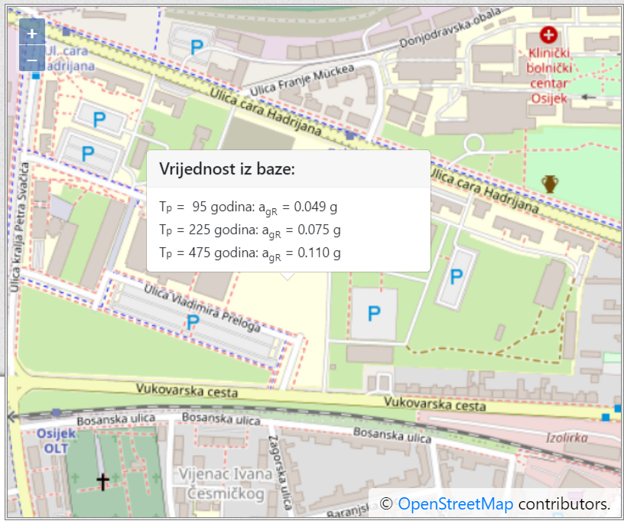

Figure 30. Seismic map of Republic of Croatia (source: Maps of earthquake areas of the Republic of Croatia (gfz.hr))

Climate and climate change
According to the Thornthwaite climate classification, a subhumid climate prevails in the City of Osijek. According to the Köppen classification, City of Osijek has a moderately warm rainy climate, with a warm summer, without dry period, with the least amount of precipitation in the cold part of the year, and there are two maxima in the annual rainfall (marked as “Cfwbx"). An important characteristic of these climates is the existence of a regular rhythm of seasons since they are mostly located in the temperate belt. There are no continuously high or continuously low temperatures, just as there are no long periods of drought or long rainy periods.
The nearest main meteorological station of the Meteorological and Hydrological Service is located in Osijek, and there are available data on the measured values of the most important climatological parameters. Based on data for the period 1899-2020, the average annual air temperature at Osijek station was 11.1°C. The warmest month was July with an average air temperature of 21.7°C, and the coldest January with -0.6°C. The highest daily temperature was measured in July 1950 and August 2012 (40.3°C), while the lowest temperature was measured in January 1987 (-27.1°C). The average annual precipitation in the specified period was 693.7 mm, and the rainiest months are May (70.8 mm) and June (82.6 mm). The maximum recorded height of snow cover at Osijek station is 93 cm (12.2.1922.). The most common form of precipitation is rain, while solid precipitation occurs in cold, and less often in the warm part of the year (hail). The average number of clear days per year is 69, and the duration of insolation is 1959 hours per year.

The conducted modelling and other analyses of changes in climate parameters in Croatia are presented in the Strategy for Adaptation to Climate Change in the Republic of Croatia for the period up to 2040 with an overview of 2070 (OG 46/20). The results relevant to the planned Sub-Project are presented below.
- Maximum air temperature (Tmax) - annual value
In the period until 2040, the average maximum temperature will rise almost uniformly throughout Croatia between 1 and 1.5 °C. In the period 2041-2070, the average annual temperature will continue to rise, also almost uniformly throughout Croatia, but the increase will be higher - about 1.9 °C. The increase in the highest air temperature values in urban areas has the effect of creating heat islands. Heat islands have an impact on increasing energy consumption, they contribute to the effect of greenhouse gases and global warming and have a negative impact on water quality and human health.
- Number of days with a maximum daily temperature above 30°C (hot days) and days with a maximum daily temperature above 35°C
The number of hot summer days (with a temperature of more than 30°) by 2040 will increase compared to the reference period for 7-10 days almost equally throughout Croatia. In the period up to 2070, the number of hot days will increase everywhere between 10 and 15 days. For the period 2040, an increase in the number of days with a temperature of more than 35°C is projected throughout Croatia. The largest increase, from 3 to 5 days, is expected in most of northern Croatia, including the Sub-Project area. In these regions, the increase is sometimes over 100% compared to the reference period, so the number of days with a temperature of more than 35°C is expected to be more than doubled. In the period up to 2070, an increase of 7-10 days is expected in the same regions where there was the largest increase in the number of days in the period up to 2040, including in the Sub-Project area.
- Number of rainy periods
In the Sub-Project area, in the period up to 2040, as well as in the period 2041-2070, no change is expected in the expected number of rainy periods (a series of at least 5 days when the amount of total precipitation exceeds 1 mm).
- Number of dry periods
In the Sub-Project area, in the period up to 2040, no change in the expected number of dry periods is expected (a series of at least 5 days when the amount of total precipitation is less than 1 mm). In the period 2041-2070 an increase in the number of dry periods, in the Sub-Project area of intervention is expected in spring and summer.
- Number of days with a maximum daily precipitation of more than 10 mm/h
In the period up to 2040, the number of days with precipitation greater than 10 mm/h will change more in the southern than in the northern parts of Croatia, with an increase expected in the Sub-Project area in spring and autumn, but the change compared to the reference period is relatively small. In the period up to 2070, the increase in the number of days in northern Croatia is expected only in autumn, and of very low intensity.
- Wind speed (at 10 m altitude) - annual value
By 2040, the mean annual wind speed (at 10 m in height) is not expected to change. For the period 2041-2070, a significant change in the annual wind speed (at 10 m high) is also not expected.
- Maximum wind speed (at 10 m height) - annual value
In the period up to 2040, a small reduction in the maximum wind speed is expected in the east of the country, of about 0.1 m/s. Even in the period up to 2070, the maximum wind speed will not change significantly compared to the reference climate.
- Solar radiation
In the period up to 2040, a very small increase in flux is expected – between 0.5 to 1 W/m². The increase in the flux of incoming solar energy continues in the period 2041-2070, with an increase of 2-3 W/m² expected in continental regions, including the Sub-Project area. As in the previous period, these changes are very small relative to the total flux values in the reference period.

Site history
There was no historical pollution recorded on the site of the planned Sub-Project such as waste disposal, accidents with dangerous substances or any other soil pollution.

Pollutants in the vicinity of the Sub-Project
There are no significant polluters (companies that perform activities using significant quantities of hazardous substances or emit pollutants into water, soil or air) in the vicinity of the planned Sub-Project.

SOCIAL-ECONOMIC BASELINE OF SUB-PROJECT AREA

Population
The Sub-Project is planned in a populated area of the town district Donji Grad, which administratively belongs to the City of Osijek. In addition to the aforementioned district, the territory of the City consists of 6 more districts; Retfala, Gornji Grad, Industrial District, Tvrđa, Novi grad and Jug II. According to the 2021 census, Osijek is the fourth largest city in the Republic of Croatia, with a total population of 96,313. Osijek is the largest city in Slavonia and is also the economic / industrial, academic, judicial, cultural and administrative center of Osijek-Baranja County.

Socio-economic context
The predominant economic activities in the City of Osijek are mechanical engineering (agricultural machinery), chemical industry (Saponia), confectionery industry (Kandit, Karolina), sugar factory (Sugar Factory Osijek), beer production (Osječko pivo), but the representation of industry used to be much higher. In recent years, the main feature of the City is high youth unemployment and a deep economic crisis. The City of Osijek, as an academic center, also offers higher education organized within the Josip Juraj Strossmayer University of Osijek, located on the university campus that enables the long-term development of most university activities. There is, among other things, concentrated and scientific research activity, focused on applied and developmental research.

Buildings and infrastructure in the vicinity of the planned Sub-Project
According to spatial documentation, the planned Sub-Project is located within zone D - public and social purpose, i.e. zone D6 - higher education, which is surrounded on the east, west and north side by an area intended for the same purpose, while from the southern surface a parking lot (P) is provided, to which the surfaces of sports and recreational purposes continue.
The Sub-Project is located at a distance of about 300 m from the Drava River. On the south side there is mostly a residential part of the city, a parking lot next to V. Preloga Street and frequent city road (Vukovarska street), on the east and north side there is a partly built area of the campus. On the west side is the building of the Faculty of Civil Engineering and Architecture. In the immediate vicinity of the planned building there is a Faculty of Agrobiotechnical Sciences Osijek and a new student dormitory (on the west side, behind the Faculty of Civil Engineering and Architecture) and a space that is used as an "art colony" (the old military facility which is used for exhibitions on the northeast side).

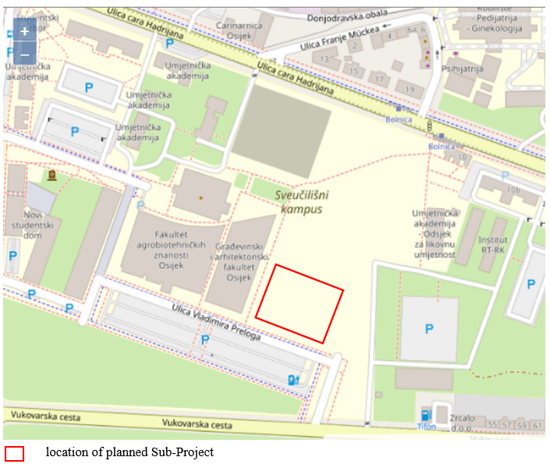
Figure 31. Surrounding of the planned Sub-Project

Cultural Heritage
Described in the Chapter 2.4.

STAKEHOLDER CONSULTATION AND INFORMATION DISCLOSURE
The Sub-Project stakeholder engagement plan is presented in Annex 1, together with the stakeholder groups which are consulted during the implementation of this Sub-Project.

Summary of previous stakeholder engagement activities
The process of development of Sub-Project’s documentation and related engagement of the stakeholders in the process
The Sub-Project for the construction and establishment of the Scientific Research Center for Electrical Engineering and Computer Science (hereinafter referred to as the Center) has been developing since 2016, during which a comprehensive analysis of problems and needs at the level of the University, its components and the economy was made.

During the analysis of problems and needs, consultations and meetings were held with all constituents within the University (Senate sessions), representatives of local self-government units, all important businessmen and researchers, who contributed with their suggestions and feedback to defining the research plans of individual research groups.

Nine scientific and research institutions and thirteen significant partner companies, as well as the City of Osijek and Osijek-Baranja County, expressed their support for this Sub-Project in writing (letters of support are stored in the DIGIT project archive).

The Sub-Project of the Scientific Research Center of Electrical Engineering and Computer Science has been recognized as strategic at all levels: national, regional, local and university level.

By including the Sub- Project in its strategic guidelines, Josip Juraj Strossmayer University in Osijek, the Osijek-Baranja County and the City of Osijek recognized the Center as a platform for the creation of new ideas and technological solutions in the field of electrical engineering, computer science and information technologies and as a basis for economic growth and increase competitiveness of the economy.

In December 2017, the J. J. Strossmayer University gave the Consent for all interventions that are foreseen in the Sub-Project called: "Scientific Research Center for Electrical Engineering and Computer Science - ZICER", and the Senate of the Josip Juraj Strossmayer University in Osijek passed the Decision on launching of the project called "Scientific Research Center of Electrical Engineering and Computer Science" (the decision is stored in the archive of the DIGIT project).

The preparation of technical documentation and the construction of the Scientific Research Center for Electrical Engineering and Computer Science are listed as one of the priority capital investments of the University in the next project period within the Strategy of the Josip Juraj Strossmayer University in Osijek.

Therefore, the components of Josip Juraj Strossmayer University are familiar with all stages of the preparation and implementation of the project for the construction of the Scientific and Research Center of Electrical Engineering and Computing Science, and the evidence of this is the decisions and minutes of the Senate sessions, which support the above. Also, at the level of the institution responsible for scientific research activities and applicants for the future Sub-Project of the construction of the Scientific Research Center of Electrical Engineering and Computer Science, all FERIT researchers have been actively involved in the organizational reform of the Faculty from the beginning.

Namely, FERIT launched an organizational reform in October 2017 and established the Scientific Research Center of Electrical Engineering and Computer Science as its organizational unit (the decision of the Faculty Council is stored in the archives of the DIGIT project) so that all activities related to scientific and research work, previously realized dispersed through several different organizational units, focused performed through the Center as a specialized organizational unit, which will improve the research organizational structure of FERIT and more effectively connect research groups at FERIT with each other, but also with researchers at the University and outside.

During the spring of 2017, the definition of the project task and preparation for the call for an urban-architectural tender for the conceptual design of the new building and the selection of the project team began, in order to achieve a high degree of readiness for the preparation of project documentation, for prerequisites for applying for EU funds and securing construction financing.

During August 2018, the Tender Elaboration for the conceptual architectural solution of the Scientific and Research Center of Electrical Engineering and Computer Science in Osijek was prepared (CLASS: 404-01/18-01/2, URBROJ: 18-84). The competition study was prepared by the Society of Architects of the City of Osijek, and its preparation was financed by the Josip Juraj Strossmayer University in Osijek.

The authors of the tender document were members of the Society of Architects of the City of Osijek, and also employees of the Faculty of Civil Engineering and Architecture in Osijek.

The contract on the creation of project-technical documentation and the process of its preparation began in August 2021.

Addition of an additional floor - modification of the construction project of the Scientific Research Center of Electrical Engineering and Computer Science

During the process of creating project-technical documentation, i.e. by the end of March 2023, the following design phases were completed: Conceptual solution (architectural competition), Conceptual design for the building and road, Issuance of location permit for the building and road, and the phase Main design for the building and road were in an advanced stage of completion (approx. 90%).

Considering the state of this project in the mentioned period, within which a location permit was obtained based on the conceptual design, it was estimated that the above solution will not be sufficient to satisfy the development of the market in the environment, nor will it provide sufficient capacities that are in line with the long-term growth trend and development of the Faculty of Electrical Engineering, Computer Science and Information Technologies Osijek.

By looking at the preliminary results of research into the current needs of the growth of the labor market in the field of electrical engineering, computer science and information technology in the area of Osijek-Baranja County, which began in January 2022 and is still ongoing, the annual growth of the aforementioned sectors was detected from approximately 20%, which could not have been anticipated at the stage of project application and preparation of the tender document.

Also, in the last five years, FERIT has recorded a significant annual increase in the number of scientific research projects being implemented, and it is to be expected that the aforementioned growth will continue in the coming period.

The implementation of projects for spatial capacities, in addition to increasing the number of new researchers, consequently also affects the increase of scientific and research equipment, with which we strive to improve the results of scientific and research work, but also to ensure the transfer of knowledge to our students and the economy. Most of the equipment has a larger capacity and volume and requires an adapted concept of the laboratory, and thus larger spatial requirements.

Accordingly, for the past three years, FERIT has been facing a major problem of housing new research equipment that is being acquired for ongoing projects, and with regard to the increasing success rate in securing sources of funding for scientific projects, this problem is becoming an increasing threat to the concept of the new building. Scientific and research center of electrical engineering and computer science, initially created in 2017. Furthermore, 120 employees currently participate in the scientific research and teaching process of FERIT. Compared to the situation at the time of application, that number increased by 13.2%.

Taking into account the mentioned trends and the fact that with the growth of the sector in the field of electrical engineering and computer science in the environment, the need for cooperation on scientific research and development projects with economic entities and the transfer of knowledge and technologies to the economy will also grow, the investor requested to change the project documentation and design an additional (5th) floor of the future building of the Scientific Research Center of Electrical Engineering and Computer Science, as a long-term response to the aforementioned growing trends.

If the aforementioned changes were to be made subsequently, that is, after the implementation of this project, the same would lead to significantly higher costs and the loss of at least an additional year of time. On the other hand, in the event that the mentioned changes are not undertaken, the relevant scientific and research infrastructure will not provide the necessary capacities in the long term, the user will have to use an additional building to carry out their activities, which will greatly affect the maintenance costs and the irrational consumption of resources, which of course, it also directly affects the state budget.

The competent body for the implementation of the project for the creation of design and technical documentation approved the mentioned change, regarding the said change, the necessary consultations were carried out and consents were obtained by the University Senate, the Faculty Council of FERIT, the Society of Architects, and the documentary evidence of the same is provided in the

In accordance with all the above, 29.06.2022. Addendum No. 1 to the Grant Agreement was signed due to the increase in the number of floors of the building and the extension of the duration of the project.

On the basis of the mentioned approvals, the Annexes to the contract were signed with the designers and the construction project manager, and the process of additional design and obtaining new documentation was started. All additional costs incurred due to the mentioned changes were taken over by FERIT.

The process of modifying the conceptual solution between investors and designers was communicated through coordination meetings (minutes from the aforementioned meetings are stored in the DIGIT project archive).

Until December 31, 2023, the preparation of sub-project’s technical documentation was completed and all relevant permits were obtained, and the overall results of the project are:
✔ Study for the assessment of environmental impact assessment has been prepared;
✔ An architectural and urban planning tender was held;
✔ Catalog of conceptual solutions has been created;
✔ Project and technical documentation has been prepared;
✔ Location and building permits have been obtained;
✔ A feasibility study was made.

Communication with the Conservation Department in Osijek, Ministry of Culture of the Republic of Croatia, related to the archaeological site

In order to ensure the necessary preconditions for the construction of the Scientific Research Center of Electrical Engineering and Computer Science, FERIT provided its own funds for conducting protective archaeological research at a location on the university campus.

Archaeological research was completed at the end of 2016, and the conditions and guidelines for the construction of a new building were received from the conservation department in July 2017 (the documents are stored in the DIGIT project archive).

In the phase of designing and preparation of project-technical documentation, intensive communication was carried out with the conservation department, including the phase of changing the floor level of the building and expanding the area of archaeological sites.

As part of the "Archaeological Heritage of Ancient Mursa" project, on October 14, 2022, additional archaeological research began on the plot of the future building of the Scientific Research Center of Electrical Engineering and Computer Science. The representative of HAZU presented to the representatives of the investors the research conducted in zone A along the western edge of the plot in an area of about 260 m², where it is expected to find the rest of buildings 1 and 10 and a possible connection with the remains below the Faculty of Civil Engineering and Architecture, and in zone B in the northern part plot of land towards the future PTF building in an area of 470 m², where a partial survey is being carried out and alignment with the plans of previously conducted surveys.

The representative of the Conservation Department confirmed to the investor that the conservation conditions will not change, that is, that only the area of the archaeological site will increase. The Investor's representative asked the Conservation Department for a statement on the additional archaeological research conducted for the purpose of supplementing the Conservation Project and presentation of archaeology (the said statement and corresponding amendments to the conservation guidelines are stored in the DIGIT project archive).

Chronological review of the issuance of special conditions for the protection of immovable cultural property by the Osijek Department for Conservation for the purpose of obtaining a Location Permit for the building and road of the Scientific Research Center of Electrical Engineering and Computer Science in Osijek:
- July 13, 2017: the first decision was issued for the purposes of announcing the urban-architectural tender;
- September 15, 2021: Special protection conditions for issuing a location permit for the building;
- September 27, 2021: Special protection conditions for issuing a location permit for a road;
- November 11, 2021: The request of the University to change part of the special conditions for the road;
- November 25, 2021: Response of the Osijek Department for Conservation on acceptance of the request;
- August 8, 2022: Special conditions for the needs of amending and supplementing the location permit for the road;
- October 10, 2022: Conservator's request for additional archaeological research (code no. 6660/22);
- October 14, 2022: Consent of the University for additional archaeological research;
- February 2, 2023: Special conditions for the needs of amending and supplementing the location permit for the building;
- August 23, 2023: the request of the University to issue a certificate of the Main Project of the access road;
- October 2, 2023: conservator's request for additional archaeological research (item no. 6660/1, 6660/23 and 6660/26);
- October 4, 2023: Consent of the University for additional archaeological research; (all above mentioned documents and the archaeology presentation project are stored in the archive of the DIGIT project).

Public presentations
The local community and the general public were also introduced to the Sub-Project through the public presentation of the project:
- May 3, 2021: the Exhibition of tender works of the Competition for the conceptual architectural solution of the Scientific and Research Center of Electrical Engineering and Computer Science in Osijek was held;
- December 13, 2023: the final conference of the project was held - around 100 participants from media representatives, institutions, businessmen, students, researchers, and representatives of local self-government units took part (signed attendance lists from both public events are stored in the archives of the DIGIT project).
Photo from the final conference | 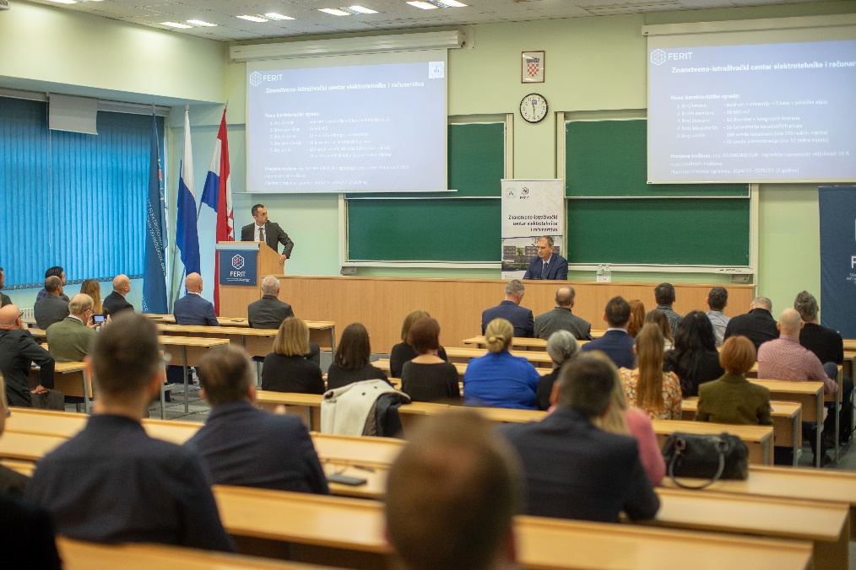

Information disclosure

In the next period, the draft ESMP will be disclosed at the DIGIT’s website for the period of two weeks and during that period the public consultations will be held. After the public consultations, the final version of the ESMP and the Stakeholder Engagement Report will be completed and re-disclosed on the DIGIT's website(https://mzo.gov.hr/istaknute-teme/znanost/digitalne-inovativne-i-zelene-tehnologije-dig-it/5463), including the feedback on the comments and questions received during the process of public consultations.

5.1.3 Additional Stakeholder Engagement Activities

On May 13, 2024 the interview has been conducted in Osijek by PIU Social Specialist with:
- Dean of FERIT;
- Dean of the Agrobiotechnical Faculty;
- -Dean of the Civil Engineering and Architecture;
- Manager of the Students Dormitory;
- Representative of the Osijek Department for Conservation;
- -Representative of the Students’ Council.

The following major topics were discussed with the participants:
- Information about the sub-project;
- Engagement in the process of defining the sub-project and its conceptual and main design;
- Expected benefits;
- Potential issues.

Main conclusions :
- All participants were well informed about the sub-project and were engaged in the process of defining either from structural aspect or by defining its objectives;
- It is expected that the Center will open new opportunities from scientific aspects (research, technological solutions and new technology development projects), educational aspects (better conditions for the students to work on the practical projects and research), but also enable development of specific technology related solutions tailored for the private sector;
- Focus of the discussion on the issues was on the following:
a/ Potential traffic related issues: since the construction site will have its own dedicated entrance directly from the main 4-lanes avenue located by the Campus, it will not disturb in any way the other facilities and regular traffic in the Campus;
b/ Potential dust and noise related issues: it was concluded that the only building which will potentially have the issues with dust and noise is the Faculty of Civil Engineering and Architecture which is located close by the construction site. Other buildings are not very close to the construction site or are even protected from the impacts by the building of the Faculty of Civil Engineering and Architecture (the Agrobiotechnical Faculty and the Students Dormitory). The buildings are quite new and have good ventilation system, so during the heavier construction works which could cause the noise and dust impacts, the windows on the buildings will be closed until the later hours when the works on the construction site will pause at the end of the day. However, it is expected that the contractor should timely provide information on the periods of such heavier construction works, so the faculties and the dormitory could timely prepare the students and dormitory residents with information and suggestions how to avoid potential impacts from the noise and dust in the best possible way. Otherwise, for the students of the Faculty of Civil Engineering and Architecture the closeness of the construction site will be a good opportunity for observing the process and the phases of the building construction, gaining worthful practical experience;
- Additional discussed topic was the archeologic findings at the location of the construction site and potentially also at the access road route. The research on the archaeological findings at the construction site was conducted by the Osijek Department for Conservation and the protection measures were also defined by the Osijek Department for Conservation. It will also monitor the construction works in order to ensure that defined protection measures will be dully respected and implemented. The archaeological research on the access road route has been planned already in the budget of the sub-project, but the next steps still have to be planned and taken in accordance to the protocols of the Osijek Department for Conservation and the Ministry of Culture and Media.

Photos from the site visit:

Position of the construction site in the Campus (the fence before the white building of the Faculty of Civil Engineering and Architecture | 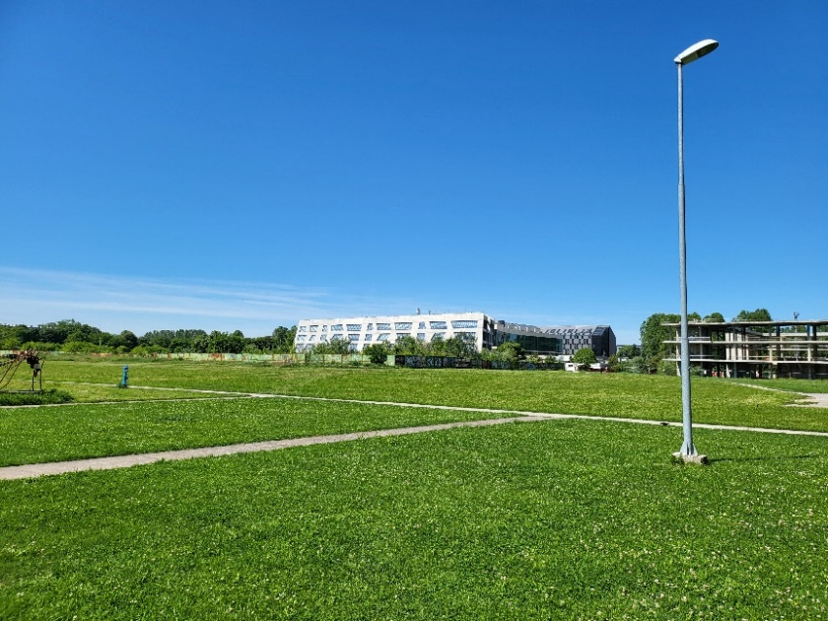
The closest distance of the building of the Faculty of Civil Engineering and Architecture to the construction site (the fence by the passage) | 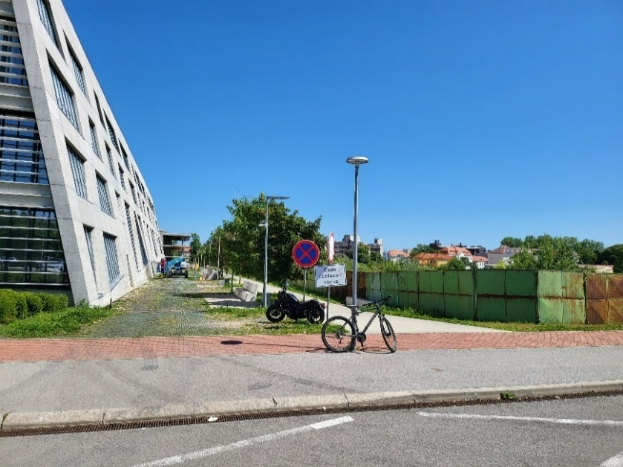
Archaeological findings within the construction site | 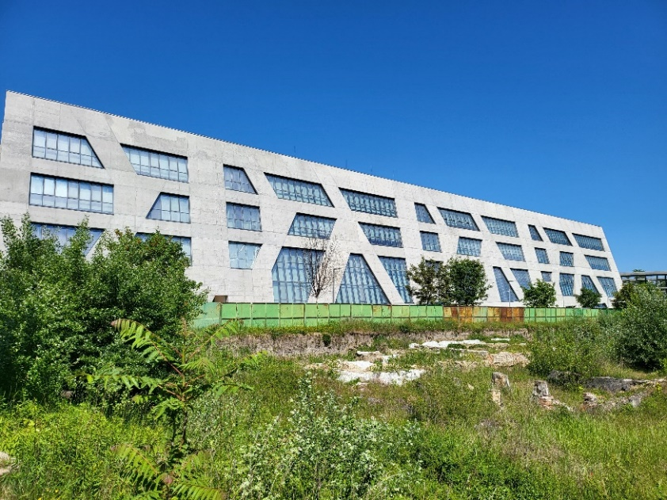
Route of the access road to the construction site | 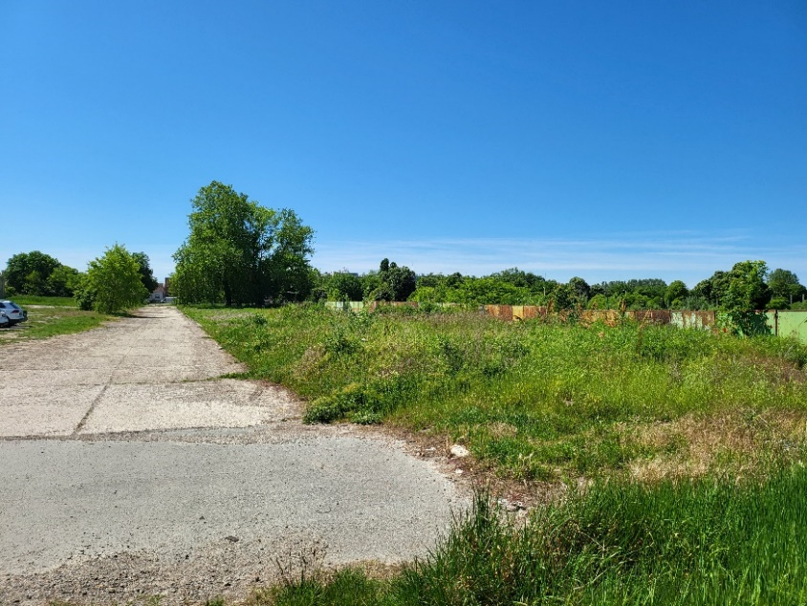
Access/entrance from the nearby avenue directly to the route of the access road | 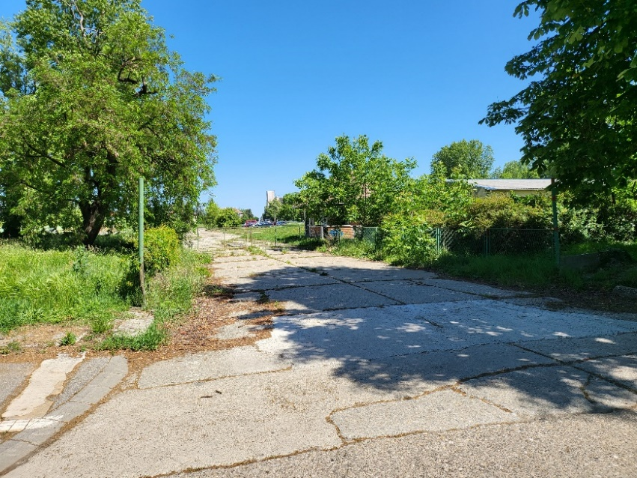
Distance of the nearest residential houses and buildings, looking from the nearest individual house: 1/ the road route of the Bosanska Street; 2/ trees in the green alley; 3/ railway track; | 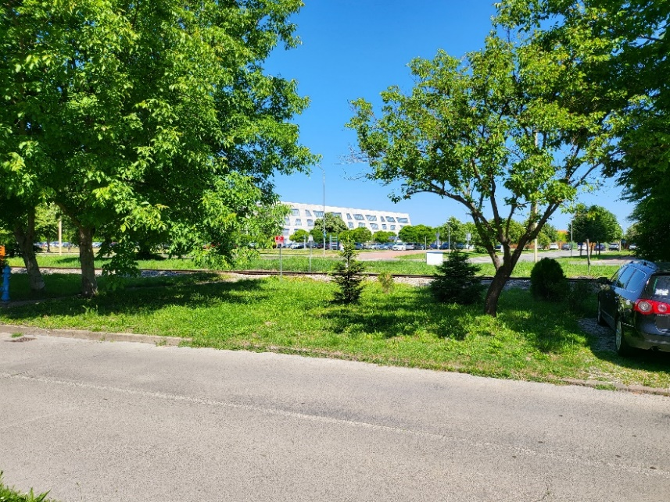
4/ four lanes avenue;  5/ pedestrian sidewalk;  6/ car parking;  7 building of the Faculty of Civil Engineering and Architecture (nearby the location of the construction site). | 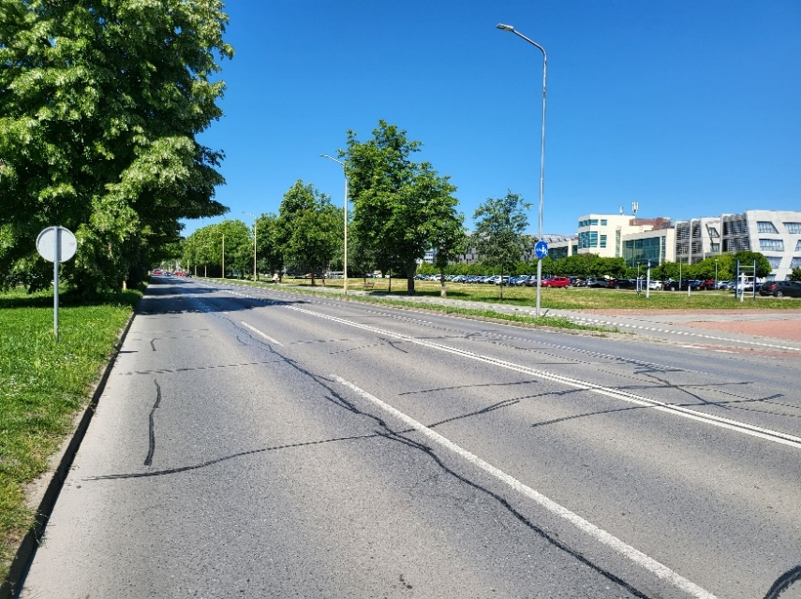
Related to the distance and existing barriers between the construction site and the nearest residential objects, it was concluded that the impacts from the dust and noise could not be significant.

POTENTIAL ENVIRONMENTAL AND SOCIAL RISK, IMPACTS AND MITIGATION MEASURES
Although there are no direct potential environmental and social adverse impacts during design phase, if design documentation is not prepared in accordance with the environmental protection standards and respond to issues raised by stakeholders, implementation of the Sub-Project may cause degradation of certain components of the environmental and environment human health and safety (e.g. life and fire-safety), adversely impact the workers, , users, and the surrounding community as well as cause damage to cultural heritage, in this case invaluable archaeological site.
Main and Detail Design must be in line with WB Environmental and Social Standards, WB EHSG, GIIP, and national legislative requirements described in section 1.4. Policy framework.
Activities during the construction phase within this Sub-Project carry moderate risks typical for all construction works:
- dust and noise emissions;
- traffic disruption;
- generation of large amounts of construction waste;
- unsafe working conditions (e.g. exposure of workers to hazardous materials such as materials containing asbestos);
- poor occupational health and safety practices;
- poor information dissemination and not sharing information on potential impacts (noise, dust and traffic) during the construction works.

Since the planned Sub-Project is located within the archaeological zone “Mursa”, there is also a risk of endangering cultural assets during construction works.
The potential risks and impacts are (i) predictable, (ii) medium in magnitude; (iii) site-specific, and (iv) low to medium probability of serious adverse effects to human health and/or the environment. The risk for Cultural Heritage (CH) given the location features, existing archaeological context and the proximity of works could be expected to be considerable without adequate measures in place; however, given high capacity and efficacy of Cultural Heritage regulatory and institutional framework in Croatia, mandatory requirements and conditions issued by the CH competent authorities, the risk can be accepted as moderate, providing (i) the design guarantees no impact to archaeological findings nor would cause impediment of further conservation excavations, strong and diligent CH (conservation) supervision is in place, as well as wide expert consensus requested by the ESF and proven through public. The construction phase is expected to extend for a total period of twenty (20) months. Main receptors are onsite workers, students and Research Center employees and residents in nearby neighbourhood. Considering work duration, there is an increased risk of negative impact of dust and noise emissions on the surrounding recipients. Despite the above, the Sub-Project’s risks and impacts can be easily mitigated in a predictable manner.
Due to the project characteristics and location, most of the potential risks and impacts are expected during construction phase (moderate), and only low potential risks and impacts during the use phase.
Potential environmental and social risks during use phase are mainly related to:
- waste management;
- increased indoor radon concentration;
- increased noise and deteriorated air quality due to use of the new building;
- vandalism;
- hazardous substances, life and fire-safety (natural gas, hydrogen).
Following the requirements which arise from the ESMF (which adheres to the WB’s ESF, WB EHSG, WHO, national regulation and GIIP), this ESMP has been prepared to analyse in more detailed potential environmental and social risks and impacts of this Sub-Project, as well as to provide appropriate mitigation measures to mitigate the potential impact to the extent possible and to establish an appropriate monitoring program.
From the impacts identification and the evaluation of their significance (described in the following subsections), it results that key mitigation measures that were addressed (during the Main and Detailed Design) are:
- radon reduction measures (problem is analysed through the detailed design and will be addressed also during construction phase);
- waste management measures: design spaces to facilitate future waste flows to reduce the negative impact of waste on the environment and human health;
- measures to provide adequate level of seismic resistance by application of Eurocode 8: Design of structures for earthquake resistance;
- reduction of climate change through design that minimizes use of fossil fuels, maximizes green spaces, and select materials to further reduce risks of creating heat islands.
- greening and re-greening in the way that includes aesthetic as well as biodiversity considerations;
- the Sub-Project has great potential of added values regarding improving microclimatic condition and mitigate heat island effect, adaptation to future increase in temperature due to climate change, biodiversity, energy efficiency, etc. Therefore, enhancement measures were implemented in Main and Detail Design: the building is designed as a nearly zero-energy smart building (nZEB) that has very high energy properties. The building will significantly use energy from renewable sources (RES), which will be produced in and on the building itself. Special attention is paid to the application of passive thermal protection measures. Building management is envisaged by the KNX-EIB smart installation system throughout the facility that will enable general communication and building management, as well as electricity consumption management. The envisaged solar, wind, water and earth energy systems will not only be in the function of electricity and heat generation for the building, but will also serve as a research training ground of the Laboratory for RES, Energy Efficiency and Advanced Microgrids of FERIT:
    - for the use of solar and wind energy (for the production of electricity and hot water): on the roof there will be a photovoltaic system, a system of solar collectors on the roof and wind turbines,
    - for the use of water energy (for the production of electricity): it is envisaged to collect and use roof stormwater to start the turbine - mHE pumping-accumulation hydroelectric power plant.
Energy efficiency and sustainability of construction will also be achieved through the reuse of water (rainwater collection) and planned green roofs and atriums.
Measures and/or procedures for construction phase are meant to be considered and adopted as appropriate by the Contractor (including sub-contractors, good supplier, service provider or others engaged or employed by the Contractor) during the construction phases of the proposed Sub-Project, City of Osijek, and FERIT. They include the key mitigation measures related to ambient and indoor air quality, fire safety measures, measures to prevent the risk of pollution of surface water/ground water/soil due to spill leakage, nature and biodiversity protection measures, excessive noise mitigation measures, as well as general measures related to site organization and OHS, community safety, traffic management measures, measures to avoid endangering cultural property, labor and working conditions and occupational health and safety measures, as well as the risks related to generation of construction and other waste ass described in the Chapter 6.
Distribution of responsibilities and supervision arrangements
Contractor is obliged to implement them, and Supervising Engineer is obliged to supervise their implementation and submit E&S compliance monthly report to E&S Specialists at PIU. The cost of mitigation measures is included in the project cost (contractor cost).
During construction, contractor is obliged to take care that all legally required permits and licenses are kept on site; construction site is organized in a safety way; generated waste is managed properly; emission in the air are minimal (watering the surface, machinery and equipment are switched off when not in use); workers wear appropriate personal protective equipment; etc. Also, contractor will have to ensure that potential impacts on nearby community are prevented or minimized.
Contractor is obliged to ensure that measures for protection of cultural heritage are implemented as stated in the CHMP, carry out works in the way that does not negatively impact the archaeological site and its elements, and organize close supervision of compliance with CHMP and conservation requirements, by a licensed CH conservation expert.
Contractor is also obliged to minimize the labor risk by following the Labor Management Procedures as presented in ESMF , this ESMP and all applicable national laws and by-laws.
Measures and/or procedures during use phase are meant to be considered and adopted as appropriate by the FERIT during the use phase of the proposed Sub-Project. The aim of these mitigation measures is to prevent and reduce the potential negative impacts during use of the Sub-Project on the environmental components to an acceptable level. The measures include, but are not limited to, waste management measures, occupational health and safety and community protection measures, noise reduction measures and measures for storage and use of hazardous substances.
In the following sub-chapters, the impacts of the Sub-Project during construction and use phases are described according to individual environment components and social issues and also measures in design and construction phase are prescribed and measures for the use phase proposed to mitigate these impacts.

Ambient air quality
- POTENTIAL IMPACT
CONSTRUCTION PHASE
Dust emissions and gaseous emissions can adversely affect air quality and cause environmental nuisance to the Sub-Project and surrounding areas.
Fugitive dust and PM will be generated during the construction of the proposed Sub-Project. This will lead to a localized reduction of air quality, which is considered to potentially affect workers on-site and some offsite receptors such as students, employees of the Scientific Research Center and neighbouring residents. The following are the main impacts expected to result from the generation of dust:
- nuisance and disturbance;
- impacts on the health of onsite workers and students, employees of the Scientific Research Center and neighbouring residents;
- increased traffic;
- visual and health disturbances to neighbouring communities.
According to the research, large particles responsible for nuisance dust are most likely deposited within 100 m of the source, while smaller particles can travel up to 1 km. Therefore, most of the dust generated is likely to be deposited within the Sub-Project area. However, there may also be additional dust deposited offsite during material and equipment transport in case of off-road vehicle movement.
Emissions of fugitive dust and PMs will potentially depend on the wind speed and direction and will persist as long as the construction is ongoing. It is expected that dust and PM are expected to increase temporarily during the construction phase. Another contributor to the air quality reduction will be the gas emissions from vehicle-exhaust during site clearing and grading, transport of material and equipment and due to equipment use. These emissions include:
- Sulphur dioxide (SO₂): the amount of SO₂ in exhaust gases is directly dependent on the sulphur content of the used fuel;
- Nitrogen oxides (NOx): NOx emissions from equipment or activities contribute to pollution in the form of acid rain, disturbances of the ozone layer and local health problems;
- Carbon oxide (CO): The release of carbon monoxide (CO) occurs because of incomplete combustion of fuel in engines.
Emissions of exhaust gases are expected to be generated from vehicles, site machinery, and heavy equipment used for construction activities. Heavy equipment such as bulldozers will produce exhaust emissions from diesel engines leading to temporary increase in SOx and NOx concentrations. Exhaust gases will lead to a localized temporary reduction of air quality which will persist as long as the construction activities last. The reduction of air quality is considered to potentially affect workers onsite, students and employees of Scientific Research Center and offsite receptors such as surrounding communities. However, the significance of impacts from the construction activities is expected to be moderate and localized.
USE PHASE
No significant increase in exhaust gases and impacts on the quality of the surrounding air are expected. The planned Sub-Project does not include facilities with emissions of pollutants into the air. Auxiliary energy sources (diesel generators) will be used in the case of power cuts. The exhaust gases will not be significant, however, can present a risk for students, employees and other users of premises and surrounding if the power room is not sealed, does not have adequate ventilation and /or the gases accumulate for any other reasons. The planned design of entire building is in accordance with the principles of energy-efficient and sustainable construction, as the so-called nZEB building, whereby the production of thermal and electrical energy for the needs of the building is partly foreseen using renewable energy sources. All of the above will contribute to reducing the consumption of heat and of electricity from fossil fuel plants, therefore it is expected that the intervention will have an indirect positive effect on air quality.

- MITIGATION MEASURES
DESIGN PHASE
Diesel generator is located in a separate fire sector on the ground floor. The floor of the aggregate area will be made of non-flammable material and impermeable to water and fuel. The aggregate area will have ventilation openings towards the open space with a total size of at least 5% of the floor area.
No other mitigation measures were foreseen in the Main and Detail Design since there are no emissions into the air.
CONSTRUCTION PHASE
Detailed description of mitigation measures is presented in the chapter 9.2.
USE PHASE
Auxiliary diesel generators, ventilation systems, sensors and alarms will regularly be maintained. No mitigation measures were foreseen in the Use Phase since no impact is expected.

Indoor air quality
- IMPACT
CONSTRUCTION PHASE
Although radon can easily migrate from the soil to the surrounding outdoor space, its concentration decreases to the level it does not pose a health risk. Therefore, no impact on human health is expected due to radon emissions during the construction phase.
USE PHASE
Every building has the potential from elevated levels of radon. The risk of getting radon-induced lung cancer increases as exposure to radon increases (either because the radon level is higher or the one lives in home longer). National (and EU) reference level is 300 Bq m⁻ ³. Geogenic radon potential in Osijek-Baranja County is rated as lower average. The radon protection Action plan 2019-2024 is in force in the Republic of Croatia, and all public and social facilities, especially health and educational institutions, during the phase of obtaining a usage permit, must also have a positive test result - the presence of radon in the building under prescribed limits. Radon concentrations in the soil in the area of planned Sub-Project are currently unknown, but testing will be done upon completion of the building. Other potential pollutants typical for use of buildings include PAHs, VOCs (e.g., formaldehyde sources include furniture and cooking), dichloromethane (from solvents), and others.
- MITIGATION MEASURES
DESIGN PHASE
The so-called "passive protection" consisting of installing appropriate films that protect the entire space of buildings, primarily from moisture, and meet the following norms will be sufficient:
- EN 13967:2012 Flexible waterproofing strips -- Plastic and elastomeric strips for protection against moisture and water from the soil -- Definitions and Features (EN 13967:2012)
- EN 13984:2013 Flexible waterproofing strips -- Plastic and elastomeric steampermering tapes -- Definitions and Features (EN 13984:2013)
CONSTRUCTION PHASE
Measurement of radon concentration upon completion of the building - a mandatory result (below the prescribed limits) as a condition for obtaining a use permit.

USE PHASE
The radon-elimination system will be fully functioning as soon as construction is finished. The building shall be tested (indoor air quality monitored) before use. In case passive systems turn out not to be fully functional, they shall be upgraded with active sub-slab or sub-membrane depressurization system, radon drainage, etc. and re-tested until the results are acceptable (below 300 Bq/m³).

Soil
- IMPACT
CONSTRUCTION PHASE
Construction activities may affect soil characteristics. Impacts on soil and land-use may be mainly the result of general site clearance and grading, construction of access roads, excavations, and foundations of buildings.
Due to the construction of the Sub-Project, there will be a permanent loss of the ecological and regulatory function of the soil on the surface of the construction of the building. Given that this is a soil whose function is primarily spatial (urban building land), intended for the development of settlements and infrastructure, as well as the fact that archaeological excavations are currently on the site, permanent loss of the ecological function of the soil, can be considered negligible, restricted to localized areas throughout the construction phase.
Since the building also has an underground floor, there will be deeper excavations of the soil and the creation of excess material from the excavation. Waste soil will be re-used safely as much as possible, the rest of the mineral waste will be deposited on a designated location with an approval from the competent authorities.
USE PHASE
No impact on soil is expected during use phase, providing safety and good housekeeping (including waste management) procedures are adhered to.
- MITIGATION MEASURES
DESIGN PHASE
Geotechnical investigations were carried out and excess soil deposit location has been identified. No mitigation measures were foreseen in the Main and Detail Design since no impacts on soil are expected.
CONSTRUCTION PHASE
Measures to mitigate the risk of soil pollution due to spills or spill leakage:
Proper management of hazardous and non-hazardous liquid waste, proper use of oils and fuels on construction site, prevention of spillage coming from tanks, containers construction equipment and vehicles, adequate response measures in case of an accident etc.
Detailed description of mitigation measures is presented in the chapter 9.2.

USE PHASE
There will be no fuelling or waste dumping at the site. All equipment and devices of thermotechnical and electrical installations that may contain pollutants (e.g. transformer oil in transformation station, diesel generator), are planned indoors or on the building itself, or on impermeable substrates, which prevents their possible reaching the soil and underground.
Tanks containing hazardous substances (diesel, transformation oil) will be protected from weather conditions, on the impermeable floor and equipped with bunds of 110% capacity. End of use waste (oil and fuel contaminated machinery, etc.) will be handed over to a licensed collector and landfilled/processed by a licensed company. In addition to application of Stockholm Convention no other specific soil protection mitigation measures were foreseen for the Use Phase.

Water Quality
- IMPACT
CONSTRUCTION PHASE
Impacts on groundwater and surface water quality during the construction phase may be the result of incidental spills at onsite maintenance locations, which could result in introducing organic matter, hydrocarbons (oils), coliforms or heavy metals to the groundwater aquifer.
Organic or hydrocarbon contamination could increase the biochemical oxygen demand (BOD) load on the groundwater. The nearest watercourse, Drava River, is approximately 350 m away from the planned location of the Sub-Project. The impact is expected to be of localized nature (limited to the project area). Sub-Project is located outside the groundwater protection zones and sanitary protection zones, no decrease in the quality of drinking water for local communities is expected. Planned Sub-Project is located in the sensitive catchment area at the area of groundwater water characterized by intergranular porosity, moderate to elevated vulnerability. Negative impacts on surface water and ground water are expected only in the case of incidental spills. The risk can be categorized as low to moderate (if all mitigation measures are in place).
USE PHASE
Potential pollutants during the use of the Sub-Project can be present in: wastewater (sanitary-fecal, technological and storm water), oils from the substation transformer and diesel generator fuel.
Using the planned wastewater collection and drainage system, under regular conditions of Sub-Project use, pollution due to their discharge is not expected. All equipment and devices of thermotechnical and electrical installations are provided indoors or on the building itself, or on impermeable substrates, which may prevent the maturity of pollutants that these installations may contain (e.g. transformer oil in the transformation station, diesel generator) into the soil and underground. Given all of the above, during the use of the procedure, no negative impact on the condition of water bodies of the Sub-Project is expected.
There is a risk in the case of inadequate waste management and illegal dumping which will be prevented/monitored through system of waste manifests and records.
- MITIGATION MEASURES
DESIGN PHASE
When designing the water supply system and the drainage system, it is necessary to respect the obtained special conditions of the competent authorities (Hrvatske vode VGO za Dunav i Donju Dravu, Vodovod Osijek Ltd.). All wastewaters will be connected to the municipal connection system.
CONSTRUCTION PHASE
Measures to mitigate the risk of pollution of surface water and groundwater due to spill leakage: proper management of liquid waste, proper use of oils and fuels on construction site, prevention of spillage coming from tanks, containers construction equipment and vehicles, adequate response measures in case of an accident, isolation of wash down areas of concrete and other equipment from watercourses, forbid groundwater extraction on unregulated way, forbid discharge of contaminated waters into the ground od streams or rivers etc.
Detailed description of mitigation measures is presented in the chapter 9.2.
USE PHASE
It is necessary to ensure that the composition of sanitary, industrial and precipitation wastewater before discharge into the public drainage system of the Osijek is in accordance with the limit values of wastewater emissions prescribed by the Ordinance on wastewater emission limit values (OG 26/29). There will be no fuelling or waste dumping at the site. All equipment and devices of thermotechnical and electrical installations that may contain pollutants (e.g. transformer oil in transformation station, diesel generator), are planned indoors or on the building itself, or on impermeable substrates, which prevents their possible reaching the soil and underground.
Tanks containing hazardous substances (diesel, transformation oil) will be protected from weather conditions, on the impermeable floor and equipped with bunds of 110% capacity.

Vulnerability of Sub-Project to the floods
- IMPACT
Since the Sub-Project is located outside the flooding areas the Sub-Project is not vulnerable to the floods. However, it can be prone to localized flooding int the case of heavy rains. This will be addressed though connection of all surface runoff collection systems to the municipal rainwater collection systems.

- MITIGATION MEASURES
No mitigation measures were foreseen since the Sub-Project is not vulnerable to the floods. Localized flooding will be prevented thought adequately designed and sized collection of surface runoff.

Biodiversity, Nature Protection Areas and Natura 2000
- IMPACT
DESIGN and CONSTRUCTION PHASE
Sub-Project is planned in an area under strong anthropogenic influence (habitat type J. Built and industrial habitats), within the existing building plot of the University Campus where ruderal vegetation and archaeological excavations prevail. Therefore, the impacts on biodiversity during the construction of the Sub-Project in the form of habitat loss, possible damage to dwellings and/or the suffering of individuals of smaller species of animals using the area, and changes in habitat conditions, can be considered negligible. During the construction work, it is possible to enter and/or spread invasive plant species due to human movement and mechanization. For the horticultural design, native vegetation, bushes and trees that are bees and bird friendly etc. will be selected.
The site is located in the area of the Mura-Drava-Danube Transboundary Biosphere Reserve declared by UNESCO as part of the Man and the Biosphere (MaB) Program, in the transition area, which consists of predominantly populated areas where educational activities are carried out and sustainable development is promoted as part of economic development.
Since the planned Sub-Project is located outside the nature protected areas and Natura 2000 sites (the nearest protected area is located at a distance of about 320 m and the nearest area of the ecological network is located at a distance of about 330 m from the Sub-Project) no impact on nature protection areas nor Natura 2000 sites are expected. Due to the archaeological excavation around the project site, construction activities are not expected to impact biodiversity.
USE PHASE
Panels of solar power plants can cause the so-called "lake effect" which implies the appearance of a water surface due to the reflection of light from the panels. In order to reduce this impact, Anti Reflective Coatings on the panels will be used.
Also, the use of wind farms in general can lead to injury and death of birds and bats due to collisions with turbine propellers. Wind turbines planned to be installed on the roof of the building represent a small-scale vertical-axis wind turbines with a nominal power of up to 500W each. Turbines are placed in a cluster with proper horizontal spacing, meaning larger power can be generated despite their small height of around 3 m and diameter of only a few meters. These features result in a very low impact on the environment and people in the surroundings. Small-scale turbines are necessary for conducting scientific research on the adequacy of this technology for urban areas with lower wind speeds.
It is also important to consider that the planned Sub-project is located in a city area where there is already a strong anthropogenic impact (in the form of disturbance, and lack of favorable habitat for nesting and / or feeding), which is why intensive activity of bird and bat fauna, especially species that would be sensitive to this impact, is not expected at the site.
Study of the need for environmental impact assessment, prepared by the certified company,
Also, the conclusion of the study, Study of the need for environmental impact assessment, prepared by the certified company, is that the use of wind farms and solar panels will not have a significant negative impact on the integrity and preservation of biodiversity.
Considering all the above, it is estimated that this impact is not significant.

- MITIGATION MEASURES
DESIGN PHASE
For the horticultural design, native vegetation, bushes and trees that are bees and bird friendly etc. will be selected. Anti Reflective Coatings on the panels will be used. Anti Reflective Coatings on the panels will be used to reduce the so called “lake effect”.
CONSTRUCTION PHASE
Measures to mitigate the risk of endangering flora and fauna:
Movement restriction of heavy machinery to the access road corridor, avoiding cutting down trees and other natural vegetation where possible, using autochthonous plant species for the landscape management.
Before recommencing works, check the area for the wildlife. If any found, competent authorities shall be notified. There will be no disturbance of animals. Setting fires will be strictly prohibited.
Detailed description of mitigation measures is presented in the chapter 9.2.
USE PHASE
Impacts to birds and bats will be monitored by logging in turbine caused deaths, for one year. The monitoring will be carried out by a third party – e.g. Biology Department, Osijek University or a prominent NGO and reported to the Ministry of Economy and Sustainable Development, Nature Protection Directorate. The Ministry will prescribe further protection measures, if needed. If no impact is recorded within the set timeframe, the monitoring can stop. The monitoring plan must be prepared, subject to the WB approval before completion of works. Turbines start with the delay when the wind speed at dusk or during the night is favourable for bats foraging.

Noise exposure
- IMPACT
CONSTRUCTION PHASE
Noise is an unavoidable environmental and social impact during construction works. It occurs during the operation of machines and equipment at the site (mainly in the processes like transport, loading/unloading machinery etc.). This impact will be limited to the location of the site and the narrower area around the site and will cease after completion of foreseen works (20 months).
Permissible noise level for the construction site is determined by the provisions of the Ordinance on the maximum allowed noise levels in the environment in which people work and live (OG 143/21) and amounts 65dB. According to the mentioned ordinance, it is allowed to exceed that level for an additional 5 dB in the period from 8 to 18 hours. The equivalent noise level of the construction site in the open or closed part of the building during the night time at the most exposed place of sound immission must not exceed 45 dB for the mixed predominantly residential area. According to aforementioned Ordinance exceeding the permissible noise levels is allowed if necessary for the technological process of the construction site for up to three (3) nights within a consecutive period of thirty (30) days. A minimum of two full night periods shall be provided between periods when exceeding allowable noise levels is anticipated without exceeding allowable noise levels during the night period.
It is expected that increased noise levels will be local – the students, professors and employees at the Faculty for Civil Engineering and Architecture will be directly affected as the nearest building, while the residents in the nearby areas (Bosanska and Zagorska Streets) and the students and employees in the nearby Student Dormitory will not be affected in any significant way (Student Dormitory is located at a distance of 300 m from the planned Sub-Project on the west side, behind the Faculty of Civil Engineering and Architecture). Due to the fact that duration of construction works are planned for period of 20 month the impact is considered moderate.
USE PHASE
Expected impact during use of the new building of Scientific Research Center include increase of noise level due to building infrastructure. Devices for the production of electricity and heat (heat pumps, small hydroelectric power plants) are planned indoors of the building, and do not cause noise emission into the environment.
Wind turbines are foreseen on the roof, which, given the very small number and low power, were estimated not to significantly contribute to increasing existing noise levels in the environment. Noise sources can also be represented by HAC systems (heating, ventilation and cooling). The building plans to use other equipment and devices that may represent sources of noise (e.g. diesel generator), but since they are intended indoors, they do not cause noise emission into the environment.

- MITIGATION MEASURES
DESIGN PHASE
No noise protection measures need to be designed.
CONSTRUCTION PHASE
Mechanisms available to monitor potential impacts and introduce mitigation measures in a timely manner will be used. The Sub-Project-affected parties will be adequately informed about the Sub-Project and contractors’ GRM. It will be ensured that the GRMs are functional. The Sub-Project-affected parties will be kept informed about construction schedules, progress, and safety precautions. It is necessary to choose and apply adequate noise protection measures: adjustment of operating time; use of temporary movable noise barriers; use of alternative working machines with lower noise emission levels.
USE PHASE
Exceeding the permissible noise values is not expected, therefore no measures are necessary. In case that generated noise levels exceed the maximum permitted noise levels (monitoring in the case of complaints), it is necessary to choose and apply adequate noise protection measures (design of noise barriers around major noise sources).

Vibration
- IMPACT
CONSTRUCTION PHASE
Since the project does not foresee activities that could affect the stability of the surrounding area, there is no risk of endangering the stability of the surrounding buildings.
Vibration from operation of the equipment/vehicles can affect workers at the site (especially workers in operating machines and equipment). It is expected that potential impact from vibration during construction will be local – students, employees, visitors and residents in nearby area will be affected. There is a risk of vibration effect on the stability of the archaeological site. By following the prescribed measures for the protection of archaeological site (e.g. manual excavation near the archaeological findings), impact can be reduced to minimum.
Due to that the impact is considered low.

- MITIGATION MEASURES
CONSTRUCTION PHASE
Before construction, it is necessary to clean the area from vegetation and replace the worn-out protection of the finds. It is also necessary to protect the remaining walls, foundations, pedestals and rooms with flooring and mosaic with a new layer of geotextile and sand, and cover everything with wooden formwork. If heavy machinery and mechanization are used in the construction zone, it is necessary to protect the archaeological finds additionally with steel plates in order to protect archaeological finds due to pressure. For the construction of the foundation slab, part of the excavation next to the archaeological excavations will be protected with steel sheet piles. An embankment of coarse-grained stone material fraction 0-32 mm, 30 cm thick will be constructed over the archaeological excavations in order to preserve archaeological excavations. After construction, the findings will be cleaned and secured/protected as elaborated in the chapter 2.4.
During the execution of the works, GRM will be available to submit complaints.

Traffic
- IMPACT
CONSTRUCTION PHASE
Delivery of construction materials and equipment to the construction site will be by road transport. The transportation of material and equipment to the construction sites will cause a temporary increase in traffic along the roads, also outside the project area. Access to the plot is provided through the Vladimir Prelog Street and Lavoslav Ružička Street. All activities of Sub-Project construction will be carried out in a way they do not endanger the safety and normal flow of traffic on the surrounding roads. Given all of the above, the impact on traffic during the construction of the project can be considered acceptable.

USE PHASE
The realization of the Sub-Project will improve the transport infrastructure at the local level, and increase frequency of traffic is possible. As part of the Sub-Project, a extension (planned by spatial planning documentation) of the corridor will be built: a new Andrija Mohorovičić Street with an appropriate number of parking spaces, a double-sided avenue and a bicycle path. The trail will continue on the existing cycling infrastructure and thus enable safer traffic, whereby quality cycling infrastructure can contribute to more cyclists, i.e. reduce the use of other means of transport. Furthermore, it is planned to install a charging station for electric bicycles on the building plot of the Scientific Research Center,

- MITIGATION MEASURES
DESIGN PHASE
Part of the design is charging stations for electrical bikes as well as sheltered parking space for bicycles.

CONSTRUCTION PHASE
Mitigation measures include adequate organization of temporary traffic arrangements to improve signage, visibility and overall safety of roads (enabling the safe and unhindered movement of students), timely information dissemination through media and placing of the signs and warnings at the scene of construction works. Adequate organization of temporary traffic arrangements must be performed according to Ordinance on Temporary Traffic Regulation and Signing and Safety of Road Works (OG 92/19).
USE PHASE
No mitigation measures are foreseen in the use phase.

Cultural Heritage
- IMPACT
CONSTRUCTION PHASE
Archaeological research at the location of the planned building has been completed, and the archaeological findings have been fully recorded and documented. By considering all the prescribed protection measures mentioned in the next chapter, the negative impact of construction works on the preservation of archaeological finds can be minimized. Archaeological research on the unexplored part of the road will be carried out before the start of work on the access road. Detail overview is available in the chapter 2.4.
Supervision of archaeological conservation measures implementation include (i) supervision of works by designated conservationist from the competent authority – Ministry of Culture and Media, Directorate for the Protection of Cultural Heritage, Osijek Department for Conservation, (ii) Conservationist engaged by Supervising Engineer (daily present at the site during earthworks, and construction of basement and ground floor as well as other potentially risky works).

USE PHASE
Conservation guidelines stipulated for all three archaeological objects that it is necessary to enable their full visibility through presentation in situ, which is foreseen by the planned intervention. Archaeological sites and their presentation thus largely determined the location of the newly planned building on the plot, as well as the disaggregation of the volume of the building. This resulted in the partial elevation of the building on the northwest side and the presentation of archaeological excavations located on the plot. Project of Conservation, Restoration and Presentation of the Archaeological site "Mursa" was also developed as a part of the project (please see chapter 2.6). All of the above will have a positive impact on the protection and preservation of this protected cultural property, and will also contribute to its popularization by making it accessible and visible to all visitors.
Risks during the use phase that can negatively affect the preservation of archaeological finds are natural disasters (floods, earthquakes), vandalism, building dismantling etc.

- MITIGATION MEASURES

DESIGN AND CONSTRUCTION PHASE
Project of Conservation, Restoration and Presentation of the Archaeological site "Mursa" was developed containing all measures necessary for ensuring adequate protection of archaeological objects.
The Sub-Project is fully designed in accordance with the prescribed protection measures from the Conservation Guidelines and Conservation, Restoration and Presentation Project of the archaeological site "Mursa".
Construction in the basement and ground floors of the Scientific Research Center building is not foreseen at the positions of archaeological objects, which ensures that the integrity of archaeological objects is not endangered during the realization of the Sub-Project.
Foundation
- the basic rates will be made of on reinforced concrete pilots because of the large forces they are absorbing and because of the impossibility of dimensional extensions due to archaeological excavations;
- for the construction of the foundation slab, part of the excavation next to the archaeological excavations will be protected with steel sheet piles, while the foundation footsteps of the pillars of the building with associated reinforced concrete piles will be carefully carried out between archaeological excavations, all in order to prevent devastation and preservation of excavations;
- in order to preserve archaeological excavations and enable the execution of works on the construction of reinforced concrete piles of foundation feet, an embankment of coarse-grained stone material fraction 0-32 mm, 30 cm thick will be constructed over the archaeological excavations;
- after the execution of the pile, it will be necessary to remove all the bulk material and access the excavations for the foundation feet of the pillars of structures;
- excavations in the zone of archaeological protection/findings need to be carried out carefully, with machine and manual excavation (as decided and requested by the competent authority – Designated Conservationist from Ministry of Culture and Media);
- it will be necessary to provide for continuous pumping of groundwater in order for the works to be carried out in dry land.

Protective measures for public and residential objects presented in situ
- the objects for archaeological presentation are protected by geotextile, and the flooring and mosaic with an additional layer of geotextile and poured sand;
- before construction, it is necessary to clean the area from vegetation and replace the worn-out protection of the finds;
- it is also necessary to protect the remaining walls, foundations, pedestals and rooms with flooring and mosaic with a new layer of geotextile and sand, and cover everything with wooden formwork;
- if heavy machinery and mechanization are used in the construction zone, it is necessary to protect the archaeological finds additionally with steel plates in order to protect archaeological finds due to pressure;
- on the surface intended for the construction and/or foundation of modern columns or piles, it is necessary to manually decompose archaeological structures directly threatened by the construction;
- it is expected that small quantities of previously damaged/decomposed archaeological material (brick, stone) will be excavated during works. In line with CH competent authority requests and conservation guidelines, it is necessary to provide adequate storage space as it will be used for further conservation and restoration of the finds;
- constant archaeological supervision and documentation will be ensured (archaeological supervision is prescribed by law – Designated Conservationist from the Ministry of Culture and Media, as well as the Conservationist engaged by Supervising Engineer).

Protective measures for original archaeological finds presented in situ within archaeological niches
- archaeological niches will be accessible to visitors, and mosaic in the archaeological niche of Object 5 will be protected from precipitation, endangerment and devastation;
- archaeological niche of Object 5 will be partially restored and / or reconstructed (with materials excavated during construction);
- reinforced concrete retaining walls of niches are floor-plan designed in the form of a circle, statically optimal shape for creating niches inside the ground;
- the perimeter supporting reinforced concrete wall inside the niches provides niches from the collapse of the surrounding landscaped terrain.

Protective measures for part of the western walls and the western city gate
- before construction, it is necessary to geodetically position the researched archaeological findings of a part of the western wall and the western city gate in order to perform a parterre presentation with a different material.
The conservation measures are elaborated in more detail in the Chapter 2.4.
USE PHASE
Plan for protection from vandalism, flooding and preservation in the dismantling phase will be prepared before the issuance of the use permit. The plan will be a subject to WB approval, and may include measures such as installation of security cameras, fences, and other security actions.

Land acquisition
- IMPACT
No land acquisition is expected for the Scientific Research Center for Electrical Engineering and Computer Science Sub-Project.

- MITIGATION MEASURES
No mitigation measures were foreseen since no land acquisition is expected for the Scientific Research Center for Electrical Engineering and Computer Science Sub-Project.

Labor and Working Conditions and Occupational Health and Safety
- IMPACT

CONSTRUCTION PHASE
The Labor Management Procedures (LMP) are prepared as part of ESMF.
Contracted and subcontracted workers will have access to a grievance mechanism. At this stage the exact number of workers is unknown, and it will be known when implementation of Sub-Project begins. Although contractors and workers employed in construction activities are likely to be locally based, there is a potential of labor influx, and contractor may engage migrant workers (local from outside the area or foreigners) subject to meeting national requirements for work permit or a work registration certificate.
Regarding the potential labor risks, they are in detail described in Labor Management Procedures within the ESMF, and here are conclusions:
- no instances of child or forced labor are likely to happen under the project as legislation on employment and labor are fully harmonized with the International Labor Organization (ILO) conventions (particularly ILO Forced Labor Convention No. 29 ratified by the Republic of Croatia) and the European Union Directives inclusive of convention on forced labor and convention on elimination of child labor and protection of children and young persons. Therefore, people under the age of 14 will not be employed under the Project;
- Project activities do not involve activities that have a high potential for harming people or the environment;
- since construction works are of small to medium-scale, there is low risk related to gender-based violence (GBV) including SEA/SH. Deployment of security forces is not envisaged.

Potential risks in the construction phase involve general occupational health and safety hazards such as:
- working at height;
- electrocutions and electrical works;
- traffic accidents;
- lifting of heavy structures;
- accidents with exposed rebars;
- exposure to construction airborne agents (dust, etc.);
- ergonomic hazards during construction;
- vibration of heavy construction equipment;
- use of rotating and moving equipment, using heavy machinery;
- noise exposure;
- lack of workers’ awareness on occupational health and safety requirements such as the use of personal protective equipment (PPE) and safe workplace practices;
- exposure to hazardous substances (e.g. paints, varnishes, asbestos);
- working with heavy and dangerous machinery;
- working around pits, ditches, stacked materials, traffic, loading and unloading, etc.;
- seismic active area;
- risk of disease spreading.
Site personnel may experience heat stress (heat rush, cramps, heat exhaustion, heat stroke, etc.) due to a combination of elevated ambient temperatures and the concurrent use of PPE. This will largely depend on the type of work and the time of year. In addition, overexposure to UV radiation in sunlight can result in sunburn to exposed skin. Similarly, storms, strong wind, and other extreme weather conditions pose a risk. There is a risk of increased number of mosquitoes during the summer, but malaria or significant outbreak of other mosquito-borne diseases has not been recorded.
Potential risks regarding labour influx related to:
- language barriers;
- different attitudes of foreign workers toward safety and risk perception, absence or low skills for certain types of works that can lead to accidents (H&S risks);
- exploitation and unfair treatment – contractual arrangements (unfair wages, excessive working hours, working in unsafe conditions, inadequate accommodation);
- integration in community: risks and impact on community related to foreign workers due to difficulty of their integration into community (e.g., the feelings of anxiety and fear for unsafe environment among the local residents when there are foreign workers living in the same building or in vicinity);
- potential cases of discrimination of foreign workers at the working place and within the community.

USE PHASE
Labor and working conditions and occupational health and safety include to hazardous materials/waste, and life and fire safety.

- MITIGATION MEASURES
DESIGN PHASE
Measures to reduce exposure to hazardous materials/waste are included in the waste management measures described in section. 6.2.14. Furthermore, related to the fire safety measures, all new buildings accessible to the public shall be designed, constructed, and operated in full compliance with local building codes, local fire department requirements and national (EU compliant) regulations, local legal/insurance requirements, and in accordance with an internationally accepted life and fire safety (L&FS) standard (in the absence of Croatian regulations for a specific area). Recognized rules of technical practice are (Österreichisches Institut für Bautechnik OIB, British Standard (BS), National Fire Protection Association (NFPA). Project sponsors’ architects and professional consulting engineers should demonstrate that the building meets these life and fire safety objectives. Life and fire safety systems and equipment should be designed and installed using appropriate prescriptive standards and/or performance-based design, and sound engineering practices.

CONSTRUCTION PHASE
Mitigation measures for occupational health and safety risks:
- measures related to workers safety (defined in Safety at Work Plan, Fire Safety Plan and Emergency Preparedness and Response Plan prepared by the contractor as a part of the Management Strategies and Implementation Plans (MSIPs), WB EHSG and GIIP, aligned with the material objectives of ESS2);
- measures to address discrimination against women/vulnerable groups in the hiring process of workers;
- measures to address risk associated with labor influx;
- measures to prevent Sexual Exploitation and Abuse (SEA)/ Sexual Harassment (SH).
Detailed description of mitigation measures is presented in the Mitigation plan and chapter 9.2.

Community Health and Safety
- IMPACT
DESIGN PHASE
Fire Protection Study was carried out by a licensed fire safety expert. The fire protection measures described in chapter 2.3.7. will be applied.
CONSTRUCTION PHASE
Regarding community health and safety, several factors from the previous subheadings were identified that could affect community health and safety. Based on the analysis of each of these factors in the previous separate chapters, it is concluded that the construction work will have small to medium impact on the health and safety of the community.
Civil works may cause disruptions to nearby communities and in the University Campus (for duration period of 20 months) such as: increased levels of dust, emissions to air, noise and vibrations or temporary disruptions to traffic, risk of road accidents for pedestrians, disruptions in utility services due to accidents or planned interventions (water, gas, electricity) and poor occupational health and safety practices.
The emissions from construction activities (emissions from excavation equipment, other machinery and construction traffic, etc.) can deteriorate the ambient air quality and affect health of sensitive receptors.
Noise pollution produced by vehicular movement, excavation and other construction machinery, concrete mixing, and other construction activities can have negative impact on the narrower area around the site due to the long duration of construction works and due to the vicinity of certain receptors (e.g. dormitory, faculties, the old military facility which is used for exhibitions on the northeast side).
One of the key potential risks associated with the construction works is the increased risk of road accidents due to increased traffic of construction vehicles.
Furthermore, the project area is prone to earthquakes which poses the risk of accidents, for workers and community, if earthquake occurs (e.g., demolition of a crane or other machinery). However, by properly organized construction site and applying defined protocols and standards this risk will be minimized.
The risk of exposure of the community to hazardous materials is limited. Management of hazardous materials, including hazardous waste, is related to construction activities and is short-term (finite duration of the construction activities). This risk will be mitigated in accordance with national labor and OHS policies, and relevant WB policies as well as adhering to appropriate measures.
Given the growing presence of foreign construction labor in the RoC, we can expect foreign workers from neighbouring countries as well as workers from further afield. During construction, due to potential labor influx, there is a risk of a potential sexual exploitation and abuse and sexual harassment within the community and/or creation of concern among local residents. Although the risk exists, it is considered small.

USE PHASE
Regarding the health of the local community, no significant impacts on the quality of the surrounding air are expected.
Also, no impacts on the soil are expected. Likewise no impact is expected on water quality nor on biological diversity, protected nature areas and Natura 2000 areas. The use of diesel generators results in the emission of CO₂ and CO, but with the observance of all legally prescribed protective measures as well as CO₂ and CO sensors, design of ventilation and position of the exhaust pipe, during use and the use of the generator only as a backup power source, the impact can be considered negligible.
The impact from wind turbines (flickering) is considered low due to the small dimensions of turbines, and distance from surrounding buildings. However, impact will be checked in the pre-use phase and corrective measures (e.g. repositioning) will be implemented if needed, also upon complaints.
Regarding the safety of the local community, no significant impacts are expected.
The Sub-Project is not located in a flooding area. The increase in traffic could threaten the safety of the local community due to the increase in the number of cars.

- MITGATION MEASURES
DESIGN PHASE
No additional measures were foreseen.

CONSTRUCTION PHASE
By properly organizing construction site and applying defined protocols and standards risk will be minimized. Waste management must in line with the national legislation and WB policies.
During construction, due to potential labor influx application of adequate labor management procedures has to be envisage presents to prevent any potential sexual exploitation and abuse and sexual harassment within the community and/or creation of concern among local residents. Contractor will be required to prepare and enforce a Code of Conduct for Workers. Also, GRM project mechanism is available.
As such, negative impacts relating to the presence of non-local and migrant workers within the community are unlikely to occur.
Mitigation measures for other risk related to community health and safety are analyzed in sub-chapters above (increased levels of noise, dust, or temporary disruptions to traffic, risk of road accidents for pedestrians, disruptions in utility services due to accidents or planned interventions (water, gas, electricity) and poor occupational health and safety practices).

USE PHASE
Risk assessment and Operational plan of legal entities that perform activities using dangerous substances will be developed according to Law on the civil protection system (NN 82/15, 118/18, 31/20, 20/21, 114/22). In the case of complaints regarding noise or flickering from the wind turbines or any other devices, FERIT will carry out monitoring based on which corrective measures will be tailored and executed.

Waste Management
- IMPACT
CONSTRUCTION PHASE
Mainly waste types from the following waste groups are expected to occur:
- group 08 - wastes from the manufacture, formulation, supply and use of coatings (paints, varnishes and vitreous enamels), adhesives, sealants and printing inks;
- group 17 - construction and demolition wastes (including excavated soil from contaminated sites);;
- group 13 - oil wastes and wastes of liquid fuels (except edible oils, and those in chapters 05, 12 and 19 of waste catalogue);
- group 15 - waste packaging; absorbents, wiping cloths, filter materials and protective clothing not otherwise specified;
- group 20 - municipal wastes (household waste and similar commercial, industrial and institutional wastes) including separately collected fractions (paper, plastics, glass, food waste etc.).
During the construction works, asbestos waste can occur (in the building planned to be demolished).
In the case weakly bound asbestos (insulating materials) would be found during demolition, Waste Management Plan will be prepared based on disposal measures prescribed by the Croatian law (Rulebook on construction waste and waste containing asbestos (OG 69/16), Instructions on handling waste containing asbestos (OG 89/08) and the Waste Management Act (OG 84/21)), and WB EHSG and GIIP will be applied, stricter ones prevailing. The Plan is a subject to WB approval.

USE PHASE
In the basement of the Science Research Center building, a room for collecting separate municipal and useful waste is provided. For the purpose of waste collection, the premises are provided with vehicular access from Andrija Mohorovičić Street. On each floor there are adequate places for sorting, collecting and recycling waste. The planned Sub-Project is expected to generate several groups of waste, including hazardous (marked with *) during use phase:
- group 13 - oil wastes and wastes of liquid fuels (except edible oils, and those in chapters 05, 12 and 19);
- group 15 - waste packaging; absorbents, wiping cloths, filter materials and protective clothing not otherwise specified;
- group 16 - waste not specified elsewhere (waste from electrical and electronic equipment);
- group 20 - municipal wastes (household waste and similar commercial, industrial and institutional wastes) including separately collected fractions (paper, plastics, glass, food waste, discarded electrical and electronic equipment etc.).

- MITGATION MEASURES
DESIGN PHASE
- A separate area was designed for separate collection of waste.
CONSTRUCTION PHASE
Waste Management Plan that defines waste management procedures at the construction site for each category of waste generated during construction, method and place of storage of individual categories of waste will be prepared by the Contractor.
Each type of generated waste on the location must be temporarily stored in separate waste containers which have to be labelled with waste type name and waste code. All waste, including construction waste, asbestos waste, soil, must be disposed exclusively at the licensed construction waste landfills and processing plants. Whenever feasible the contractor shall reuse and recycle appropriate and viable materials. Burning or illegal dumping of waste is strictly prohibited. Records (waste manifests, landfill/processing receipts, etc.) will be kept and checked.
Work and handling with asbestos must be performed by a licensed Contractor with appropriate qualifications and experiences and with not-defaulted proven past performance references, adequate tools and protection for the safe removal of asbestos cover. The same will apply for weakly bound asbestos.
All works with asbestos must be in line with Asbestos Removal and Management Plan. Plan includes procedures for removing materials containing strongly and weakly bound asbestos all according to Ordinance on the protection of workers from risk related to exposure to asbestos (OG 40/7), Rulebook on construction waste and waste containing asbestos (OG 69/16), Instructions on handling waste containing asbestos (OG 89/2008) and the Law on waste management (OG 84/21), WB EHSG, GIIP).
USE PHASE
Scientific Research Center must ensure separate collection of waste at the place of origin, keep records, store waste in appropriate containers and temporarily store waste in a specially separated area until processing or until handing over to an authorized person.

Positive social impacts
With the realization of the Sub-Project, a number of positive impacts on the community are expected, through the development of excellence and innovation in the field of electrical engineering and computing with the aim of achieving competitiveness of small and medium-sized enterprises, and assistance to the knowledge-based economy.

By building the Scientific Research Center, researchers will be provided with quality access to knowledge, exchange of scientific information, creation of databases and technological solutions, and provide space for various events (congresses, lectures, seminars, etc.) where the exchange and transfer of knowledge will take place.
The scientific infrastructure of the Scientific Research Center will also be used to improve the quality of studies, especially graduate and postgraduate studies, with students having access to top-notch equipment and the latest scientific knowledge.
It is expected that the Scientific Research Center will integrate into the scientific community, but also that it will be open to the community for the purpose of presentation / popularization of science, and that it will become a focal place for various scientific events at the University, in the City of Osijek and the entire region.
Through green mobility and through the very concept of the building as nZEB, the Sub-Project supports and promotes a sustainable lifestyle. By arranging the green areas around the building, but also on the building itself (roof garden, atrium), the Sub-Project will contribute to improving the microclimate and ecological value of the urban landscape, and strengthening the green infrastructure system of the city by connecting to the existing city greenery.

INSTITUTIONAL ARRANGEMENT
To ensure the effective implementation of this ESMP, there is need for clear roles, responsibility and reporting procedure by various institutions. As part of the environmental and social management, MSEY must ensure that this ESMP is part and parcel of the contract documents for the construction works on the Scientific Research Center of Faculty of Electrical Engineering and Computer Science III Sub-Project.

The Ministry of Science and Education, through the Project Implementation Unit (PIU) will have the responsibility to ensure that the ESMP and the monitoring plan are implemented. They must ensure that all stakeholders (the Contractor, sub-contractors, goods supplier, service provider or others engaged or employed by the Contractor), are familiar with the contents of the ESMP and their roles, that they understand and adopt ESMP, that resources are available and key staff for implementing the activities are adequately trained.
Contractor will be required to develop Environmental and Social Management Strategies and Implementation Plans (ES-MSIP) to manage the following key Environmental and Social (ES) risks if awarded the contract:
Waste Management Plan
- defines waste management procedures at the construction site for each category of waste generated during construction, method and place of storage of individual categories of waste.
Asbestos Removal and Management Plan
- defines procedures for removing materials containing asbestos before proceeding with the removal of the building structures, describes application of necessary measures to protect workers health and safety, all according to Ordinance on the protection of workers from risk related to exposure to asbestos (OG 40/7) and Rulebook on construction waste and waste containing asbestos (OG 69/16).).
Plan for establishing Grievance Redress Mechanism (GRM)
- describes action for planning the establishment of protocols for receiving and resolving complaints and managing incidents and accidents, internal (within the contractor's company) and external (receiving and resolving complaints from the community). GRM should ensure special referral pathways for grievances on GBV and SEA/SH.
Safety at Work Plan
- measures to reduce health hazards and to ensure safety at work during the execution of works according to Ordinance on occupational safety at temporary construction sites (OG 048/2018), WB EHSG and GIIP);
- includes Occupational Health an Safety (OHS) measures during the execution of construction works, accommodation conditions, food and transportation of workers, sanitary facilities and wardrobe, organization of first aid, personal protective equipment, workplaces with special working conditions and medical examination of workers, training of workers in occupational safety, safety measures in the work of subcontractors.
Emergency Preparedness and Response Plan
- actions that must be taken to ensure staff safety in an emergency (spills, accidents, fire, explosion, earthquake…), including a list of all emergency equipment at the construction site (such as fire extinguishing systems, spill control equipment, communications), and alarm systems (internal and external), and decontamination equipment, contacts of responsible persons, competent authorities, other emergency numbers, communication procedures and evacuation plan.

Fire Safety Plan
- includes a list of major workplace fire hazards, their proper handling and storage procedures, potential ignition sources and control procedures, and a description of fire protection, trainings documentation, equipment, and systems, as well as maintenance and plans for safety drills.
These MSIPs collectively comprise the Contractor’s Environmental and Social Management Plan (C-ESMP). Contractor ESMP (C-ESMP) will be developed and continuously updated (minimum every 6 months) to enable implementation of mitigation measures.

In addition to regular activities of professional supervision of construction, the activities of Site Supervising Engineers will also include:
- regular monitoring and assessment of measures to prevent and/or mitigate negative environmental and social impacts of the Sub-Project in accordance with the ESMP;
- regular submission of monthly reports on monitoring carried out to the E&S Specialists;
- intense CH supervision by licensed conservationist during earthworks and construction of the basement and ground floor, CH supervision plan with identified competent expert and competent authority, is a subject to WB approval and commencement of works.
The following monitoring reports will be produced:
- the Contractor will prepare monthly reports according to the requirements defined in the chapter 10 and contract for works;
- the Site Supervising Engineer will prepare monthly reports on the implementation of the ESMP and CHMP for the PIU Environmental and Social Specialists. The monthly report will include information on monitoring and the implementation of the ESMP on the location of Sub-Project that have been collected by the Site Supervising Engineer in accordance with the prescribed Metric for Progress Reports (which includes reporting of implementation of all mitigation measures during construction proposed by this ESMP);
- Quarterly on ESMP and CHMP compliance until differently agreed. Sub-Project progress reports will be prepared by the E&S Specialists at PIU, by combining monthly reports and the results of review meetings. The progress report reports in detail on progress in the preparation and the quality and success of ESMP implementation and highlights the environmental and social issues resulting from the activities supported by the Sub-Project, the status of mitigation measures and the necessary follow-up steps. The status of mitigation measures and the follow-up steps will be submitted to the World Bank (Environmental & Social Specialists) for review. In case non-compliances are noted in the implementation of the ESMP and the World Bank policies and procedures, ESMP measures and / or national legislation, the PIU will suggest corrective measures. If the non-compliances are significant, they will notify the World Bank Environmental & Social Specialists without a delay. In the event of major non-compliances or failure to implement corrective measures, financial measures against the contractor are also possible, including withholding payments (until acceptable E&S report), which in the worst case include the termination of the contract;
- Notification Reports on incidents and accidents during construction: E&S Specialists at PIU will prepare and implement an incident reporting procedure, indicating details of the incident, institutional responsibilities, immediate measures to address the reported incident and information requirements to be provided by the Supervising Engineer. Supervising Engineer will have to fulfil the Notification Report and promptly notify the PIU1 E&S Specialists within the 12 hours of any incident or accident related to the construction works activities which have, or is likely to have, a significant adverse effect on the environment, the affected communities, the public or workers including health and safety serious injuries and road accidents. E&S Specialist will then notify the WB within 48 hours after learning of the incident or accident.
In accordance with the Law on the Protection and Preservation of Cultural Property (Official Gazette 69/99, 151/03, 157/03, 87/09, 88/10, 61/11, 25/ 12, 136/12, 157/13, 152/14, 98/15, 44/17, 90/18, 32/20, 62/20, 117/21, 114/22) Osijek Department for Conservation will appoint conservation supervision. The dynamics and supervision plan are determined by the Osijek Department for Conservation. In addition to this, the Supervision engineer will include daily presence of licensed conservation expert during earthworks and construction of basement and ground floor.
Table 5. Capacity building plan for implementation of the ESMP
Activity | Target Group/Participants | Responsibility | Timeline
In line with ESCP training on monitoring and reporting under ESF, waste management, GRM, OHS, CHMP, and asbestos when deem needed | Contractor workers and Beneficiary | PIU | Once Sub-project is awarded and prior to implementation of the Sub-Project
Specific training on directing the complaints from the community to Project GRM | Contractor's employees | PIU Social Specialist | Prior to commencement of the construction works
Training on Contractor’s GRM | Contractors and sub-contractors’ workers | Contractor | Prior to commencement of the construction works
Training on the Code of Conduct (part of which is SEA/SH sensitization) | Contractors and sub-contractors’ workers | Contractor | Prior to commencement of the construction works and when deem needed

GRIEVANCE REDRESS MECHANISM
The main objective of the Grievance Redress Mechanism is to allow the Sub-Project’s stakeholders to submit complaints, feedback, queries, suggestions, or even compliments, related to the overall management and implementation of the Sub-Project. The GRM should address issues and complaints reported by the stakeholders in an efficient, timely, and cost-effective manner. It should ensure transparent and credible processes for fair, effective and lasting outcomes. It should build trust and cooperation as an integral component of broader community inclusion that facilitates corrective actions.

Project GRM
The Projects Grievance Redress Mechanism (GRM) will be available over the Project’s website by using dedicated email address (digit@mzo.hr) or make a call over the telephone (+385 1 4594 341), to receive potential complaints or to report on occurred (or noticed) incidents. The GRM will also enable postal delivery (Donje Svetice 38, 10 000 Zagreb) for those persons who are not comfortable in using electronic ways of communication. The GRM will allow anonymous complaints to be raised and addressed, in accordance with Croatian law.
Information on GRM will be communicated on the Project’s website and by its various communication materials, including through flyers at the construction site.
The local community will submit their complaints only through Project GRM.
As part of the GRM training for the contractor's workers, the workers will be trained to direct members of the local community, who want to submit complaints, to the Project’s GRM.

Contractors GRM
Labor GRM
The Contractor will be required to prepare and enforce a Code of Conduct for workers and report on regularly basis all related incidents that might occur during the construction works.
Contractor will develop Plan for establishing Contractor Grievance Redress Mechanism (GRM) as one of ES-MSIP where the protocol for receiving and resolving complaints and administering incidents and accidents and training program for contractor and all subcontract workers will be defined.
Finally, Contractor ESMP (C-ESMP) will be developed containing a detailed description of Contractors GRM. After establishment of Contractor’s GRM, Contractor will also provide training for all sub-workers on Contractor’s GRM.
A list of all complaints received, and corrective actions taken will be included in monthly reports for the PIU Environmental and Social Specialists.

Community GRM
The Contractor and (all sub-contractors) will direct complaints received from the local community to the PIU (Sub-Project GRM). GRM training will be held by the PIU Social Specialist for the Contractor's employees to educate them on directing the complaints to Project GRM.

Both Project and Contractors GRM will ensure special referral pathways for grievances on GBV and SEA/SH.

ENVIRONMENTAL AND SOCIAL MITIGATION AND ENHANCEMENT PLAN
This section considers mitigation of the potential impacts resulting from the realization of the Scientific Research Center for Electrical Engineering and Computer Science Sub-Project that were identified and evaluated in Chapter 6.
The main objective of the mitigation measures is to reduce the significance of the potential impacts to an acceptable level for all aspects of the Sub-Project in relation to the receiving environment.
Mitigation measures are defined for construction and use phase of the Sub-Project. They are grouped according to the various receptors (air, soil, water, and human environment).

Environmental and social mitigation plan - Construction phase

Environmental and social mitigation plan for Construction Phase is presented in Table 6.
Table 6. Environmental and social mitigation plan for Construction Phase
Environmental and Social aspect | Proposed mitigation measure (Design and Construction Phase) | Cost | Responsibility
 |  |  | Implementation | Supervision
General conditions
Permits and certificates; Design | All required permits must be acquired prior to works and kept on site (e.g., building permit). | Included in project cost | Building contractor, PIU | Supervising Engineer, PIU
 | Contractor and subcontractors must have valid operating licenses. | Included in project cost | Building contractor | Supervising Engineer, PIU
 | The state inspectorate must be notified of upcoming activities and the copy of notification must be available at the construction site. | Included in project cost | PIU | Supervising Engineer, PIU
 | Materials quality certificates, vehicles attest, certificates for working at heights, health and safety certificates for workers (e.g. to operate heavy machinery and vehicles) must be in place before works commence. | Included in project cost | Building contractor | Supervising Engineer, PIU
Site organization | Construction Work Plan must be available at the construction site (in case that two or more contractors perform construction activities).  All occupational health and safety measures must be ensured:  Contractor must develop Environmental and Social Management Plan (C-ESMP) that also takes into account and reflects CHMP measures, to enable implementation of mitigation measures for environmental and social risks. C-ESMP comprises of ES- Management Strategies and Implementation Plans MSIPs: Waste Management Plan, Asbestos Removal and Management Plan, Plan for establishing Grievance Redress Mechanism (GRM), Safety at Work Plan, Emergency Preparedness and Response Plan, Fire Safety Plan. | Included in project cost | Building contractor | Supervising Engineer, PIU
 | Emergency Preparedness and Response Plan must be prepared for works (as part of C-ESMP) and it must cover actions that must be taken to ensure staff safety from emergencies. It shall include, but it is not limited to a list of all emergency equipment at the construction site (such as fire extinguishing systems, spill control equipment, communications), and alarm systems (internal and external), and decontamination equipment (where this equipment is required), contacts of responsible persons, competent authorities, other emergency numbers, communication procedures and evacuation plan. EPR must be kept up to date. In addition, the plan must include the location and a physical description of each item on the list, and a brief outline of its capabilities.  Staff will be trained/instructed in all emergency, waste management, first aid and firefighting and other relevant procedures. Procedures will be available at the site. | Included in project cost | Building contractor | Supervising Engineer, PIU
 | Temporary material storage on the construction site should be clearly marked. | Included in project cost | Building contractor | Supervising Engineer, PIU
 | There shall be no temporary storage of construction materials and waste within any type of private property. | Included in project cost | Building contractor | Supervising Engineer, PIU
 | The surrounding area near the project must be kept clean and good housekeeping practices must be applied at the site. Works must be carried out in a safe way. | Included in project cost | Building contractor | Supervising Engineer, PIU
 | Stockpiles must be located away from drainage lines, natural waterways and places susceptible to land erosion. | Included in project cost | Building contractor | Supervising Engineer, PIU
 | Stockpiles must not exceed 2 m in height to prevent dissipation and risk of fall. Materials to be lifted by forks, cranes cannot be placed under or in the vicinity of overhead transmission lines. | Included in project cost | Building contractor | Supervising Engineer, PIU
 | Producer of asphalt, gravel, concrete must possess all necessary concessions, working and OHS permits, and emission permits, quality certifications and labor and working conditions requirements.  During earthworks (and where applicable) utility providers must be consulted to avoid damages to other infrastructure. In areas where other infrastructure is present, only manual work will be applied. | Included in project cost | Building contractor | Supervising Engineer, PIU
 | All transportation vehicles and machinery must be equipped with appropriate emission control equipment, regularly maintained and attested. | Included in project cost | Building contractor | Supervising Engineer, PIU
 | There shall be no unlicensed borrow pits, quarries, or waste dumps in adjacent areas, especially not in protected areas. | Included in project cost | Building contractor | Supervising Engineer, PIU
Occupational Health and Safety and Community Safety
Worker’s safety | Safety at Work Plan (as part of the C-ESMP) must be prepared and shall include:  - measures to reduce health hazards and to ensure safety at work during the execution of works according to Ordinance on occupational safety at temporary construction sites (OG 048/2018), this ESMP, WB Environmental, Health and Safety Guidelines (EHSG) and Good International Industrial Practice (GIIP), stricter ones prevailing;  - occupational health and safety (OHS) measures during the execution of all construction works, accommodation conditions, food and transportation of workers, sanitary facilities and wardrobe, organization of first aid, personal protective equipment, workplaces with special working conditions and medical examination of workers, training for workers and visitors of construction site in occupational safety, safety measures in the work of subcontractors.  - measures for identified risks from weather extremes such as strong winds, excessive heat, storms, etc. | Included in project cost | Building contractor | Supervising Engineer, PIU
 | Staff must be properly trained (and certified if applies) for the positions and work performed, workers must hold valid workers certificates for e.g., certificates for electrical safety (for licensed electrician), working with asbestos materials, working at heights, operating dangerous machinery, etc. | Included in project cost | Building contractor | Supervising Engineer, PIU
 | Engaged workers must use protective equipment, workers’ personal protective equipment and safety procedures comply with legislation and international good practice (ESH and safety glasses, safety boots, harnesses when needed, personal hearing protection equipment when needed, and other work specific protective equipment, appropriate masks or respirators when dealing with the asbestos, etc.). Contractor must ensure that sufficient quantities and quality of equipment is available. | Included in project cost | Building contractor | Supervising Engineer, PIU
 | Appropriate informative and warning signposting of the sites shall inform workers (and authorized visitors) of key rules and regulations to follow. | Included in project cost | Building contractor | Supervising Engineer, PIU
 | Appropriate marking in and out of the construction sites /section by section and speed-reduction signs must be ensured. | Included in project cost | Building contractor | Supervising Engineer, PIU
 | All dangerous spots in the working sites such as pits, trenches, etc. must be clearly marked and fenced. | Included in project cost | Building contractor | Supervising Engineer, PIU
 | The transportation routes outside the construction areas (local, county and state roads) must be kept clean. | Included in project cost | Building contractor | Supervising Engineer, PIU
 | Machines must be handled only by experienced and appropriately trained personnel, certified in line with the national regulation (where applicable), thus reducing the risk of accidents. | Included in project cost | Building contractor | Supervising Engineer, PIU
 | Fire Safety Plan (as part of C-ESMP) must be prepared and shall include a list of major workplace fire hazards, their proper handling and storage procedures, potential ignition sources and control procedures, and a description of fire protection, trainings documentation, equipment, and systems. | Included in project cost | Building contractor | Supervising Engineer, PIU
 | Devices, equipment and fire extinguishers must be attested and functional, so in case of need they could be used rapidly and efficiently. | Included in project cost | Building contractor | Supervising Engineer, PIU
 | Constant presence of attested firefighting devices must be ensured on sites in case of fire or other damage. Their position must be communicated to workers and marked. The level of fire-fighting equipment must be assessed and evaluated through a typical risk assessment. | Included in project cost | Building contractor | Supervising Engineer, PIU
 | First aid kits shall be available on the site and personnel trained to use it. | Included in project cost | Building contractor | Supervising Engineer, PIU
 | Procedures for cases of emergency (including spills, accidents, etc.) as part of the Emergency Preparedness and Response Plan must be available at the construction site and conveyed to all workers. | Included in project cost | Building contractor | Supervising Engineer, PIU
 | Adequate sanitary facilities (toilets and washing areas) must be provided at the construction site with adequate supplies of hot and cold running water and soap. | Included in project cost | Building contractor | Supervising Engineer, PIU
 | Work must be aligned with weather conditions which can factor in safe organization of works and OHS measures. | Included in project cost | Building contractor | Supervising Engineer, PIU
Worker’s health due to improper asbestos handling | Asbestos Removal and Management Plan (as part of C-ESMP), subject to PIU and WB approval, must be prepared and include procedures for removing materials containing asbestos before proceeding with the removal of the building structures, describes application of necessary measures to protect workers health and safety, all according to Ordinance on the protection of workers from risk related to exposure to asbestos (OG 40/7), Rulebook on construction waste and waste containing asbestos (OG 69/16), Instructions on handling waste containing asbestos (OG 89/2008) and the Law on waste management (OG 84/21). | Included in project cost | Building contractor | Supervising Engineer, PIU
 | Workers must be equipped with appropriate personal protective equipment for respiratory protection and other personal protective equipment, which workers must continually use. | Included in project cost | Building contractor | Supervising Engineer, PIU
Discrimination against women/vulnerable groups in the hiring process of workers and during sub-project implementation | The workers have to be explicitly informed of their rights and also on GRM. | Included in project cost | Building contractor | Supervising Engineer, PIU  through GRM
 | Wages and contract conditions offered to all staff should be in keeping with Croatian labor laws or higher set standards which should be competitive in all categories of workers including foreign workers. | Included in project cost | Building contractor | Supervising Engineer, PIU  through GRM
 | Access to safe GRM for workers (Contractor GRM) must be ensured and also other grievance mechanisms (unions, arbitration). | Included in project cost | Building contractor | Supervising Engineer, PIU
Labor influx | Information regarding Worker Code of Conduct and information on GRM availability and access, must be provided in local language and language accessible to foreign workers. | Included in project cost | Building contractor | Supervising Engineer, PIU
 | Workers should be hired through national employment service in order to avoid hiring “at the gate” and therefore to discourage spontaneous influx of job seekers. The contractors employing the foreign workers directly should guarantee that foreign workers are provided with working conditions and accommodation that comply with both national laws and ESS2 (fair recruitment): employment contracts are comprehensible, equitable, and transparent, and are given in a language that the worker can understand. The foreign workers should be informed about their rights and responsibilities, as well as the resources they can access if they encounter exploitation or discrimination. All contractors and their sub-contractors must respect and implement the World Bank Group Code of Ethics. Any such complaint or shared information will be the subject of Ethics Review by the DIGIT project. | Included in project cost | Building contractor | Supervising Engineer, PIU
Sexual Exploitation and Abuse (SEA)/ Sexual Harassment (SH) | Contractor’s Personnel shall not engage in Sexual Harassment, which means unwelcome sexual advances, requests for sexual favors, and other verbal or physical conduct of a sexual nature with other Contractor’s or Employer’s Personnel. | Included in project cost | Building contractor | Supervising Engineer, PIU
 | Workers shall not engage in Sexual Exploitation, which means any actual or attempted abuse of position of vulnerability, differential power or trust, for sexual purposes, including, but not limited to, profiting monetarily, socially or politically from the sexual exploitation of another. | Included in project cost | Building contractor | Supervising Engineer, PIU
 | Workers shall not engage in Sexual Abuse, which means the actual or threatened physical intrusion of a sexual nature, whether by force or under unequal or coercive conditions. | Included in project cost | Building contractor | Supervising Engineer, PIU
 | Workers shall not engage in any form of sexual activity with individuals under the age of 18. | Included in project cost | Building contractor | Supervising Engineer, PIU
 | All relevant competent authorities will be notified of commencement of works (police, state inspectorate, firefighters, etc.). | Included in project cost | Building contractor | Supervising Engineer, PIU
 | Grievance Redress Mechanism will be available to for receiving and resolving complaints. Complaints received must be dealt with in accordance with the article 134. of Labor Act (OG 93/14, 127/17, 98/19, 151/22, 46/23, 64/23), WB ESF and Sub-Project GRM. | Included in project cost | Building contractor | Supervising Engineer, PIU
 | SEA/SH sensitization (education for contract workers) will be performed as part of the Code of Conduct training. All workers shall sign a code of conduct on SEA/SH. | Included in project cost | Building contractor | Supervising Engineer, PIU
Community safety | All relevant competent authorities will be notified of commencement of works (police, state inspectorate, firefighters, etc.). | Included in project cost | Building contractor | Supervising Engineer, PIU
 | Local community shall be timely informed in case of power shortages | Included in project cost | Building contractor | Supervising Engineer, PIU
 | The construction site will be properly fenced and marked. | Included in project cost | Building contractor | Supervising Engineer, PIU
 | Safe passages will be provided for the pedestrians. | Included in project cost | Building contractor | Supervising Engineer, PIU
 | Entry for unemployed person within the construction site will be prohibited (within the warning tapes and fences when/where deem needed). | Included in project cost | Building contractor | Supervising Engineer, PIU
 | The surrounding area near the construction site will be kept clean. No temporary storage of construction materials and waste cannot occur within any type of private property. | Included in project cost | Building contractor | Supervising Engineer, PIU
 | Waste management will be in line with the national legislation, this ESMP, WB EHSG and GIIP, stricter ones prevailing. | Included in project cost | Building contractor | Supervising Engineer, PIU
 | Scaffolds and other protection installations will be installed in line with the regulation, and best industry best practices (GIIP). It will consider past climate change extremes such as strong winds. | Included in project cost | Building contractor | Supervising Engineer, PIU
 | Measures to minimize dusts, noise, water and ground pollution (described in following lines) will be applied. | Included in project cost | Building contractor | Supervising Engineer, PIU
Air quality
Radon emission | Measurement of radon concentration before obtaining the Use Permit. The building can be used if legally prescribed limits are met. | Included in project cost | Building contractor | Supervising Engineer, PIU
Reduced air quality in the nearby construction area and access road due to emission of dust and particulates | Sprinkle water at the construction materials and non-asphalted roads where appropriate and when needed (e.g., during dry and/or windy periods). Use water where and when appropriate to reduce dust at land clearing, grubbing, scraping, excavation, land levelling, grading, cut and fill and demolition activities which may cause dusting and particles emissions. | Included in project cost | Building contractor | Supervising Engineer, PIU
 | Cover load (surfaces) with plastic coverings during material storage and transportation to avoid dust spreading. Cover bulk materials were not in use. | Included in project cost | Building contractor | Supervising Engineer, PIU
 | Adequate locations for storage, mixing and loading of construction materials should be established. | Included in project cost | Building contractor | Supervising Engineer, PIU
 | Limit vehicles speed (30 km/h) in the construction area and on the access roads near the residential houses. | Included in project cost | Building contractor | Supervising Engineer, PIU
 | Construction site and access roads must be regularly cleaned from debris. | Included in project cost | Building contractor | Supervising Engineer, PIU
 | Prevent offsite spread of dust using appropriate screens - a mechanical barrier between the work site and the functional part of the clinic. | Included in project cost | Building contractor | Supervising Engineer, PIU
 | Avoid unnecessary journeys. | Included in project cost | Building contractor | Supervising Engineer, PIU
Reduced air quality in the nearby area due to gaseous emissions | Use modern attested construction machinery to minimize emissions, provided with mufflers and maintained in good and efficient operation condition. | Included in project cost | Building contractor | Supervising Engineer, PIU
 | Use low Sulphur content fuel, when possible, for machinery and equipment to reduce SO₂ emissions from engines whenever possible. Fuel is purchased only from licensed distributors. | Included in project cost | Building contractor | Supervising Engineer, PIU
 | Machinery and equipment should be switched off when not in use (idle mode). | Included in project cost | Building contractor | Supervising Engineer, PIU
 | Regularly maintain, service and tune the engines and service construction equipment. All vehicles and machinery must be attested. | Included in project cost | Building contractor | Supervising Engineer, PIU
 | To minimize dust (mainly PM₁₀) from construction material collection, material retention time at the site should be reduced to a minimum, in order to minimize exposure to wind. | Included in project cost | Building contractor | Supervising Engineer, PIU
 | Diesel generator for auxiliary power supply room:  (a) must be designed to ensure good ventilation and prevent the accumulation of harmful gases;  (b) equipped with ventilation outlets positioned and designed in such a way that they do not endanger the lives, health or quality of life of other users of the building and the wider community;  (c) The room is provided with an adequate fire alarm system and fire fighting equipment;  (d) The unit will be regularly maintained and certified in the operational phase.  (e) CO sensor with an alarm will be installed in the room before putting the unit into operation. | Included in project cost | Building contractor | Supervising Engineer, PIU
 | Burning of waste at the site (or elsewhere) is strictly forbidden. | Included in project cost | Building contractor | Supervising Engineer, PIU
Noise
Increased noise level in the nearby area | Ensuring that generated noise levels do not exceed the maximum permitted noise levels defined in Ordinance on the maximum allowed noise levels with regard to the type of noise source, time and place of occurrence (OG 143/21). | Included in project cost | Building contractor | Supervising Engineer, PIU
 | The Sub-Project-affected parties will be adequately informed about the Sub-Project and contractors’ GRM. The Sub-Project-affected parties will be kept informed about construction schedules, progress, and safety precautions. It is necessary to choose and apply adequate noise protection measures during construction phase: adjustment of operating time; use of temporary movable noise barriers; use of alternative working machines with lower noise emission levels. | Included in project cost | Building contractor | Supervising Engineer, PIU
 | Plan heavy construction works as much as possible outside of working hours and during the summer and winter holidays, if this would not cause the unwanted impact on the dynamics of construction works. | Included in project cost | Building contractor | Supervising Engineer, PIU
 | All equipment must be maintained in good operating condition and be attested. | Included in project cost | Building contractor | Supervising Engineer, PIU
 | During operations the engine covers of generators, air compressors and other powered mechanical equipment shall be closed, and equipment placed as far as possible from the residential houses. | Included in project cost | Building contractor | Supervising Engineer, PIU
 | When necessary, night work shall be scheduled carefully. Noise during night work must not exceed the limit values defined in the Ordinance on the maximum allowed noise levels with regard to the type of noise source, time and place of occurrence (OG 143/21). | Included in project cost | Building contractor | Supervising Engineer, PIU
Water and groundwater quality / Soil quality
Risk of pollution of surface water, groundwater and soil due to spill leakage | Hazardous liquid waste must be: collected separately (by type), managed by authorized companies and treated/disposed only at licensed sites. Collection containers should have secondary containment system (e.g., double walled or bunded containers) with sufficient volume to contain a spill from the largest fuel tank in the structure (minimum 110 %) and should be protected from impact of weather conditions. | Included in project cost | Building contractor | Supervising Engineer, PIU
 | Containers with hazardous substances must be kept closed, except when adding or removing materials/waste. They must not be handled, opened, or stored in a manner that may cause them to leak. | Included in project cost | Building contractor | Supervising Engineer, PIU
 | Non-hazardous liquid waste must not be discharged into nature without a prior treatment. | Included in project cost | Building contractor | Supervising Engineer, PIU
 | It is necessary to designate a special and limited area for refueling construction vehicles to avoid spillage. Fuel and oil handling shall be performed on impermeable surfaces with retention in safe and responsible manner (as the area is classified as a sensitive catchment area). Avoid storing fuel and other hazardous liquids and materials on construction site. If installation of fuel storage tanks is needed, they should be secondary tanks with sufficient volume to contain a spill from the largest fuel tank in the structure (minimum 110%) and will be protected from impact of weather conditions. | Included in project cost | Building contractor | Supervising Engineer, PIU
 | Handling and management of all materials must be in accordance with instructions included in Material Safety Data Sheets (MSDS) and Technical Data Sheets (TDS) which must be available at the construction site. | Included in project cost | Building contractor | Supervising Engineer, PIU
 | Material storage areas must be organized and covered. | Included in project cost | Building contractor | Supervising Engineer, PIU
 | Hazardous spillage coming from tanks, containers (mandatory secondary containment system, e.g., double walled or bunded containers), construction equipment and vehicles (regular maintenance and check-ups of oil and gas tanks) must be prevented. | Included in project cost | Building contractor | Supervising Engineer, PIU
 | It is necessary to comply with measures and standards for construction machinery. | Included in project cost | Building contractor | Supervising Engineer, PIU
 | Digging foundation and demolition will be carried out in the way that it does not jeopardize or disturb stability of surrounding buildings. | Included in project cost | Building contractor | Supervising Engineer, PIU
 | In case of an accident, hazardous liquid must be removed from the soil using adsorption materials such as sand, sawdust or mineral adsorbents. Such waste material must be collected in tanks, stored in the space provided for hazardous waste storage and handed over to authorized companies for hazardous waste. This waste will be managed and treated/disposed as hazardous waste. | Included in project cost | Building contractor | Supervising Engineer, PIU
 | Wash down areas of concrete and other equipment must be isolated from watercourse by selecting areas for washing that are not free draining directly or indirectly into watercourse as well as those that are placed on impermeable surfaces and equipped with/connected to municipal water collection system. | Included in project cost | Building contractor | Supervising Engineer, PIU
 | It is forbidden to extract groundwater on unregulated way, or discharge cement slurries, or any other contaminated waters into the ground or adjacent streams or rivers. | Included in project cost | Building contractor | Supervising Engineer, PIU
Biodiversity (flora and fauna)
Risk of endangering flora and fauna by removing vegetation and polluting water and soil | Restrict the movement of heavy machinery to the access road corridor. Construction site should take up only necessary space. | Included in project cost | Building contractor | Supervising Engineer, PIU
 | Work along watercourses and canals should be limited to as small area as possible. | Included in project cost | Building contractor | Supervising Engineer, PIU
 | Cutting down trees and other natural vegetation should be avoided, where possible. In the case of removing vegetation, the areas from which the vegetation will be removed should be clearly marked to prevent unnecessary loss of vegetation in the project area. Removal of larger numbers of trees is not envisaged under the Sub-Project. | Included in project cost | Building contractor | Supervising Engineer, PIU
 | In order to reduce the risk of entering and/or spreading invasive plant species due to human movement and mechanization it is necessary to regularly remove newly grown ruderal and weed vegetation in the working belt and the scope of the Sub-Project. | Included in project cost | Building contractor | Supervising Engineer, PIU
 | For the landscape management and regreening, autochthonous plant species that occur in the vegetation communities present in the wider area of the Sub-Project should be used. | Included in project cost | Building contractor | Supervising Engineer, PIU
Material management
Risk of environmental pollution through inadequate handling of dangerous substances | The subcontractor must have all the necessary skills and experience and precautionary systems in place to prevent a wash off of bituminous materials (primer or primer binder). | Included in project cost | Building contractor | Supervising Engineer, PIU
 | Water in bitumen emulsion production or concrete should not be contaminated (however, technological water is preferred). | Included in project cost | Building contractor | Supervising Engineer, PIU
 | Equipment shall be cleaned in areas where there will be no impact to the environment or danger of surface run-off (e.g., areas where water is collected to retention basins and transported to proper water treatment, and waste is separated and appropriately disposed). | Included in project cost | Building contractor | Supervising Engineer, PIU
 | All materials have to be approved by the Supervising Engineer. | Included in project cost | Building contractor | Supervising Engineer, PIU
 | Materials temporarily stored on site shall be protected and separated. HDPE pipes are not to be in touch or stored next to oil, coatings, solvents, etc. | Included in project cost | Building contractor | Supervising Engineer, PIU
Traffic disturbance
Increased road traffic | Traffic management has to be conducted in accordance with provisions of traffic legislation and ESF (e.g., appropriate lighting, traffic safety signs, barriers and flag persons that are seen easily or are easy to follow, road speed shall be clearly posted). | Included in project cost | Building contractor | Supervising Engineer, PIU
 | Traffic must be organized in a safe manner. Access road speed must not exceed 30 km/h. Major transport activities should be avoided during rush hours. | Included in project cost | Building contractor | Supervising Engineer, PIU
 | Safe passages and crossings for pedestrians and workers where construction traffic interferes must be ensured. | Included in project cost | Building contractor | Supervising Engineer, PIU
 | All materials prone to dusting and susceptible to weather conditions must be protected from atmospheric impacts either by windshields, covers, watered or other appropriate means. | Included in project cost | Building contractor | Supervising Engineer, PIU
 | Roads must be regularly swept and cleaned at critical points. Spilled materials should be immediately removed from the road and cleaned. Access roads must be well maintained. | Included in project cost | Building contractor | Supervising Engineer, PIU
 | Spilled materials must be immediately removed from tracks and cleaned. Tracks must be well maintained. | Included in project cost | Building contractor | Supervising Engineer, PIU
 | Access of the construction and material delivery vehicles must be strictly controlled, especially during the wet weather. | Included in project cost | Building contractor | Supervising Engineer, PIU
 | In an event where the traffic will be interrupted the Contractor needs to organize alternative routes and timely announce alternative traffic regulation to the local communities in line with the SEP. | Included in project cost | Building contractor | Supervising Engineer, PIU
 | Adequate organization of temporary traffic arrangements must be performed according to Ordinance on Temporary Traffic Regulation and Signing and safety of road works (OG 92/19). | Included in project cost | Building contractor | Supervising Engineer, PIU
Waste generation and management
Waste generation | Waste Management Plan that defines waste management procedures at the construction site for each category of waste generated during construction, method and place of storage of individual categories of waste will be prepared by the Contractor (as part of the Management Strategies and Implementation Plans (MSIPs). | Included in project cost | Building contractor | Supervising Engineer, PIU
 | Each type of generated waste on the location must be temporary stored in separate waste container which have to be labelled with waste type name and waste code and located at the solid surface foreseen for that purpose on the construction site. | Included in project cost | Building contractor | Supervising Engineer, PIU
 | Mineral (soil) waste must be disposed exclusively at the designated locations, approved by competent authorities, or be reused. Records of this must be kept. | Included in project cost | Building contractor | Supervising Engineer, PIU
 | Records on waste streams and amounts must be kept for each type of waste generated at the location. | Included in project cost | Building contractor | Supervising Engineer, PIU
 | Keeping records of waste generated is the obligation of the contractor. Records will be shared with PIU upon request. | Included in project cost | Building contractor | Supervising Engineer, PIU
 | All waste must be handed over with appropriate documentation to the companies authorized for the waste management (companies that have adequate waste management permit). Waste can be disposed/processed only at licensed landfills/processing plants. | Included in project cost | Building contractor | Supervising Engineer, PIU
 | For all waste, information on handing over waste to the final destination must be obtained. | Included in project cost | Building contractor | Supervising Engineer, PIU
 | Whenever feasible the contractor shall reuse and recycle appropriate and viable materials (except asbestos). | Included in project cost | Building contractor | Supervising Engineer, PIU
 | Mineral (natural) construction and demolition wastes have to be separated from general refuse, organic, liquid and chemical wastes by on-site sorting and temporarily stored in appropriate containers. Depending on its origin and content, mineral waste has to be reapplied to its original location or reused. | Included in project cost | Building contractor | Supervising Engineer, PIU
 | Excess soil should be adequately disposed of at the designated location, i.e. act in accordance with the Ordinance on the treatment of surplus excavation, which represents mineral raw material when carrying out construction works (OG 79/14). | Included in project cost | Building contractor | Supervising Engineer, PIU
 | Transportation of hazardous substances and waste conduct in line with Act on the Transport of Dangerous Goods (OG 79/07, 70/17) and other relevant national legislation and World Bank EHSG and GIIP. | Included in project cost | Building contractor | Supervising Engineer, PIU
 | Burning or illegal dumping of waste is strictly prohibited. | Included in project cost | Building contractor | Supervising Engineer, PIU
 | Asbestos located on the Project site must be marked clearly as hazardous material.  The strong-bound asbestos prior to removal must be treated with a wetting agent to minimize asbestos dust. In the case of soft-bound asbestos is found, specific measures for asbestos removal will be applied in line with the national legislation and best practices. Asbestos Removal Plan must be prepared, subject to the WB approval. | Included in project cost | Building contractor | Supervising Engineer, PIU
 | After removal, asbestos waste must be properly stored at the location and handed over to the authorized waste collector/waste treatment facility as early as possible in accordance with the waste management regulations. | Included in project cost | Building contractor | Supervising Engineer, PIU
 | Asbestos waste must be stored in a covered container or tightly closed bags (for construction rubble), thus preventing spreading, dispersing and spillage of that waste out of construction site due to weather conditions. | Included in project cost | Building contractor | Supervising Engineer, PIU
 | It is forbidden to dispose asbestos waste into the mixed municipal waste and mixing with other waste and other non-waste materials. | Included in project cost | Building contractor | Supervising Engineer, PIU
 | The removed asbestos will not be reused. It will be disposed to a licensed landfill before closing of the Sub-Project. | Included in project cost | Building contractor | Supervising Engineer, PIU
Accidents and emergencies
Accident/  incident | Emergency Preparedness and Response Plan (as part of the C-ESMP) must be prepared and shall include actions that must be taken to ensure staff safety in an emergency (spills, accidents, fire, explosion, earthquake…), including a list of all emergency equipment at the construction site (such as fire extinguishing systems, spill control equipment, communications), and alarm systems (internal and external), and decontamination equipment, contacts of responsible persons, competent authorities, other emergency numbers, evacuation plan. | Included in project cost | Building contractor | Supervising Engineer, PIU
 | When installing the system for generating ultra-high purity hydrogen, it is necessary to adhere to the conditions of safe installation prescribed by the manufacturer, while checking the formation of danger zones around the device itself and the method of protection. | Included in project cost | Building contractor | Supervising Engineer, PIU
 | In the case of significant accident/incident (fatality, serious injury, larger spilling, fire, and similar) Supervising Engineer will notify the PIU (E&S specialists) without delay and fulfil the Notification report. Activities will be carried out in accordance with the Project’s Incident/Accident Procedure. | Included in project cost | Building contractor | Supervising Engineer, PIU
Cultural heritage (mitigation measures according to Cultural Heritage Management Plan (CHMP)
Protection of cultural heritage | Conservation supervision expert (licensed) will monitor implementation of mitigation measures, and conservation guidelines during the construction works and carry out documentation. All instructions received from the competent authority (Ministry of Culture and Media) must be adhered to. | Included in project cost | Building contractor | Supervising Engineer, PIU
 | When carrying out the works, it is necessary to adhere to all measures prescribed in the project documentation, conservation guidelines and to respect the rules of the profession:  - works must be carried out in accordance with the execution technology defined in the Detailed Design and Cultural heritage management Plan (CHMP; integral part to this ESMP), with the consent and under the supervision of the conservator;  - the foundation must be carried out according to the guidelines and conditions of the conservator, in such a way as to preserve the archaeological site, and prevent any negative impact to cultural heritage/archaeological findings;  - for the construction of the foundation slab, part of the excavation next to the archaeological excavations will be protected with steel sheet piles;  - an embankment of coarse-grained stone material fraction 0-32 mm, 30 cm thick will be constructed over the archaeological excavations;  - excavations in the zone of archaeological excavations need to be carried out carefully, with machine and manual excavation. Excavation technique will be decided by the competent authority;  - it will be necessary to provide for continuous pumping of groundwater in order for the works to be carried out in dry land;  - before construction, it is necessary to geodetically position the researched archaeological finds of part of the western wall and the western city gate in order to perform parterre presentation with a different material;  - before construction, it is necessary to clean the area from vegetation and replace the worn-out protection of the finds;  - it is necessary to protect the remaining walls, foundations, pedestals and rooms with flooring and mosaic with a new layer of geotextile and sand, and line everything with wooden formwork;  - if heavy machinery and machinery are used in the construction zone, it is necessary to protect the archaeological finds with additional steel plates in order to protect archaeological finds due to pressure;  - on the surface intended for the construction and/or foundation of modern columns or piles, it is necessary to manually decompose archaeological structures directly endangered by the construction;  - for decomposed archaeological material (brick, stone) it is necessary to provide adequate storage space because it will be used for conservation and restoration of finds,  - it is necessary to ensure constant archaeological supervision and documentation. In addition to the regulation required supervision, the Supervising engineer will perform competent (licensed) conservation supervision on daily basis during the excavation, laying foundations, construction of basement and ground floor. | Included in project cost | Building contractor | Supervising Engineer (archeologist), PIU
Chance finds | If chance finds take place, works must stop immediately, PIU and competent authorities must be notified without delay and their instruction followed. Works can re-commence only upon approval of the competent authority (Ministry of Culture and Media). | Included in the Project | Contractor | Supervising engineer
Stakeholder engagement
Engagement of Local Community | Public is informed on the works through appropriate notification in the media and/or at publicly accessible communication channels (including the site of the works) according to Sub-Project SEP. | Included in project cost | Building contractor, FERIT and PIU in coordination | PIU
Key stakeholders in cultural heritage preservation will be proactively consulted on the ESMP and CHMP, including (but not limited to):
- the Ministry of Culture and Media – Directorate for the Protection of Cultural Heritage;
- Council of Expert Association of Archaeologies (Croatian Chamber of Commerce);
- Croatian Archaeological Association;
- Croatian Conservation Institute;
- UNESCO
 | The PIU team established Project Grievance Redress Mechanisms for local community and University Campus users (and also site workers) for receiving and resolving complaints. Complaints from local community that will be addressed to Contractor GRM will be redirected to Project GRM. | Included in project cost | PIU | PIU
Social conflicts arising from presence of construction personnel and construction works | Code of Conduct for Workers to be prepared, disseminated, signed and enforced. Training courses on the Code of Conduct are organized for all workers. | Included in project cost | Building contractor | PIU, Supervising Engineer
 | Stakeholders’ engagement will be conducting prior, during and after construction works, all in accordance with Sub-Project SEP developed by the PIU Team. | Included in project cost | PIU | PIU
 | A Contractor Grievance Redress Mechanisms will be prepared and implemented. Plan for establishing Grievance Redress Mechanism (GRM) as part of the C-ESMP must be prepared by the Contractor and must include action for planning the establishment of protocols for receiving and resolving complaints and managing incidents and accidents, internal (within the Contractor’s company) and external (direct complaints to the PIU team). | Included in project cost | Building contractor | PIU, Supervising Engineer
 | Person who oversees communication with and receiving requests/complaints must be assigned (communication with and receiving requests/complaints from construction workers). Complaints from University Campus users and community will be redirected to Project GRM (PIU team). | Included in project cost | Building contractor | Supervising Engineer, PIU

Environmental and social mitigation plan - Use Phase

Environmental and social mitigation plan for use phase is presented in Table 7.
Table 7. Environmental and social mitigation plan for use phase
Environmental and Social aspect | Proposed mitigation measure (Use Phase) |  | Cost | Responsibility
 |  |  |  | Implementation | Supervision
Occupational Health and Safety and Community Safety
Worker’s health and safety and labor and working conditions | It must be ensured that indoor levels of natural radon during the use phase of the Scientific Research Center premises are in line with Act on Radiological and Nuclear Safety (OG 141/13, 39/15, 130/17, 118/18, 21/22, 114/22) and its by-laws (less than 300 Bqm-³). The building must be tested before use (measure radon emission). |  | Included in project cost | FERIT | City of Osijek
 | Moving in must be preceded by obtaining the use permit. |  | Operating costs and maintenance | FERIT | City of Osijek
 | Emergency Preparedness and Response Plan must be prepared prior to use phase. The fire alarm and fire systems must be regularly maintained and certified. |  | Operating costs and maintenance | FERIT | City of Osijek
 | Hazardous materials that must be managed (that is, used, stored, and handled) in accordance with WBG EHSGs requirements from Section 1.5 “Hazardous Materials”. Their use must include a hazard assessment of the potential for uncontrolled reactions such as fire and explosions and actions to manage these materials safely and the safety specifications for these materials and equipment.  Short circuits causing sparks) under frequent startup and shutdown phases. |  | Operating costs and maintenance | FERIT | City of Osijek
 | Safety and maintenance plan for all equipment will be prepared before use and regularly implemented. |  | Operating costs and maintenance | FERIT | City of Osijek
 | Space will be reserved for access of fire protection vehicles to the building at any time. |  | Operating costs and maintenance | FERIT | City of Osijek
 | Ensuring working conditions and management of worker relationships (terms and conditions of employment, Non-discrimination and equal opportunity, prohibition of child labor, etc.) according to Labor Act (OG 93/14, 127/17, 98/19, 151/22, 46/23, 64/23). |  | Operating costs and maintenance | FERIT | City of Osijek
Waste management
Waste generation, collection and storage | A sufficient number of containers must be installed for the separate collection of the main waste fractions. Waste will be collected separately, kept and temporarily stored in the safe manner and handed over for processing and disposal to licensed companies, all in line with the EU regulation and best practices described in this ESMP. |  | Operating costs and maintenance | FERIT | City of Osijek
 | It must be ensured that the local municipal company regularly collects waste for recovery or disposal in authorized facilities. |  | Operating costs and maintenance | FERIT | City of Osijek
 | The oil and grease separator must be regularly maintained and emptied. The emptied sludge must be disposed of in accordance with the waste legislation and secondary regulations. |  | Operating costs and maintenance | FERIT | City of Osijek
 | Dismantle dangerous equipment in the safe manner. Handling of waste, transport and final disposal or processing will be carried out by licensed companies. |  | Operating costs and maintenance | FERIT | City of Osijek
Air quality
Indoor air quality | Regularly monitor indoor air quality (for relevant parameters e.g. radon, and other relevant) |  | Operating costs and maintenance | FERIT | City of Osijek
Noise
Increased noise emission | It must be ensured that the noise does not exceed the permitted levels during regular day and night work. In case that generated noise levels exceed the maximum permitted noise levels, it is necessary to choose and apply adequate noise protection measures (design of noise barriers around major noise sources). |  | Operating costs and maintenance | Environmental inspector according to the inspection plan or by invitation to intervention | City of Osijek
Cultural heritage
Protection of archeological site | Plan for protection from vandalism, flooding and preservation in the dismantling phase will be prepared before the issuance of the use permit. |  | Operating costs and maintenance | FERIT | City of Osijek
Hazardous substances
Risk of accidents and danger to human health | In case of hazardous substances use or storage in quantities exceeding those prescribed by the Regulation on the prevention of major accidents involving dangerous substances (OG 44/14, 31/17, 45/17), it is necessary to prepare a Risk Assessment of legal entities that perform activities using hazardous substances and a Plan of legal entities that perform activities of used hazardous substances. |  | Operating costs and maintenance | Environmental inspector according to the inspection plan or by invitation to intervention | City of Osijek
 | O&M plan for the diesel generator and system for generating ultra-high purity hydrogen will be prepared prior to the building handover. |  | Operating costs and maintenance | Environmental inspector according to the inspection plan or by invitation to intervention | City of Osijek
 | All equipment is regularly maintained in line with the yearly maintenance plan, legislation and GIIP, including but not limited to: CO sensors, fire safety equipment and alarms, etc.  Potable water quality is monitored regularly and in the case of incompliances with national regulation, corrective measures are implemented. |  | Operating costs and maintenance | FERIT | Inspection
 | In the case of complaints related to flickering and noise caused by wind turbines will be relocated or work adjusted to reduce nuisance to acceptable levels. |  | Operating costs and maintenance | FERIT | Inspection
 | When using the system for generating ultra-high purity hydrogen, it is necessary to adhere to the conditions of safe method of use prescribed by the manufacturer, while checking the formation of danger zones around the device itself and the method of protection. |  | Operating costs and maintenance | Environmental inspector according to the inspection plan or by invitation to intervention | City of Osijek
Biodiversity
 |  | In the case of proven bird and bats kills from wind turbines or other devices, Biology Department, University of Osijek will prescribe corrective measures and prolong monitoring. In the case of significant impact, ministry of Environmental Protection will be notified. | Operating costs and maintenance | FERIT; University of Osijek, Biology Department | Inspection/  Ministry in charge of environmental protection.

ENVIRONMENTAL AND SOCIAL REPORTING AND MONITORING PLAN

Building contractor will be responsible for the establishment and continuous implementation of mitigation measures proposed by this ESMP and for monthly reporting to PIU Environmental and Social Specialists on the implementation of the ESMP (according to proscribed Metrics for Reporting). Metrics for Reporting will be a part of the contract for works.
Supervising Engineer will be monitoring the implementation of ESMP and also monthly reporting to PIU Environmental and Social Specialists on any non – compliances.
PIU Environmental and Social Specialists are responsible for the environmental and social measures defined by ESMP, as well as monitoring and supervision of implementation of mitigation measures for environmental protection and OH&S according to the Monitoring plan and reporting to the WB on the results.

Table 8. Environmental and social monitoring plan – Civil Works
 | What  (is the parameter to be monitored?) | Where  (is the parameter to be monitored?) | How  (is the parameter to be monitored?) | When  (Define the frequency / or continuous?) | Why  (Is the parameter being monitored?) | Cost  (if not included in project budget) | Who  (Is responsible for monitoring?)
 |  |  |  |  |  |  | Implementation/reporting | Monitoring
CONSTRUCTION PHASE (monitoring according to Metrics for Reporting)
GENERAL CONDITIONS
 | Obtaining permits and certificates | On construction site | By inspecting the site and keeping written records, Supervising Engineer report | At the start of construction works | To ensure workers safety and minimize the risks of accidents | Included in project budget | Building contractor and sub-contractors/  Supervising Engineer | PIU’s Environmental and Social Specialists
 | Site organization | On construction site | By inspecting the site and keeping written records, Supervising Engineer report | Monthly | To ensure workers and community safety and minimize the risks of accidents | Included in project budget | Building contractor and sub-contractors/  Supervising Engineer | FERIT and PIU’s Environmental and Social Specialists
OCCUPATIONAL HEALTH AND SAFETY AND COMMUNITY SAFETY
 | Worker’s safety | On construction site | By inspecting the site and keeping written records, Supervising Engineer report | Daily | To ensure workers safety | Included in project budget | Building contractor and sub-contractors/  Supervising Engineer | PIU’s Environmental and Social Specialists
 | Discrimination against women/vulnerable groups in the hiring process of workers and during sub-project implementation | On construction site | By inspecting the site and keeping written records, GRM records, Supervising Engineer report | Monthly | To prevent discrimination and gender biases at work and ensure workers and community safety | Included in project budget | Building contractor and sub-contractors/  Supervising Engineer | PIU’s Environmental and Social Specialists
 | Worker’s health due to improper asbestos handling | On construction site | By inspecting the site and keeping written records, Supervising Engineer report | Monthly | To ensure proper handling with asbestos and workers safety | Included in project budget | Building contractor and sub-contractors/  Supervising Engineer | PIU’s Environmental and Social Specialists
 | Labor influx | On construction site | By inspecting the site and employment records, keeping written records, Supervising Engineer report | Monthly | To ensure workers and community safety | Included in project budget | Building contractor and sub-contractors/  Supervising Engineer | PIU’s Environmental and Social Specialists
 | Sexual Exploitation and Abuse (SEA)/ Sexual Harassment (SH) | On construction site | By inspecting the site and keeping written GRM records, Supervising Engineer report | Monthly | To ensure workers and community safety | Included in project budget | Building contractor and sub-contractors/  Supervising Engineer | PIU’s Environmental and Social Specialists
 | Community safety | On construction site | By inspecting the site, GRM records, and keeping written records, Supervising Engineer report | Monthly | To ensure community safety | Included in project budget | Building contractor and sub-contractors/  Supervising Engineer | FERIT and PIU’s Environmental and Social Specialists
AIR QUALITY
 | Reduced air quality in the nearby construction area and access road due to emission of dust and particulates | On construction site | By inspecting the site and keeping written records, Supervising Engineer report; by measuring PM10 and PM2.5, metals and other relevant parameters upon complaints | Monthly, and upon complaints | To ensure air quality | Included in project budget | Building contractor and sub-contractors/  Supervising Engineer | FERIT and PIU’s Environmental and Social Specialists
 | Reduced air quality in the nearby area due to gaseous emissions | On construction site | By inspecting the site and keeping written records, Supervising Engineer report | Monthly | To minimize the impact on air quality | Included in project budget | Building contractor and sub-contractors/  Supervising Engineer | FERIT and PIU’s Environmental and Social Specialists
NOISE
 | Increased noise level in the nearby area | On construction site | By inspecting the site and keeping written records, Supervising Engineer report; measuring levels upon complaints | Monthly and upon complaints | To minimize the noise emission | Included in project budget | Building contractor and sub-contractors/  Supervising Engineer | FERIT and PIU’s Environmental and Social Specialists
WATER AND GROUNDWATER QUALITY / SOIL QUALITY
 | Risk of pollution of surface water, groundwater and soil due to spill leakage | On construction site | By inspecting the site and keeping written records, Supervising Engineer report | Daily | To minimize the risks of air, soil, groundwater and surface water pollution | Included in project budget | Building contractor and sub-contractors/  Supervising Engineer | FERIT and PIU’s Environmental and Social Specialists
BIODIVERSITY (FLORA AND FAUNA)
 | Risk of endangering flora and fauna by removing vegetation and polluting water and soil | On construction site | By inspecting the site and keeping written records, Supervising Engineer report | Daily | To minimize the risks on biodiversity by introducing alien invasive species | Included in project budget | Building contractor and sub-contractors/  Supervising Engineer | FERIT and PIU’s Environmental and Social Specialists
MATERIAL MANAGEMENT
 | Risk of environmental pollution through inadequate handling of dangerous substances | On construction site | By inspecting the site and keeping written records, Supervising Engineer report | Daily | To ensure workers and community safety and minimize the risks of accidents | Included in project budget | Building contractor and sub-contractors/  Supervising Engineer | FERIT and PIU’s Environmental and Social Specialists
TRAFFIC DISTURBANCE
 | Increased road traffic | On construction site | By inspecting the site and keeping written records, Supervising Engineer report | Monthly | To ensure traffic safety, to ensure workers and community safety | Included in project budget | Building contractor and sub-contractors/  Supervising Engineer | FERIT and PIU’s Environmental and Social Specialists
WASTE MANAGEMENT
 | Waste generation and management | On construction site | By inspecting the site and keeping written records, Supervising Engineer report | Randomly, at least once a week | To ensure proper waste management | Included in project budget | Building contractor and sub-contractors/  Supervising Engineer | PIU’s Environmental and Social Specialists
ACCIDENT AND EMERGENCIES
 | Accident/incident | On construction site | By inspecting the site and keeping written records, Supervising Engineer report | Daily | To ensure workers and community safety | Included in project budget | Building contractor and sub-contractors/  Supervising Engineer | PIU’s Environmental and Social Specialists
CULTURAL HERITAGE
 | Protection of cultural heritage | On  construction site | By inspecting the site and keeping written records, Supervising Engineer report | Daily during construction works on earthworks, laying foundations, construction of basement and the ground floor. Otherwise according to the dynamics of monitoring the implementation of measures defined by the Conservation Department | To protect cultural heritage by ensuring implementation of measures prescribed in Conservation Guidelines and Project of conservation, restoration and presentation of archaeology | Included in project budget | Building contractor and sub-contractors/  Supervising Engineer and Conservation Supervision | Osijek Department for Conservation, FERIT and PIU’s Environmental and Social Specialists
STAKEHOLDER ENGAGEMENT
 | Social conflicts arising from presence of construction personnel and construction works | On construction site | By interviewing the Contractor and Supervising Engineer and keeping written records, GRM records, conducting activities defined by sub-project SEP | During construction | To keep records of all complaints | Included in project budget | Building contractor and sub-contractors/  Supervising Engineer | FERIT and PIU’s Social Specialist
 | Contractor’s GRM | On construction site | The Contractor will be required to prepare and enforce a Code of Conduct for workers and report on regularly basis all related incidents that occur during the construction works. | During construction | To raise workplace concerns | Included in project budget | Building contractor and sub-contractors/  Supervising Engineer | Osijek Department for Conservation, FERIT and PIU’s Environmental and Social Specialists
 | Project GRM | N/A | Through e-mail, telephone, post, and Contractor monthly report | During construction on daily basis | To keep records of all complaints. | Included in project budget | PIU’s Environmental and Social Specialists | /
USE PHASE
 | Was moving into the building was carried out after the use permit had been issued? | On project site | By inspecting the site and keeping written records | Once before the Center starts to operate | To ensure employee’s and student’s safety | Inspection costs covered by the State Inspectorate  FERIT | Building inspector according to the inspection plan or by invitation to intervention.  Persons in charge of area maintenance | PIU’s Environmental and Social Specialists  City of Osijek
 | Are fire protection equipment and system regularly maintained and certified? | On project site | By inspecting the site and keeping written records | During use phase | To ensure employee’s and patient’s safety | Inspection costs covered by the State Inspectorate  FERIT | Building inspector according to the inspection plan or by invitation to intervention  Persons in charge of area maintenance | City of Osijek
 | Is there sufficient number of waste containers? | On project site | By inspecting the site and keeping written records | During use phase | To ensure proper waste management | Inspection costs covered by the State Inspectorate | Environmental/ Sanitary inspector according to the inspection plan or by invitation to intervention. | City of Osijek
 | Is oil and grease separator regularly maintained, and content is handed over to authorized company? | On project site | By inspecting the site and keeping written records | During use phase | To ensure proper waste management | Inspection costs covered by the State Inspectorate | Environmental/ Sanitary inspector according to the inspection plan or by invitation to intervention. | City of Osijek
 | Noise levels during day and night work do not exceed the permissible levels | On project site | By inspecting the site and keeping written records | During use phase | To minimize the noise emission | Inspection costs covered by the State Inspectorate. | Environmental inspector according to the inspection plan or by invitation to intervention. | City of Osijek
 | Indoor radon concentration | Indoor spaces of Center | By monitoring indoor in line with the EU acceptable standards and methodologies at the site and keeping written records | After construction works and when needed (depending on the results of the radon concentration measurement after the construction works are completed and before the use permit is issued) | To check if employees and students are exposed to excessive concentrations of indoor radon (300 Bq m⁻ ³) | Inspection costs covered by the State Inspectorate | FERIT / or City of Osijek | PIU’s Environmental and Social specialists  City of Osijek
 | Wastewater quality from laboratory, pathology and cytology | Discharge after neutralization | Sampling | In line with the Law on Water for Human Consumption (OG 30/23) | To prevent spreading of pathogens and contamination | FERIT | City of Osijek | MSEY
 | Flickering and noise from wind turbines | At source and imission | Measuring and observation | In the case of complaints | To prevent nuisance and impact to human health | FERIT | FERIT | Inspection
 | Impact of windturbines to birds and bats | At source (roof) | Biology Department will check for bird and bat carcases/injured birds. Log the findings. If findings are significant (in number or type of birds depending on the protection status), adjust position and ignition of turbines and notify Ministry in charge of environmental protection. | Weekly for 1 year. If no significant killings of birds and bats (e.g. killing of endangered species, in number significant to the Biology Department, , University Of Osijek) are recorded the monitoring program is prolonged for 1 year of monthly monitoring. If results are satisfactory to the Biology Department, it can be further reduced in frequency. However, it is recommended that monitoring continues during the entire use phase. Detailed monitoring plan will be prepared by the Biology Department, a subject to WB approval. | To protect biodiversity and urban wildlife | FERIT | Biology department | Biology department/FERIT/ Monitoring Results shall be sent to the Ministry in charge of environmental protection.

ANNEXES

ANNEX 1. Stakeholder Engagement Plan (SEP)

 | PRE-CONSTRUCTION PHASE |  |  | CONSTRUCTION PHASE |  |  | POST-CONSTRUCTION PHASE
 | Concerns | Timeframe | Activities, Responsibilities  and Indicators | Concerns | Timeframe | Activities, Responsibilities  and Indicators | Concerns | Timeframe | Activities, Responsibilities  and Indicators
DIRECTLY AFFECTED
FERIT Students | Informed and engaged through their participation in the Faculty’s Council and Senate of the University. Interested in the use of the Center and on the benefits of the sub-project and engaged in defining the designs of the building and the equipment planned to be installed and used in the Center. | The activities should be implemented during development of the sub-project, during development of the conceptual design and the main design and during development of the ESMP document. The activities should be fully completed before the start of the construction works. | FERIT,  University of Osijek  (by use of their internal communication channels: information board, electronic system used to inform the students, regular meetings with the students + public presentation of the project and its conceptual/main design)  Overall responsibility of PIU (Project’s website + public presentation of ESMP)  INDICATORS:  Information should be accessible to all students of FERIT, while as many of them should be active and participate in the process of defining the designs of the Center. | Timely informed on the start and end date of the construction works, as well as temporarily traffic arrangements – if any will be necessary and would affect regular traffic inside the Campus. Concerned about the potential dust and noise impacts and related protection/mitigation options. | Information should be provided at the start of the construction works and also during the whole period of construction works | FERIT,  University of Osijek  (by use of their internal communication channels: information board, electronic system used to inform the students, regular meetings with the students). Overall responsibility of PIU (Project’s website; monitoring of the construction works and through the reports and information provided by the Building Supervisor)  INDICATORS:  Information should be accessible to all students of FERIT. | Information on completion of the construction works and options to use the new facility. | Information should be provided after completion of the construction works | FERIT,  University of Osijek  (by use of their internal communication channels + public opening of the Center, potentially also by conducting of the satisfaction survey). Overall responsibility of PIU (Project’s website, public event, PR in media outlets).  INDICATORS:  Information should be accessible to all students of FERIT and the students should be motivated to explore their potential use of the Center.
Students of the Agrobiotechnical Faculty and Faculty of Civil Engineering and Architecture, students residents of the Students Dormitory inside the Campus | Informed and engaged through their participation in the Senate of the University.  Concerned on potential impacts (noise and dust) from the construction site. Interested in the use of the Center and on the benefits of the sub-project and engaged in defining the designs of the building and the equipment planned to be installed and used in the Center. | The activities should be implemented during development of the sub-project, during development of the conceptual design and the main design and during development of the ESMP document. The activities should be fully completed before the start of the construction works. | FERIT, other two faculties in the Campus, management of the Students Dormitory and the University of Osijek  (by use of their internal communication channels: information board, electronic system used to inform the students, regular meetings with the students + public presentation of the project and its conceptual/main design).  Overall responsibility of PIU (Project’s website + public presentation of ESMP)  INDICATORS:  Information should be accessible to all students of the University of Osijek, especially those on the faculties located in the Campus, while as many of them should be active and participate in the process of defining the designs of the Center. | Timely informed on the start and end date of the construction works, as well as temporarily traffic arrangements – if any will be necessary and would affect regular traffic inside the Campus. Concerned about the potential dust and noise impacts and related protection/mitigation options. | Information should be provided at the start of the construction works and also during the whole period of construction works | FERIT, other two faculties in the Campus, management of the Students Dormitory and the University of Osijek (by use of their internal communication channels + public presentation of the project and its conceptual/main design).  Overall responsibility of PIU (Project’s website; monitoring of the construction works and through the reports and information provided by the Building Supervisor)  INDICATORS:  Information should be accessible to all students of the University of Osijek, especially those on the faculties located in the Campus. | Information on completion of the construction works and options to use the new facility. | Information should be provided after completion of the construction works | FERIT,  University of Osijek  (by use of their internal communication channels + public opening of the Center, potentially also by conducting of the satisfaction survey). Overall responsibility of PIU (Project’s website, public event, PR in media outlets)  INDICATORS:  Information should be accessible to all students of the University of Osijek and the students should be motivated to explore their potential use of the Center.
FERIT Professors | Informed and engaged through their participation in the Faculty’s Council, Senate of the University and the Research Groups. Interested in the use of the Center and on the benefits of the sub-project and engaged in defining the designs of the building and the equipment planned to be installed and used in the Center. | The activities should be implemented during development of the sub-project, during development of the conceptual design and the main design and during development of the ESMP document. The activities should be fully completed before the start of the construction works. | FERIT,  University of Osijek (by use of their internal communication channels: information board, electronic ways of official communication, regular meetings of the professors + public presentation of the project and its conceptual/main design).  Overall responsibility of PIU (Project’s website + public presentation of ESMP).  INDICATORS:  Information should be accessible to all professors of FERIT, while as many of them should be active and participate in the process of defining the designs of the Center. | Timely informed on the start and end date of the construction works, as well as temporarily traffic arrangements – if any will be necessary and would affect regular traffic inside the Campus. Concerned about the potential dust and noise impacts and related protection/mitigation options. | Information should be provided at the start of the construction works and also during the whole period of construction works | FERIT,  University of Osijek  (by use of their internal communication channels: information board, electronic ways of official communication, regular meetings of the professors).  Overall responsibility of PIU (Project’s website; monitoring of the construction works and through the reports and information provided by the Building Supervisor)  INDICATORS:  Information should be accessible to all professors of FERIT. | Information on completion of the construction works and options to use the new facility. | Information should be provided after completion of the construction works | FERIT,  University of Osijek  (by use of their internal communication channels + public opening of the Center, potentially also by conducting of the satisfaction survey).  Overall responsibility of PIU (Project’s website, public event, PR in media outlets).  INDICATORS:  Information should be accessible to all professors of FERIT and they should be already prepared for their participation in the educational programmes of the Center.
Professors of the Agrobiotechnical Faculty and Faculty of Civil Engineering and Architecture | Informed and engaged through their participation in the Faculty’s Council, Senate of the University and the Research Groups. Interested in the use of the Center and on the benefits of the sub-project and engaged in defining the designs of the building and the equipment planned to be installed and used in the Center. | The activities should be implemented during development of the sub-project, during development of the conceptual design and the main design and during development of the ESMP document. The activities should be fully completed before the start of the construction works. | FERIT, other two faculties,  the University of Osijek (by use of their internal communication channels: information board, electronic ways of official communication, regular meetings of the professors + public presentation of the project and its conceptual/main design).  Overall responsibility of PIU (Project’s website + public presentation of ESMP).  INDICATORS:  Information should be accessible to all professors of the University of Osijek, especially those on the faculties located in the Campus, while as many of them should be active and participate in the process of defining the designs of the Center. | Timely informed on the start and end date of the construction works, as well as temporarily traffic arrangements – if any will be necessary and would affect regular traffic inside the Campus. Concerned about the potential dust and noise impacts and related protection/mitigation options. | Information should be provided at the start of the construction works and also during the whole period of construction works | FERIT, other two faculties, the University of Osijek  (by use of their internal communication channels: information board, electronic ways of official communication, regular meetings of the professors).  Overall responsibility of PIU (Project’s website; monitoring of the construction works and through the reports and information provided by the Building Supervisor).  INDICATORS:  Information should be accessible to all professors of the University of Osijek, especially those teaching on the faculties located in the Campus. | Information on completion of the construction works and options to use the new facility. | Information should be provided after completion of the construction works | FERIT, other two faculties, the University of Osijek  (by use of their internal communication channels + public opening of the Center, potentially also by conducting of the satisfaction survey).  Overall responsibility of PIU (Project’s website, public event, PR in media outlets).  INDICATORS:  Information should be accessible to all professors of the University of Osijek and they should be motivated for their participation in the educational programmes of the Center.
Faculty’s Employees (FERIT) | Internally informed through Faculty’s management structure  Interested in better working conditions in the new building. | The activities should be implemented during development of the sub-project, during development of the conceptual design and the main design and during development of the ESMP document. The activities should be fully completed before the start of the construction works. | FERIT  (by use of their internal communication channels: information board, electronic ways of official communication, regular meetings of the management and the employees + public presentation of the project and its conceptual/main design);  Overall responsibility of PIU (Project’s website + public presentation of ESMP).  INDICATORS:  Information should be accessible to all employees of FERIT, while as many of them should be active and participate in the process of defining the designs of the Center. | Timely informed on the start and end date of the construction works, as well as temporarily traffic arrangements – if any will be necessary and would affect regular traffic inside the Campus. Concerned about potential dust and noise impacts and related protection/mitigation options. | Information should be provided at the start of the construction works and also during the whole period of construction works | FERIT  (by use of their internal communication channels: information board, electronic ways of official communication, regular meetings of the management and the employees);  Overall responsibility of PIU (Project’s website; monitoring of the construction works and through the reports and information provided by the Building Supervisor).  INDICATORS:  Information should be accessible to all employees of FERIT. | Information on completion of the construction works and options to use the new facility. | Information should be provided after completion of the construction works | FERIT  (by use of their internal communication channels + public opening of the Center, potentially also by conducting of the satisfaction survey);  Overall responsibility of PIU (Project’s website, public event, PR in media outlets).  INDICATORS:  Information should be accessible to all employees of FERIT, especially those who will be engaged to work in the Center.
Employees of the Agrobiotechnical Faculty and Faculty of Civil Engineering and Architecture, Employees of the Students Dormitory | Internally informed through Faculty’s management structure  Interested in potentials new jobs in the new building in the Campus. | The activities should be implemented during development of the sub-project, during development of the conceptual design and the main design and during development of the ESMP document. The activities should be fully completed before the start of the construction works. | FERIT, other two faculties,  the University of Osijek (by use of their internal communication channels: information board, electronic ways of official communication, regular meetings of the management and the employees + public presentation of the project and its conceptual/main design).  Overall responsibility of PIU (Project’s website + public presentation of ESMP).  INDICATORS:  Information should be accessible to all employees of the University of Osijek, especially those on the faculties located in the Campus, while as many of them should be active and participate in the process of defining the designs of the Center. | Timely informed on the start and end date of the construction works, as well as temporarily traffic arrangements – if any will be necessary and would affect regular traffic inside the Campus. Concerned about the potential dust and noise impacts and related protection/mitigation options. | Information should be provided at the start of the construction works and also during the whole period of construction works | FERIT, other two faculties, the University of Osijek  (by use of their internal communication channels: information board, electronic ways of official communication, regular meetings of the management and the employees).  Overall responsibility of PIU (Project’s website; monitoring of the construction works and through the reports and information provided by the Building Supervisor).  INDICATORS:  Information should be accessible to all employees of the University of Osijek, especially those working on the faculties located in the Campus. | Information on completion of the construction works and options to use the new facility. | Information should be provided after completion of the construction works | FERIT, other two faculties, the University of Osijek  (by use of their internal communication channels + public opening of the Center, potentially also by conducting of the satisfaction survey).  Overall responsibility of PIU (Project’s website, public event, PR in media outlets).  INDICATORS:  Information should be accessible to all employees of the University of Osijek, especially those working on the faculties located in the Campus.
University of Osijek | Informed and engaged in development the project for the benefits of science, research work and the professors and students. | The activities should be implemented during development of the sub-project, during development of the conceptual design and the main design and during development of the ESMP document. The activities should be fully completed before the start of the construction works.  INDICATORS:  Information on the plans about the Center should be publicly disclosed and accessible to all students, professors, employees and general public. | FERIT  (by regular exchange of information through the structure of the University + public presentation of the project and its conceptual/main design) | Timely informed on the start and end date of the construction works, as well as concerned about the temporarily traffic arrangements and potential noise and dust impacts on the regular functioning of the faculties and Students Dormitory. | Information should be provided at the start of the construction works and also during the whole period of construction works | FERIT  (by regular exchange of information through the structure of the University)  Overall responsibility of PIU (Project’s website; monitoring of the construction works and through the reports and information provided by the Building Supervisor).  INDICATORS:  Information on the start and end of the construction works should be publicly disclosed and accessible to all students, professors, employees and general public. | Information on completion of the construction works and options to use the new facility. | Information should be provided after completion of the construction works | FERIT  (by regular exchange of information through the structure of the University + public opening of the Center).  Overall responsibility of PIU (Project’s website, public event, PR in media outlets).  INDICATORS:  Information on the completion of construction works should be publicly disclosed and accessible to all students, professors, employees and general public.
City of Osijek and Osijek-Baranja County | Informed and engaged in development of the project for the benefits of their citizens. | The activities should be implemented during development of the sub-project, during development of the conceptual design and the main design and during development of the ESMP document. The activities should be fully completed before the start of the construction works.  INDICATORS:  Information about the Center should be publicly disclosed and accessible to all citizens of the City of Osijek and Osijek-Baranja County. | FERIT,  University of Osijek  (by the use of their standard communication channels for exchange of information + public presentation of the project and its conceptual/main design).  Overall responsibility of PIU (Project’s website + public presentation of ESMP) | Timely informed on the start and end date of the construction works, as well as temporarily traffic arrangements – if any will be necessary and would affect regular traffic inside the Campus) | Information should be provided at the start of the construction works and also during the whole period of construction works.  INDICATORS:  Information about the start and end of the construction works should be publicly disclosed and accessible to all citizens of the City of Osijek and Osijek-Baranja County. | FERIT,  University of Osijek  (by the use of their standard communication channels for exchange of information).  Overall responsibility of PIU (Project’s website; monitoring of the construction works and through the reports and information provided by the Building Supervisor) | Information on completion of the construction works and options to use the new facility. | Information should be provided after completion of the construction works | FERIT,  University of Osijek  (by the use of their standard communication channels for exchange of information + public opening of the Center).  Overall responsibility of PIU (Project’s website, public event, PR in media outlets).  INDICATORS:  Information about the completion of construction works should be publicly disclosed and accessible to all citizens of the City of Osijek and Osijek-Baranja County.
Inhabitants of the city of Osijek and Osijek-Baranja County | The inhabitants which gravitate to the Osijek University for their education of education of their children or potentially for some jobs at the Campus, should be informed about the project and what benefits it could potentially bring to them. | The activities should be implemented during development of the sub-project, during development of the conceptual design and the main design and during development of the ESMP document. The activities should be fully completed before the start of the construction works. | FERIT,  University of Osijek,  city of Osijek, Osijek-Baranja County  (by use of their websites, social networks, press-releases, media, public presentations etc.)  Overall responsibility of PIU (Project’s website + public presentation of ESMP).  INDICATORS:  Information about the Center should be publicly accessible to all citizens of the City of Osijek and the Osijek-Baranja County. | They should be informed on the start and end date of the construction works and potential issues and impacts. | Information should be provided at the start of the construction works and also during the whole period of construction works | FERIT,  University of Osijek,  city of Osijek, Osijek-Baranja County.  Overall responsibility of PIU (Project’s website; monitoring of the construction works and through the reports and information provided by the Building Supervisor).  INDICATORS:  Information about the start and end of the construction works should be publicly accessible to all citizens of the City of Osijek and the Osijek-Baranja County. | Information on completion of the construction works and options to use the new facility | Information should be provided after completion of the construction works | FERIT,  University of Osijek  (by the use of their standard communication channels for exchange of information + public opening of the Center).  Overall responsibility of PIU (Project’s website, public event, PR in media outlets).  INDICATORS:  Information about the completion of construction works should be publicly accessible to all citizens of the City of Osijek and the Osijek-Baranja County.
Local Community (nearby neighbours of the Campus) | They should be timely informed on potential construction works related impacts (dust, noise and traffic) and issues.  Concerned also about the design of the building | The activities should be implemented during development of the sub-project, during development of the conceptual design and the main design and during development of the ESMP document. The activities should be fully completed before the start of the construction works. | FERIT,  University of Osijek,  city of Osijek  (by use of their websites, social networks, press-releases, media, public presentations etc.)  Overall responsibility of PIU (Project’s website + public presentation of ESMP).  INDICATORS:  Information about the Center should be publicly accessible to all citizens of the City of Osijek, while the nearby neighbours should be invited to participate in the public presentation of the sub-project. | They should be informed on the solutions to potential impacts and issues caused by the construction works, as well as the start and end date of the construction works. They should be also informed on the GRM. | Information should be provided at the start of the construction works and also during the whole period of construction works | FERIT,  University of Osijek,  city of Osijek.  Overall responsibility of PIU (Project’s website; monitoring of the construction works and through the reports and information provided by the Building Supervisor).  INDICATORS:  Information about the start and end of the construction works should be publicly accessible to all citizens of the City of Osijek, with special attention for nearby neighbours to be timely reached with information. | Information on completion of the construction works and options to use the new facility. | Information should be provided after completion of the construction works | FERIT,  University of Osijek  (by the use of their standard communication channels for exchange of information + public opening of the Center).  Overall responsibility of PIU (Project’s website, public event, PR in media outlets).  INDICATORS:  Information about the completion of construction works should be publicly accessible to all citizens of the City of Osijek, with special attention for nearby neighbours to be timely reached with information.
Conservation Department of the Ministry of Culture and Media of Croatia | Concerned about the protection of the archaeological findings related to the Archaeological Heritage of Ancient Mursa Project. | The activities should be implemented during development of the sub-project, during development of the conceptual design and the main design and during development of the ESMP document. The activities should be fully completed before the start of the construction works. | FERIT  (by use of their standard communication channels for communications and cooperation + public presentation of the project and its conceptual/main design)  Overall responsibility of PIU (Project’s website + public presentation of ESMP).  INDICATORS:  The engagement of the Conservation Department in the process of archaeological research and defining the conservation measures is crucial. The Conservation Department should provide official information to all other stakeholders (including other related archaeological and conservation institutions and organisations). | Protection of the archaeological findings related to the Archaeological Heritage of Ancient Mursa Project. | Information should be provided at the start of the construction works and also during the whole period of construction works | FERIT  (by use of their standard communication channels for communications and cooperation).  Overall responsibility of PIU (Project’s website; monitoring of the construction works and through the reports and information provided by the Building Supervisor).  INDICATORS:  The Conservation Department should be monitoring the construction works and guide on the implementation of conservation measures during the construction works. The Conservation Department should provide official information to all other stakeholders (including other related archaeological and conservation institutions and organisations). | Promotion of well protected archaeological findings related to the Archaeological Heritage of Ancient Mursa Project. | Information should be provided after completion of the construction works | FERIT  (by use of FERIT’s website, social networks, press-releases, media, public presentations etc.).  Overall responsibility of PIU (Project’s website, public event, PR in media outlets).  INDICATORS:  The Conservation Department should provide official information about successful implementation of conservation measures to all other stakeholders (including other related archaeological and conservation institutions and organisations).
Other institutions and organisations concerned about the archaeological findings and their protection/conservation:  the Ministry of Culture and Media – Directorate for the Protection of Cultural Heritage; Council of Expert Association of Archaeologies (Croatian Chamber of Commerce); Croatian Archaeological Association; Croatian Conservation Institute; UNESCO | Concerned about the protection of the archaeological findings related to the Archaeological Heritage of Ancient Mursa Project. | The activities should be implemented during development of the sub-project, during development of the conceptual design and the main design and during development of the ESMP document. The activities should be fully completed before the start of the construction works. | Responsibility of the Conservation Department and overall responsibility of PIU. The listed organisations and institutions should be informed about the sub-project and invited to the public presentation of ESMP (Project’s website + public presentation of ESMP).  INDICATORS:  Information should be officially accessible to all stakeholders (archaeological and conservation institutions and organisations) | Protection of the archaeological findings related to the Archaeological Heritage of Ancient Mursa Project. | Information should be provided at the start of the construction works and also during the whole period of construction works | Responsibility of the Conservation Department of the Ministry of Culture and Media of Croatia (by use of their official reporting channels); Overall responsibility of PIU (Project’s website; monitoring of the construction works and through the reports and information provided by the Building Supervisor).  INDICATORS:  Timely provided official information to all related stakeholders (archaeological and conservation institutions and organisations) | Reporting on well protected archaeological findings of the Archaeological Heritage of Ancient Mursa Project. | Information should be provided after completion of the construction works | Responsibility of the Conservation Department of the Ministry of Culture and Media of Croatia (by use of their official reporting channels); Overall responsibility of PIU (Project’s website, public event, PR in media outlets).  INDICATORS:  Official information provided to all related stakeholders (archaeological and conservation institutions and organisations) on the successful implementation of the conservation measures.
Biology Department of the University of Osijek | Concern on potential impacts from the roof wind-turbines on the birds population in the area | The consultations between the Department of biology and the designer of conceptual/main design should be implemented during development of the sub-project, during development of the conceptual design and the main design and during development of the ESMP document. | The consultations on potential impacts of the roof wind-turbines to the birds population in the area should be discussed between the Department of the biology and the designer of the conceptual/main design to plan in the design the appropriate technology solution. Related monitoring/mitigation measures should be planned.  Responsibility of the designer and PIU  INDICATORS:  The Biology Department should be timely included in the process to estimate the potential impacts on the birds population in the area and suggest adequate mitigation measures. | Roof wind-turbines technology should be adequately installed. | During the construction works | The appropriate instalment of the roof wind-turbines should be monitored by the Supervising Engineer and reported to PIU.  INDICATORS:  Information about the start and progress of the construction works, especially about the installation of the rood wind-turbines, should be timely provided and the Department should be engaged to supervise the installation of the roof wind-turbines. | The effects of the roof wind-turbines on the birds population should be observed to determine potential harmful impacts to the birds population.  Responsibility of the Biology Department, beneficiary (FERIT) | After completion of construction works and during the use of the roof wind-turbines | Information should be communicated through official channels (reports/recommended measures) to responsible institutions and all other related stakeholders (NGOs).  INDICATORS:  The Department should monitor the works of the roof wind-turbines to determine the impacts on the birds population in the area.
PROJECT WORKERS
Construction Workers | - | - | - | They should be informed on their rights, timely noted on all work and safety related procedures, as well as informed on potential specific cultural issues (in case of labour influx), implementation of Code of Conduct, but also how to use the project’s / subproject’s GRM.  The initial training should be provided in cooperation of the contractor and PIU, before the start of the works | Information should be provided at the start of the construction works and also during the whole period of construction works | FERIT,  Construction company  (by use of their websites, social networks, trainings and other forms of information dissemination, as well as regular reports and reports on eventual incidents).  Overall responsibility of PIU (Project’s website; monitoring of the construction works and through the reports and information provided by the Building Supervisor)  INDICATORS:  All workers should attend the trainings before the start of the construction works and they should confirm in writing that they have been provided with information on accessibility of GRM(s). | - | - | -
INDIRECTLY AFFECTED
Media and Journalists | They should be informed on the specifics of the project, its potential benefits for the community and potential impacts during the construction works. | Information should be provided during development of the conceptual design and the main design and during development of the ESMP document. The activities should be fully completed before the start of the construction works. | FERIT/PIU  (by use of their websites, social networks, press-releases, media + public presentation of the project and its conceptual/main design).  INDICATORS:  Information should be accessible to all media in the City of Osijek and Osijek-Baranja County. Coverage of at least one information disseminated per type of media outlet is expected. | They should be informed about the start and end date of the construction works and all information related to the potential impacts of the construction works (intensified traffic, dust and noise), so they could adequately inform further the general public. They should also communicate information on subproject’s GRM | Information should be provided through the whole period of construction works. | FERIT / PIU  (by use of their websites, social networks, press-releases, media).  INDICATORS:  Information should be accessible to all media in the City of Osijek and Osijek-Baranja County. Coverage of at least one information disseminated per type of media outlet is expected. | They should be informed about the results of the project, so they could adequately inform the general public about the outcomes and the benefits. They should also be able to see information on management of the GRM processes (complaints, suggestions, requests etc.) | Information should be provided after completion of the construction works. | FERIT / PIU  (by use of their websites, social networks, press-releases, media, public event etc.).  INDICATORS:  Information should be accessible to all media in the City of Osijek and Osijek-Baranja County. Coverage of at least one information disseminated per type of media outlet is expected.

INFORMATION FLOW AND RESPONSIBILITIES FOR PROVIDING INFORMATION

ACTIVITY |  | FLOW OF INFORMATION AND RESPONSIBILITY
A | Development of Conceptual Design and Main Design | STAKEHOLDERS FERIT DESIGNERS
B | Development of ESMP document | FERIT (providing needed inputs) PIU STAKEHOLDERS, INSTITUTIONS, MEDIA AND GENERAL PUBLIC
C | Specific information on archaeological findings and the measures for their protection | C1/ RESPONSIBLE CONSERVATION DEPARTMENT IN OSIJEK FERIT PIU  C2/ RESPONSIBLE CONSERVATION DEPARTMENT IN OSIJEK ARCHAEOLOGICAL AND CONSERVATION RELATED INSTITUTIONS AND ORGANISATIONS, GENERAL PUBLIC  C3/ PIU ARCHAEOLOGICAL AND CONSERVATION RELATED INSTITUTIONS AND ORGANISATIONS, GENERAL PUBLIC
D | Specific information on potential impacts from the use of wind-turbines on birds population in the area | D1/ During pre-construction phase: DESIGNER BIOLOGY DEPARTMENT,  D2/ During construction phase: SUPERVISING ENGINEER PIU  D3/ During the use of rood wind turbines: BENEFICIARY (FERIT) BIOLOGY DEPARTMENT;
E | Information on potential impacts from construction works (traffic, dust and noise) | PIU / FERIT / UNIVERSITY OF OSIJEK DIRECTLY AFFECTED STAKEHOLDERS, MEDIA AND GENERAL PUBLIC
F | Information on Ethics Code, WB’s ESS, GRM | F1/ PIU / FERIT DIRECTLY AFFECTED STAKEHOLDERS, MEDIA AND GENERAL PUBLIC  F2/ PIU Construction Company Construction workers
G | Received complaints, comments and suggestions on GRM | G1/ STAKEHOLDERS GRMs (CONSTRUCTION COMPANY / BENEFICIARY / PIU) PIU Ethics Committee  G2/ PIU (responses) STAKEHOLDERS / CONSTRUCTION COMPANY / BENEFICIARY
H | Information on occurred incidents | H1/ CONSTRUCTION COMPANY / SUPERVISING ENGINEER PIU MINISTRY OF SCIENCE AND EDUCATION / WORLD BANK  H2/ PIU (feedback / requests) CONSTRUCTION COMPANY / SUPERVISING ENGINEER

ANNEX 2. CHMP (Cultural Heritage Management Plan)
Being situated in two protected cultural goods for which the Osijek Department for Conservation is responsible: Cultural and Historical Urban Units of the City of Osijek, registration number: Z-4341 and Archaeological Zones "Mursa, Pristanište i Vijenac Ivana Meštrovića", registration number Z -6380, the planned Sub-Project is subject to all provisions of the Act on Protection and Preservation of Cultural Property (Official Gazette 69/99, 151/03, 157/03, 100/04, 87/09, 88/10, 61/11, 25/12, 136/12, 157/13, 152/14, 98/15, 44/17, 90/18, 32/20, 62/20, 117/21, 114/22) that prescribes the protection of cultural assets, thus also the protection of archaeological sites.

Archaeological research includes all destructive (systematic, protective, supervisory, probe research) and non-destructive (geomagnet, georadar, LiDAR) archaeological excavations defined by the Ordinance on Archaeological Research (OG 102/10, 2720).

Archaeological protection measures, conditions and manner of construction are an integral part of the Urban Development Plan of the University Campus J.J. Strossmayer in Osijek (UPU SJJS (2003), UPU SJJS IiD (2010), UPU-SJJS IiD (2013), UPU-SJJS IiD (2015)).

In the construction area of the future building of the Scientific Research Center for Electrical Engineering and Computer Science within the University Campus in Osijek, Special Conditions for the protection of cultural property were issued, based on which protective archaeological research was carried out, which was conducted on the basis of a public tender and the Decision of the Osijek Department for Conservation by the company "Delmat Galiot Ltd. After conducting protective archaeological research, the expert valorization of the researched area issued Conservation Guidelines, which prescribe measures for the protection of archaeological finds in situ and the obligation to prepare the Project of restoration, conservation and presentation of archaeology in the area of construction of the Scientific Research Center for Electrical Engineering and Computer Science building.

Chronological review of the issuance of special conditions for the protection of immovable cultural property by the Osijek Department for Conservation for the purpose of obtaining a Location Permit for the building and road of the Scientific Research Center of Electrical Engineering and Computing in Osijek:
- July 13, 2017: the first decision was issued for the purposes of announcing the urban-architectural tender;
- September 15, 2021: Special protection conditions for issuing a location permit for the building;
- September 27, 2021: Special protection conditions for issuing a location permit for a road;
- November 11, 2021: The request of the University to change part of the special conditions for the road;
- November 25, 2021: Response of the Osijek Department for Conservation on acceptance of the request;
- August 8, 2022: Special conditions for the needs of amending and supplementing the location permit for the road;
- October 10, 2022: Conservator's request for additional archaeological research (code no. 6660/22);
- October 14, 2022: Consent of the University for additional archaeological research;
- February 2, 2023: Special conditions for the needs of amending and supplementing the location permit for the building;
- August 23, 2023: the request of the University to issue a certificate of the Main Project of the access road;
- October 2, 2023: conservator's request for additional archaeological research (item no. 6660/1, 6660/23 and 6660/26);
- October 4, 2023: Consent of the University for additional archaeological research; (all above mentioned documents and the archaeology presentation project are stored in the archive of the DIGIT project).
During August 2018, the Tender Elaboration for the conceptual architectural solution of the Scientific and Research Center of Electrical Engineering and Computer Science in Osijek was prepared (CLASS: 404-01/18-01/2, URBROJ: 18-84). The competition study was prepared by the Society of Architects of the City of Osijek, and its preparation was financed by the Josip Juraj Strossmayer University in Osijek.

In the area of the planned access road and the parking lot of the future building of the Scientific Research Center, partial archaeological research carried out by the Department of Archaeology of the Croatian Academy of Sciences and Arts was conducted. Research was financed by multi-year campaigns from the projects of the Ministry of Culture and Media (Danube Limes in Osijek-Baranja County and Archaeological Research of Ancient Mursa). The aim of those protective research was to explore the area between the plots of future construction, on which, based on the terms of reference, the legal obligation of archaeological research was not prescribed. Also, these investigations explored the area east of the future Scientific Research Center for Electrical Engineering and Computer Science building, partly in the area of parking lots and access roads.

The issued Special Conditions for protection stipulate the obligation to conduct protective archaeological research in the area of access road construction and parking lots for the purpose of building the Scientific Research Center of Electrical Engineering and Computer Science, which will be done and is foreseen by the bill of quantities within the framework of project and technical documentation. Archaeological research will be carried out according to the rules of the profession with the obligation to keep all accompanying documentation. For these archaeological excavations, professional archaeological supervision based on the Decision on the Appointment of Conservation Supervision is carried out by the competent archaeologist of the Osijek Department for Conservation in accordance with the Law on the Protection and Preservation of Cultural Property (OG 69/99, 151/03, 157/03, 87/03, 87/09, 88/10, 61/11, 25/12, 136/12, 157/13, 152/14, 98/15, 44/17, 90/18, 32/20, 62/20, 117/21, 114/22).

Required approvals according to national legislation during design phase are listed in following table.

Table 9. Required approvals
Document | Approval by the Ministry of Culture and Media, Osijek Department for Conservation
Conceptual Design | Conservation Guidelines, issued 13 July 2017, and 19 March 2028
Project of Restoration, Conservation and Presentation of Archaeology | Special Conditions
Main Design | Approval of Main Design

CONSERVATION GUIDELINES
Conservation guidelines issued for the planned building and access road from Ministry of Culture, Administration for protection of cultural heritage, Osijek Department for Conservation are listed in the Table 10.
Table 10. Conservation guidelines
Conservation guidelines | Mitigation measures
Class 612-08/17-23/3446, Reg.no 532-04-02-05/01-17-03, 19 March 2018 | In the position of buildings 1, 3 and 5, construction of basement and ground floor is not possible at full height of the floor.
 | Objects 1,3 and 5 need to be presented in situ with the possibility of building above the buildings in the level of the first floor (second floor above ground).
 | The foundation of the building cannot be carried out in the protection zone of archaeological objects 1,3 and 5. It is possible to build columns or foundations of singles in Channel 425 as well as in the northwestern edge of the excavation.
 | The foundation on the remaining part, outside the archaeological presentation, needs to be designed in such a way that the foundation does not damage the found ancient structures.
 | The architectural concept of the faculty building, especially in the ground floor part, needs to be designed in a way that would allow the presentation in situ of all three objects.
 | Given that the explored Roman structures in the western and northern parts of the excavation go beyond the dimensions set by the construction of the building, it is necessary to carry out additional archaeological research with the aim of considering the whole and its valorization.
 | The final decision on the presentation of the site will be made on the basis of a complete valorization of the findings, i.e. the assessment of the importance of archaeological finds in the area of construction of the Scientific Research Center as well as the Faculty of Food Technology.
 | Based on the report on archaeological research and valorization of the finds, it is necessary to prepare conservation documentation containing the Project of conservation and presentation of the archaeological site.
 | Construction and design implies mandatory measures for the protection of the site, as well as the principle of non-violation of the integrity of the site that combine its authenticity and material remains.
 | The continuation of archaeological excavations of objects 1, 3 and 5 indicated for the archaeological presentation in situ is not in the financial obligation of the investor.
Class 612-08/18-23/1035, Reg.no 532-04-02-05/04-18-03, 19 March 2018 | With the architectural concept, it is necessary to unite the archaeological presentation at the locations of the construction of Scientific Research Center and the building of Faculty of Food Technology, i.e. treat it as a homogeneous, unique whole. The parterre area must not be degraded by future construction.
 | It is necessary to provide a view from the higher floors (balcony, cantilever point, glass wall, etc.) to the archaeological presentation in situ from the northern façade of the future Scientific Research Center building.
 | The presentation of the archaeological object 1 on the western part of the explored area should also be presented in situ in a way that it is not visually separated from the presentation unit with objects 3 and 5, i.e. not to disturb their physical connection. Therefore, it does not matter what level of floor is predicted by future construction.

SPECIAL CONDITIONS/CONSERVATION MEASURES

Special conditions for the for the protection of immovable cultural property for planned building and access road from Ministry of Culture, Administration for protection of cultural heritage, Osijek Department for Conservation are listed in the Table 11.
Table 11. Special conditions
Special conditions | Mitigation measures
For the building  Class: 612-0823 -23/0410 Reg.no.: 532-05-02-05/02-23 -02 Osijek, 2.2.2023. | The zone of archaeological presentation that extends to the west should be presented and harmonized in such a way that it forms an integral whole with the remaining part of the archaeological presentation on the plot in question.
 | Pillar foundation zones must avoid and in no way damage the presented archaeological objects, walls and flooring.
 | Archaeological presentation area is desirable to fit in and treat as an integral and accessible part of the building.
 | For everything else it is necessary to comply with the provisions and measures from the current spatial planning documentation.
 | The zone of archaeological presentation that extends to the west should be presented and harmonized in such a way that it forms an integral whole with the remaining part of the archaeological presentation on the plot in question.
For the access road  Class: 612-08121 -23/4504 Reg.no.: 532-05-02-05/05-21 -03 Osijek, 27.9.2021. | On the surfaces of the construction of access roads, parking lots, driveways and electric vehicles charging stations, it is necessary to ensure archaeological supervision.
 | All earthworks for the purpose of the construction of the building in question on the cadastral parcel number 6660/1 cadastral municipality Osijek must be carried out under the supervision and according to the instructions of archaeologists.
 | If archaeological finds are observed during the supervision of the excavation, the investor is obliged to ensure the implementation of protective archaeological excavations according to the instructions of archaeologists and the Osijek Department for Conservation.
 | Provision of archaeological supervision is a condition for obtaining a Main Design Approval.
 | The contract for archaeological supervision must be contained in the Main Design subject to specific conditions for the protection of immovable cultural property.
 | The costs of archaeological supervision or archaeological research are borne by the investor and is obliged to ensure all the necessary conditions for their smooth implementation.
 | According to art. 47 st.1. of the Law on the Protection and Preservation of Cultural Goods, archaeological excavations and research may be carried out only with the approval of the Conservation Department and in accordance with the provisions of the Ordinance on Archaeological Research (OG 102/10).
 | The construction of the building in question will depend on the results of archaeological research.
 | The implementation of aforementioned measures for the protection of archaeological sites is a condition for obtaining a positive opinion during the technical inspection of the building.
 | For everything else it is necessary to comply with the provisions and measures from the current spatial planning documentation.

DESIGN AND CONSTRUCTION MEASURES FOR PROTECTION OF CULTURAL HERITAGE

Design and construction measures for protection of cultural heritage are listed in the Table 12.
Table 12. Measures for protection of cultural heritage
Special conditions | Mitigation measures
Treatment of original archaeological finds presented in situ within archaeological niches | Archaeological niches will be accessible to visitors, and mosaic in the archaeological niche of Object 5 will be protected from precipitation, endangerment and devastation.
 | Archaeological niche of Object 5 will be partially restored and / or reconstructed since, along with the floor mosaic, parts of decorating the walls with frescoes on lime plaster were found; surface damage to the walls will be repaired with restoration methods of cleaning, removing and/or replacing damaged bricks; partitioning and/or wall reconstruction will be subject to restoration, consolidation and restoration of wall and floor surfaces as well as mosaics.
Treatment of public and residential objects presented in situ | The objects for archaeological presentation are protected by geotextile, and the flooring and mosaic with an additional layer of geotextile and poured sand.
 | Before construction, it is necessary to clean the area from vegetation and replace the worn-out protection of the finds.
 | It is also necessary to protect the remaining walls, foundations, pedestals and rooms with flooring and mosaic with a new layer of geotextile and sand, and cover everything with wooden formwork.
 | If heavy machinery and mechanization are used in the construction zone, it is necessary to protect the archaeological finds additionally with steel plates in order to protect archaeological finds due to pressure.
 | On the surface intended for the construction and/or foundation of modern columns or piles, it is necessary to manually decompose archaeological structures directly threatened by the construction.
 | For decomposed archaeological material (brick, stone) it is necessary to provide adequate storage space as it will be used for conservation and restoration of the finds.
 | When carrying out works, it is necessary to ensure constant archaeological supervision and documentation.
Treatment of part of the western walls and the western city gate | Before construction, it is necessary to geodetically position the researched archaeological findings of a part of the western wall and the western city gate in order to perform a parterre presentation with a different material.
Construction and used materials | The structural elements of the park will be primarily used to secure the soil and overcome sudden height differences.
 | The perimeter supporting reinforced concrete wall inside the niches provides niches from the collapse of the surrounding landscaped terrain.
 | Reinforced concrete retaining walls of niches are floor-plan designed in the form of a circle, statically optimal shape for creating niches inside the ground.
 | The foundation is solved with foundation strips that follow the reinforced concrete retaining wall in the ground plan.
 | In addition to the supporting walls, a staircase with bleachers was made of reinforced concrete.
 | Inside the park, reinforced concrete columns of the Building of the Scientific Research Center for Electrical Engineering and Computer Science appear, based on pilot foundations.
Materials and linings used | The area of the park will be solved through four basic materials at two basic levels – levels of archaeological finds and levels at the elevation of flat terrain.
 | At the height of the parterre, the transient area around the buildings where there are no archaeological finds will be solved through grassy areas with the use of tartan in the areas below the building.
 | Spaces within the dimensions of ancient objects, i.e. the former rooms will be taken over as a floor covering by crushed stone, while the zones of ancient walls will be emphasized using cast concrete.
 | Archaeological niches will be emphasized by using metal linings on non-archaeological elements – retaining walls, staircases, stands and fences.
 | By comprehensively applying one material through all surfaces of niches, the monolithic character of the volume will be obtained and the circular archaeological niche as a prominent artificial volume will become a clear access point to archaeological finds.
 | At the level of archaeological finds, cast concrete is used to emphasize the strokes of the walls and the crushed stone in the rest of the zones.
Construction pit | The basic rates need to be based on reinforced concrete pilots because of the large forces they are absorbing and because of the impossibility of dimensional extensions due to archaeological excavations.
 | Foundation pits need to be cleaned of segregated material before concreting.
 | The minimum depth of the foundation must be 0.8 – 1.0 m below the surface of the terrain.
 | For the construction of the foundation slab, part of the excavation next to the archaeological excavations will be protected with steel sheet piles, while the foundation footsteps of the pillars of the building with associated reinforced concrete piles will be carefully carried out between archaeological excavations, all in order to prevent devastation and preservation of excavations.
 | In order to preserve archaeological excavations and enable the execution of works on the construction of reinforced concrete piles of foundation feet, an embankment of coarse-grained stone material fraction 0-32 mm, 30 cm thick will be constructed over the archaeological excavations.
 | A working plateau is carried out in such a way that a mound of coarse-grained stone material of fraction 0-32 mm thick 30 cm is carried out through the excavations.
 | Such working plateau will allow manipulation of the machinery and equipment necessary to perform the pilot.
 | From a plateau, the construction of reinforced concrete piles is approached to the elevation according to the project designs.
 | After the execution of the pile, it will be necessary to remove all the bulk material and access the excavations for the foundation feet of the pillars of structures.
 | Excavations in the zone of archaeological excavations need to be carried out carefully, with machine and manual excavation.
The work order on the protection of the construction pit and the construction of the reinforced concrete pile is as follows:
- construction of the working plateau through archaeological excavations;
- construction of piles foundation feet of construction columns from the arranged working plateau;
- careful manual and machine removal of the bulk material of the working plateau;
- careful manual and machine excavation for the foundation feet of the columns;
- construction of steel sheet pile type as "Larssen 605" with archaeological excavations;
- machine excavation of the construction pit for the foundation slab of the building;
- construction of concrete channels and concrete wells for pumping water.
 | In addition to archaeological excavations, it will be necessary to carry out the protection of the construction pit with steel sheet pile type as "Larssen 605" with a length of 10 m.
 | Steel sheet pile should be carried out at the minimum possible distance from the dimensions of the foundation plate in order to interfere as little as possible with archaeological excavations.
It will be necessary to provide for continuous pumping of groundwater in order for the works to be carried out in dry land:
- concrete channels 50/20/50 cm will be installed for the drainage of surface water around the perimeter of the construction pit;
- water from the channels will need to be drained into pumping shafts with concrete covers, ø1000 mm in diameter, at least 1.5 m deep, in which pumps are installed;
- water will be discharged from pump shafts into a nearby road sewer using a pump.
 | After the completion of the works, it is necessary to remove the bulk stone material and return the terrain to its original condition (the removal should be carried out carefully in approximate percentage 50% by machine and 50% manually taking into account the preservation of archaeological excavations.
Additional measures | All existing and new archaeological findings will be (if not yet) preserved, recorded, documented and protected.
 | All actions that may cause negative impact to ruins and findings are strictly prohibited.
 | If chance finds take place, works must stop immediately, PIU and competent authorities must be notified without delay and their instruction followed. Works can re-commence only upon approval of the competent authority (Ministry of Culture and Media).

Simplified view of CHMP measures are described in the following table. The monitoring of the implementation of the CHMP is an integral part of the ESMP Monitoring Plan.

Table 13. CHMP measures (Tables 10. ,11. and 12.)
Phase | Mitigation measure | When should the measure be implemented | Implementation responsibility | Supervision
Preparation | Conceptual Design | implemented | Designer | Ministry of Culture and Media, Osijek Department for Conservation
 | Conservation Guidelines | issued | Ministry of Culture and Media, Administration for the protection of cultural heritage, Osijek Department for Conservation
 | Special conditions for the protection of immovable property | issued | Ministry of Culture and Media, Osijek Department for Conservation
Main & Detailed Design | Implementation of special requirements | Implemented into Main Design and Detailed Design | Designer
 | Development of Project of Restoration, Conservation and Presentation of archaeology | developed | Cultural Heritage Specialist with accreditation from Ministry of Culture and Media for development of the Conceptual, Main and detailed Design for works on immovable cultural property. | Ministry of Culture and Media, Osijek Department for Conservation
Construction | Implementation of the Main & Detailed design | During entire period of civil works | Contractor; Supervision Engineer | Conservation supervision appointed by the Osijek Department for Conservation;  Supervising Engineer contracted licensed conservation expert

ANNEX 3. Documentation issued from the Ministry of Economy and Sustainable Development) related to Environmental Impact Assessment
- Decision confirming that the planned intervention does not require the environmental impact assessment procedure

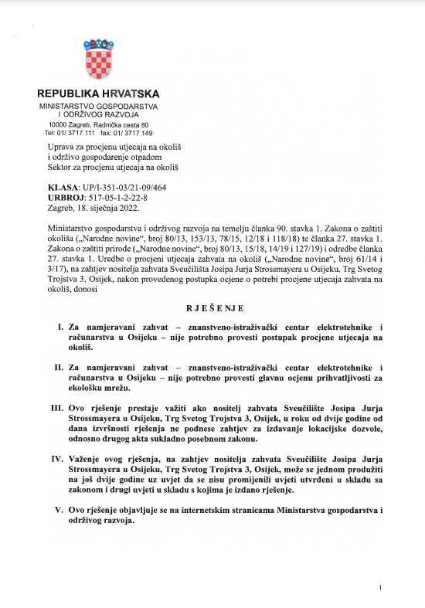

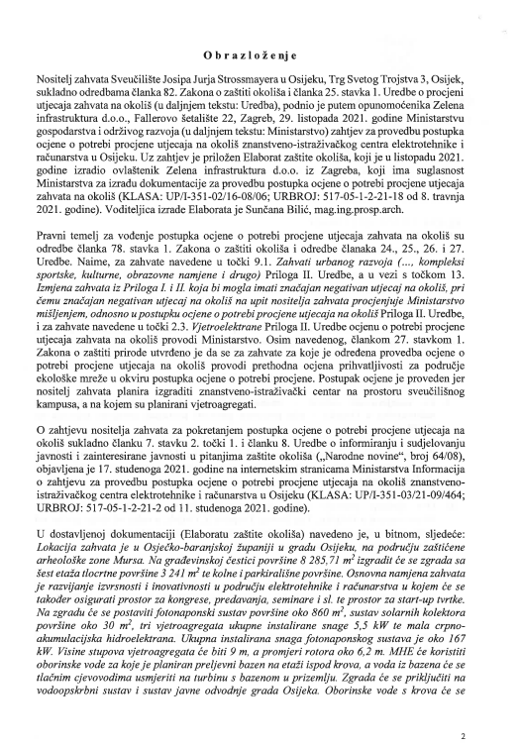

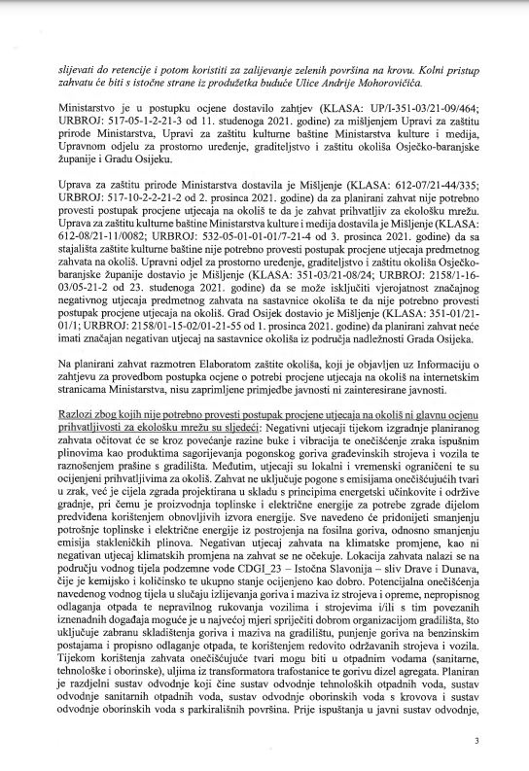

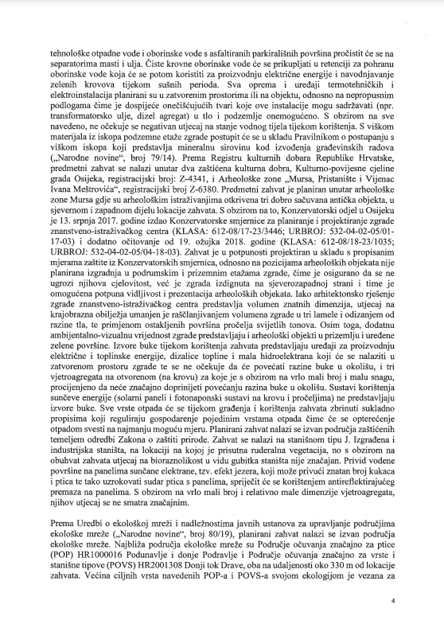

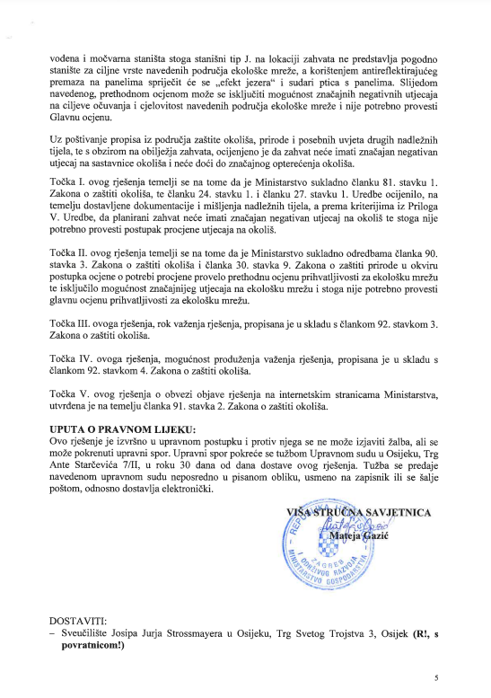

- Opinion confirming that it is not necessary to carry out the procedure of Screening of the need for Environmental Impact Assessment for planned Sub-Project

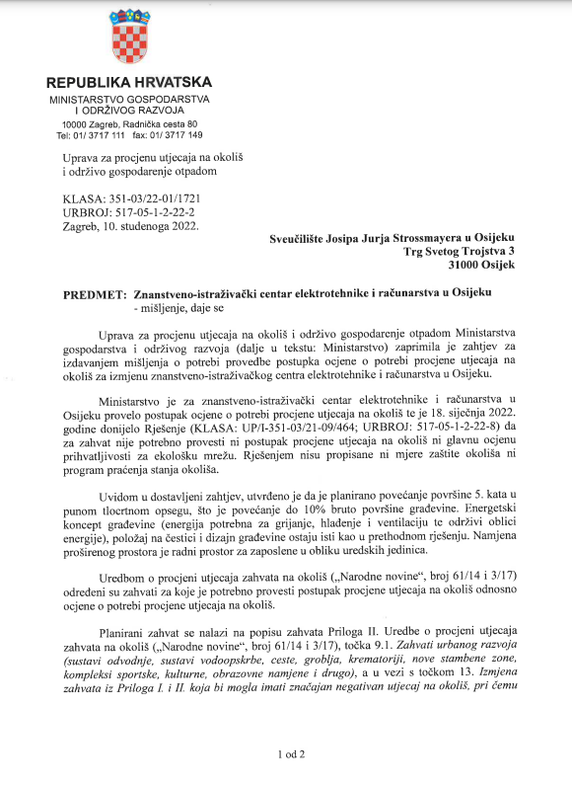



According to the World Bank's Environmental and Social Standards (ESS), the term „Associated Facilities“ means facilities or activities that are not funded as part of the project and are: (a) directly and significantly related to the project; and (b) carried out, or planned to be carried out, contemporaneously with the project; and (c) necessary for the project to be viable and would not have been constructed, expanded or conducted if the project did not exist. For facilities or activities to be Associated Facilities, they must meet all three criteria. Associated Facilities should meet the requirements of the ESSs, to the extent that the Borrower has control or influence over such Associated Facilities.
https://mzo.gov.hr/UserDocsImages/dokumenti/Znanost/Projekt-digit/digit-esmf-2nd-draft-18-04-2023.pdf
National Recovery and Resilience Plan (2021-2026) – national plan of reforms and investments designed to mitigate the pandemic's socioeconomic fallout.
The Recovery and Resilience Facility - temporary instrument that is the centerpiece of NextGenerationEU -the EU’s plan to emerge stronger and more resilient from corona epidemic and to be better prepared for future crisis.
European Green Deal - set of policy initiatives by the European Commission with the overarching aim of making the European Union (EU) climate neutral in 2050.
Republic of Croatia is signatory to Montreal Protocol on Substances that Deplete the Ozone Layer (1987) so freons used will be those alowed under the afroementioned protocol.
Roman Limes, or the borders of the Roman Empire, stretch over more than 9,500 km and today cover 20 countries on three continents (Europe, Asia and Africa).
http://radon.civilna-zastita.hr/
http://radon.civilna-zastita.hr/radonski-zemljovidi/radon-u-tlu/grp-po-zupanijama/
POP - conservation areas important for birds, POVS - conservation areas important for species and habitat types
https://prilagodba-klimi.hr/wp-content/uploads/2019/05/Rezultati-klimatskog-modeliranja-na-sustavu-HPC-Velebit.pdf; https://prilagodba-klimi.hr/wp-content/uploads/2019/05/Dodatak_Klimatsko_modeliranje_VELEbit_12.5km.pdf
https://prilagodba-klimi.hr/wp-content/uploads/2019/05/Procijenja-ranjivosti-na-klimatske-promjene-po-pojedinim-sektorima.pdf
https://mpgi.gov.hr/UserDocsImages//dokumenti/Potres/Svjetska%20banka//ESMF_Component_1_January%202022.pdf
US EPA, Office of Air and Radiation, 2001: Building Radon Out, A Step-by-Step Guide on How To Build Radon-Resistant Homes
Habitat type J (built and industrial habitats) represents built, industrial, and other terrestrial or water surfaces on which a permanent and strong targeted (planned) human impact is manifested. This habitat type implies spatial complexes in which different types of built and cultivated green areas alternate in various proportions of representation.
Zelena infrastruktura Ltd. Otober 2021
an e-mail address will be created for the FERIT Sub-Project
Decisions on the appointment of conservation supervision are made by the competent archaeologist of the Osijek Department for Conservation in Osijek in accordance with the Law on the Protection and Preservation of Cultural Property (Official Gazette 69/99, 151/03, 157/03, 87/09, 88/10, 61/11, 25/ 12, 136/12, 157/13, 152/14, 98/15, 44/17, 90/18, 32/20, 62/20, 117/21, 114/22).

