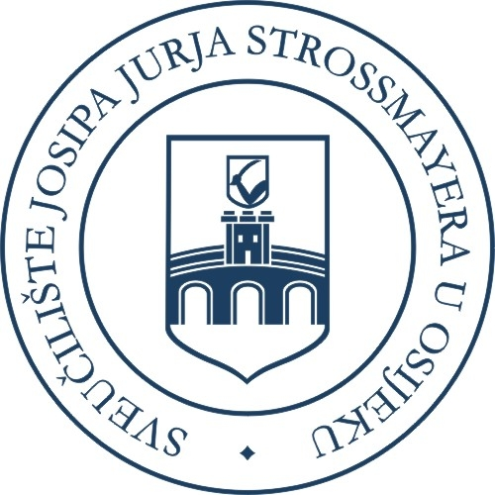


APPLICATION FORM
for Incoming Staff Mobility
within ERASMUS+

Note
Dear Guests, please fill in the below form concerning your Erasmus+ activity at our University and submit this form to the UNIOS IR Office (e-mail: erasmus@unios.hr) and your contact person at the host University unit.
The information that you will provide in this form will be used only for purpose of issuing official Letter of Invitation.
For more information please contact International Relations office at UNIOS (tel: 00385 31 224 125; fax: 00385 31 224 126; e-mail: erasmus@unios.hr ). Thank you for your cooperation!

To be filled by the Erasmus+ incoming staff member

Home Institution: ………………………………………………………….…………………
Home Faculty / unit: ……………………………………………………………………………
Erasmus code of home institution (if any): …...………………………………………………..
Name and Surname of staff member:……………………………………...……………………
Age:………………………… Gender: M  F 
Nationality:……………………………………………………………………………….……
Purpose of mobility: teaching  professional training  job shadowing  other 
Subject area of activity: ……………………………….………………………………………
Experience: Junior  Intermediate  Senior 
Host UNIOS Faculty:…………………………..……………………………………………….
Contact person at host UNIOS Faculty: ……….……………………………………………….
Activity start: dd/mm/yyyy ………………….. Activity end: dd/mm/yyyy ……………….
Only for teaching activity
Number of teaching hours to be held at UNIOS: ………………………………………………………..
Level of teaching: Undergraduate Graduate  Postgraduate 
Language of teaching:…………………………………………………………...…………...……..……

Place, Date:…………………………………………………………………

Signature of Incoming staff member:…..………………………………..

To be filled by UNIOS

Proposed mobility is approved by the host UNIOS Faculty ………………………………………………………………

Erasmus academic coordinator’s name and signature: ………………………………………………………………….

Letter of Invitation is issued by UNIOS IR Office by Institutional Erasmus Coodrinator on (dd/mm/yyyy)

